Stuttgart-based Lapp Group provides training and courses in eleven skilled trades
19 new apprentices at Lapp

Stuttgart, 01 September 2014

When this year's apprenticeships begin on 1st September 2014, a total of 19 school-leavers will be starting their careers at the Lapp Group. At its headquarters in Stuttgart, the leading supplier of integrated solutions and branded products in the cable and connection technology sector will be providing training and courses in eleven skilled trades. As a result, the Lapp Group offers a wide range of career prospects, from machine and plant operation to industrial management, and even dual studies.

Andreas Lapp, Chairman of Lapp Holding AG, said: "Well trained and qualified employees are a crucial element in our company's success. Our commitment to training reflects our sense of social responsibility. Good professional training is a key requirement for a successful future, not just for the company, but for each individual person."

From day one, the Lapp apprentices will be completely integrated into the company. During their training, they will spend time in almost every department, ensuring they are familiar with all aspects of the company. Before the official start of their apprenticeships, the new recruits were invited to a “welcome barbecue” along with their trainers and apprenticeship coordinators.

The Lapp apprenticeships begin today with a training week. Here, the beginners get to know their colleagues, are given an overview of the apprenticeships within the Lapp Group and find out about the company's values, industries and branded products. The week is capped off by cooperative team building involving all trainee year groups.

To strengthen team spirit and cooperation skills, conventional training will be accompanied by a series of special events and projects that the apprentices will be actively involved in. These include organisation of the annual anniversary celebrations, the company's appearance at the major apprentice and student fair and at "vocatium Stuttgart", a specialist trade fair for training and study, as well as the "Job Shuttle - Next Stop Training/Study" careers information event. The varied apprenticeship programme also includes regular training weeks and team training, along with the opportunity to spend several weeks working at one of Lapp's international companies. "This gives them a chance to acquire not only professional qualifications but also to develop important social skills", says Anne Voigt, a training manager at U.I. Lapp GmbH.

Apprenticeships in the following skilled trades are offered by Lapp in Stuttgart: warehouse logistics specialist, industrial sales representative, information technology officer, wholesale and foreign trade dealer, system integration IT specialist, machine and plant operator focusing on metal and plastic technology, and mechatronic engineer. Dual courses in Business Studies with Service Management and Logistics Management, Industrial Business Studies, Business IT and Industrial Engineering with a focus on Electrical Engineering are also available. In all 64 young men and women are currently on apprenticeships at the Stuttgart site.

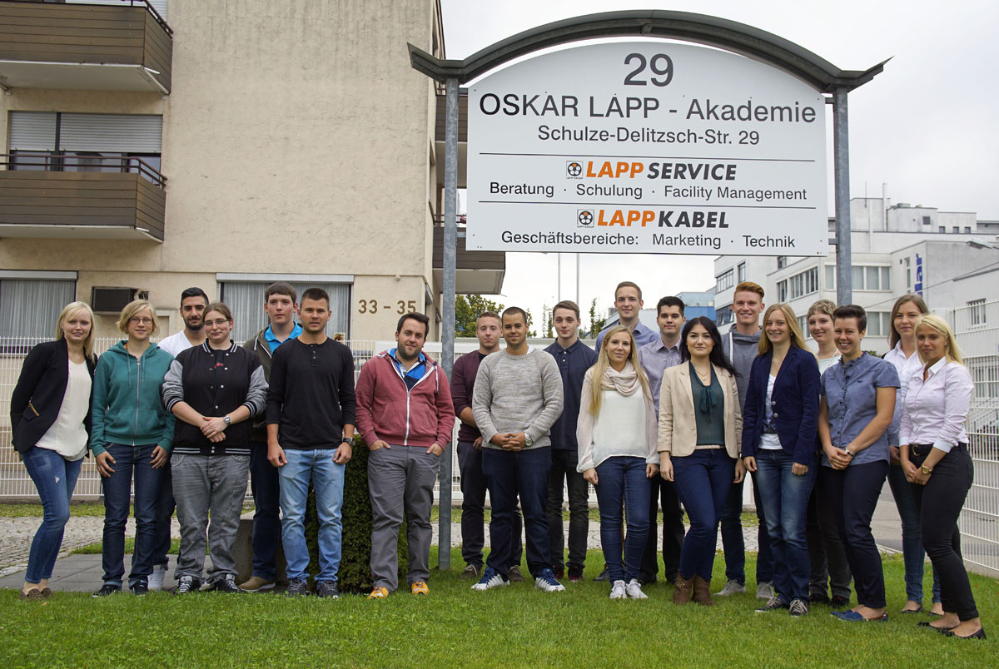
Image caption:
The new Lapp apprentices' first day at work began with an introductory training session at the “Oskar Lapp Akademie”

Find the image in printable quality here
www.lappkabel.com/press

About the Lapp Group:
Headquartered in Stuttgart, Germany, Germany, the Lapp Group is a leading supplier of integrated solutions and branded products in the field of cable and connection technology. The Group's portfolio includes standard and highly flexible cables, industrial connectors and screw technology, customised system solutions, automation technology and robotics solutions for the intelligent factory of the future, as well as technical accessories. The Lapp Group’s core market is in the industrial machinery and plant engineering sector. Other key markets are in the food industry as well as the energy and the mobility sector.

The Lapp Group has remained in continuous family ownership since it was founded in 1959. In the 2012/13 business year, it generated a consolidated turnover of 830 million euros. Lapp currently employs approximately 3,200 people across the world, has 18 production sites and over 40 sales companies. It also works in cooperation with around 100 foreign representatives.

