CFO with experience of family companies and plant engineering
Andreas Hermann Member of the Board for Finance and Controlling at Lapp

Stuttgart, 20 March 2014

The Supervisory Board of Stuttgart-based Lapp Holding AG has appointed Andreas Hermann (45) CFO and Member of the Board responsible for Finance and Controlling with effect from 1 March 2014. Andreas Hermann brings with him many years of experience in industrial machinery and plant engineering and has held similar positions at large, family-run companies in Baden-Württemberg for some 15 years. He also has extensive international experience.

"With Mr Hermann, we not only have an outstanding expert in Finance and Controlling, but also someone who understands how family companies think and act. He will support our sustainable corporate management and help ensure that our family company remains firmly on course for growth in the future", explains Andreas Lapp, Chairman of the Board at Lapp Holding AG.

Mr Hermann was the Member of the Board responsible for Finance, Human Resources, IT and Investor Relations at Homag Group AG in Schopfloch for several years, and then CFO at Gebr. Schmid GmbH in Freudenstadt. "I enjoy working at family-based companies and Lapp has an outstanding reputation. I am looking forward to the challenges", says Andreas Hermann.

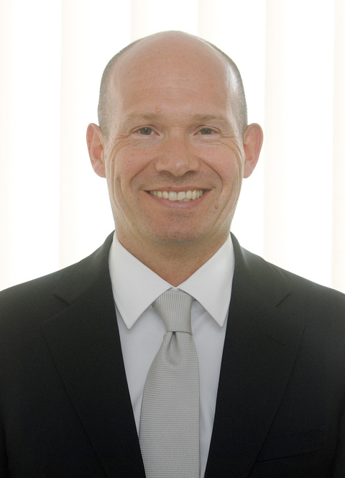
The image is available in printable quality here

www.lappkabel.com/press

About the Lapp Group:
Headquartered in Stuttgart, Germany, Germany, the Lapp Group is a leading supplier of integrated solutions and branded products in the field of cable and connection technology. The Group's portfolio includes standard and highly flexible cables, industrial connectors and screw technology, customised system solutions, automation technology and robotics solutions for the intelligent factory of the future, as well as technical accessories. The Lapp Group’s core market is in the industrial machinery and plant engineering sector. Other key markets are in the food industry as well as the energy and the mobility sector.

The Lapp Group has remained in continuous family ownership since it was founded in 1959. In the 2012/13 business year, it generated a consolidated turnover of 830 million euros. Lapp currently employs approximately 3,200 people across the world, has 18 production sites and over 40 sales companies. It also works in cooperation with around 100 foreign representatives.

