Swiss injection moulding plant in the Lapp Group positions itself on the market
Lapp Tec AG as a new service provider for plastic injection moulding solutions

Stuttgart, 03rd December 2014
The injection moulding plant of the Stuttgart Lapp Group, based in Diessenhofen, Switzerland, has repositioned itself. Effective immediately, it is no longer an exclusive producer for the Lapp Group for the manufacture of SKINTOP® cable glands and EPIC® industrial connectors made of plastic; instead it will also provide its services and expertise in the area of injection moulding technology to external companies. The company has therefore been renamed from Lapp Kabel AG to Lapp Tec AG and was entered into the commercial register of the Canton of Thurgau at the end of October.

"Tec stands for Technology and represents the range of services from product engineering to series production of plastic solutions," explains Roman Germann, Managing Director of Lapp Tec AG. Together with the name change, production capacity was expanded and the plants were modernised. For example, this past summer a new injection moulding plant was put into operation and in 2015 an investment will be made in a new multiple-component injection moulding plant that will make it possible to manufacture parts made of different plastics in a single operation. In addition, together with expert partners in injection moulding of microcellular foams, initial testing was successfully completed. During this process, the molten mass and a gas (nitrogen or carbon dioxide) are dissolved in a supercritical state. The microscopic bubbles are formed during the injection of the molten-mass-gas solution into the mould. This makes it possible to achieve improvements in quality features such as flatness, roundness and distortion. The operating efficiency is also improved as a result of the reduced use of materials, shorter cycle times and the use of smaller injection moulding machines. The part designer also has greater freedom in the design process. In addition, the internal capacity for design and engineering will be increased, the business and production processes further optimised and an independent sales department developed. In the coming months, focus will also be placed on the development and expansion of a testing laboratory for functional testing at the Diessenhofen site that will support the production process. When necessary, three-shift operation will be expanded from five to seven days a week.

"Our strengths are based on decades of know-how in plastics technology and on our position in the Lapp Group's global network, particularly in research and engineering. External customers can now also benefit from our expertise. They receive from us complete, sophisticated plastic injection moulding solutions, from the original idea to series production," explains Roman Germann on the new strategy.

Lapp Tec AG was founded 25 years ago under the name Lapp Kabel AG. Today 22 injection moulding machines, six assembly systems and 120 injection moulds are in three-shift operation in the 1,600 square metre production facility. Every year, 175 million plastic parts and 75 million finished products are manufactured there. The EPIC® and SKINTOP® range is made up of over 800 different cable glands, connector components, connectors, cables and electrical accessories. Some 700 tonnes of raw materials, such as polyamide and polycarbonate, are consumed annually. 37 employees ensure operations run smoothly at the site. As part of the repositioning, the number of employees will also be increased. Training of plastics technologists has already begun.

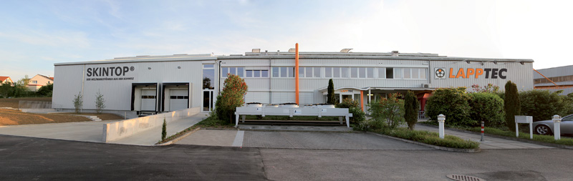
The new Lapp Tec AG also provides its expertise in injection moulding technology to external customers

Find the image in printable quality here
www.lappkabel.com/press

About the Lapp Group:
Headquartered in Stuttgart, Germany, the Lapp Group is a leading supplier of integrated solutions and branded products in the field of cable and connection technology. The Group's portfolio includes standard and highly flexible cables, industrial connectors and screw technology, customised system solutions, automation technology and robotics solutions for the intelligent factory of the future, as well as technical accessories. The Lapp Group’s core market is in the industrial machinery and plant engineering sector. Other key markets are in the food industry as well as the energy and the mobility sector.

The Lapp Group has remained in continuous family ownership since it was founded in 1959. In the 2012/13 business year, it generated a consolidated turnover of 830 million euros. Lapp currently employs approximately 3,200 people across the world, has 18 production sites and over 40 sales companies. It also works in cooperation with around 100 foreign representatives.

