Oskar Lapp Research Prize and Grant Awarded
Oskar Lapp Foundation supports young cardiac researchers

Stuttgart, 15th July 2014

During the 80th annual conference of the German Cardiac Society (DGK) in Mannheim, the Oskar Lapp Foundation awarded two sponsorship prizes to young cardiac researchers. The Oskar Lapp Research Prize 2014, which also carries a €12,000 cash prize, went to Dr Thomas Fischer and associate professor Dr Samuel T. Sossalla from the Göttingen Heart Centre. The two researchers identified a promising starting point for future treatment strategies for cardiac arrhythmia and contractile dysfunction.

The Oskar Lapp Grant 2014 was awarded to Dr Christian A. Gleißner, Associate Professor at the University Clinic in Heidelberg. His research subject is vascular calcification that can lead to infarction. Specifically, he is studying how the responsible cells can be influenced to prevent the dangerous calcification. The grant is worth up to €20,000 for equipment, and supports active clinical physicians and academics who are involved in experimental and clinical research. It offers up to a two-year period of sponsorship.

The Oskar Lapp Foundation was founded in 1992 in honour of the Stuttgart-based businessman Oskar Lapp, who died on 25th April 1987 as a result of a heart attack. The foundation aims to provide young scientists with additional incentives to effectively engage them in cardiovascular research. Ursula Ida Lapp, Chair of the Foundation's Board of Trustees said: "There is a lot of work to be done in cardiovascular research. There is still a need for much better research into prophylaxis, diagnostics, therapy and rehabilitation for coronary heart disease."

Along with the founding family, the members of the Oskar Lapp Foundation Board of Trustees are Prof. Gunther Arnold (formerly Director of the German Cardiac Society), Prof. Anton Both (retired Medical Director, Klinikum Stuttgart – Katharinenhospital), Dr Rolf Thieringer ( Mayor of the state capital of Stuttgart), Prof. Roderich C. Thümmel (lawyer), Prof. Thomas Nordt (Medical Director, Klinikum Stuttgart – Katharinenhospital) and Konstantinos Papoutsis (Director of the German Cardiac Society).

For donations, the Oskar Lapp Foundation's bank details are as follows: Baden-Württembergische Bank, account no. 2076087, sort code 600 501 01, or IBAN: DE68600501010002076087, BIC: SOLADEST600.

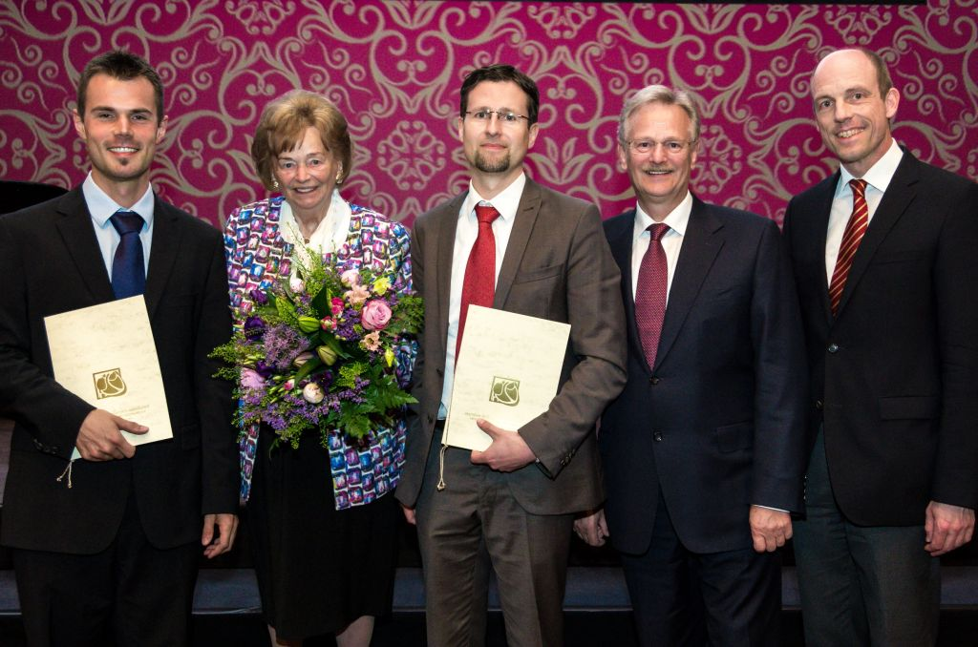
Presentation of the Oskar Lapp Research Prize, left to right: Prize winner Dr Thomas H. Fischer, Ursula Ida Lapp, prize winner Associate Professor Dr Samuel T. Sossalla, Siegbert Lapp and Prof. Thomas Nordt

Find the image in printable quality here
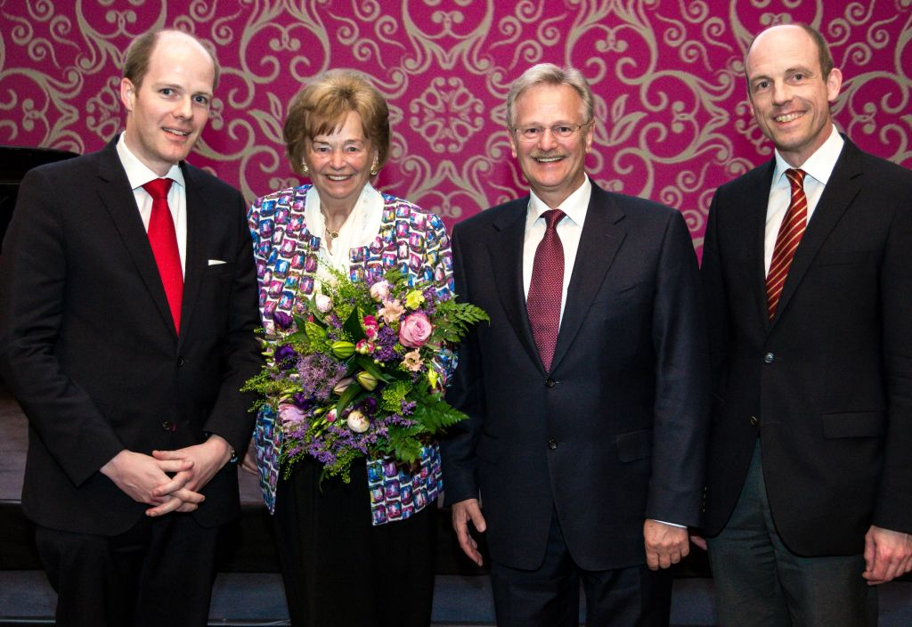
Congratulations on the Oskar Lapp Grant 2014, left to right: Dr Christian A. Gleißner, Ursula Ida Lapp, Siegbert Lapp and Prof. Thomas Nordt
(photos: DGK/Thomas Hauss)

Find the image in printable quality here
www.lappkabel.com/press

About the Lapp Group:
Headquartered in Stuttgart, Germany, the Lapp Group is a leading supplier of integrated solutions and branded products in the field of cable and connection technology. The Group’s portfolio includes standard and highly flexible cables, industrial connectors and screw technology, customised system solutions, automation technology and robotics solutions for the intelligent factory of the future, as well as technical accessories. The Lapp Group’s core market is in the industrial machinery and plant engineering sector. Other key markets are in the food industry as well as the energy and the mobility sector.

The Lapp Group has remained in continuous family ownership since it was founded in 1959. In the 2012/13 business year, it generated a consolidated turnover of €830 million. Lapp currently employs approximately 3,200 people around the world, has 18 production sites and over 40 sales companies. It also works in cooperation with around 100 foreign representatives.

“CaMKII and PKA differentially regulate SR Ca²+ -leak in human cardiac pathology”
"Molekulare Mechanismen der LGALS3BP-induzierten Makrophagenmodulation" (Molecular mechanisms in LGALS3BP induced macrophage modulation)

