SPS IPC Drives in Nuremberg: Lapp Group presents SKINTOP® HYGIENIC and other innovative products

For use under extreme conditions

Stuttgart, 06 October 2014
A the SPS IPC Drives 2014 exhibition in Nuremberg from 25 to 27 November, the Lapp Group will be presenting a range of innovative products in Hall 6/Stand 258. The highlights include the new SKINTOP® HYGIENIC stainless steel cable gland for use in food production and the pharmaceutical industry, the new UNITRONIC® ROBUST for data transmission, the new ÖLFLEX® SERVO CY 719 and an extended portfolio for the Industrial Ethernet sector.

Three important factors contribute to the SKINTOP® HYGIENIC being very easy to clean and ensuring compliance with the most stringent hygiene standards: its material, the design, and precise fit. The SKINTOP® HYGIENIC’s rounded shape with no corners and angles as well as its precise fit thanks to very low tolerances in production means that no residues can accumulate. The material, Class V4A stainless steel (1.4404), means that it will endure the use under extreme conditions for long periods of time. This is shown by certification from ECOLAB and the use of materials for the US market in compliance with the corresponding standards from the FDA and NFS. This means the SKINTOP® HYGIENIC is approved for direct contact with foodstuffs in production. In addition, tests are currently in process for EHEDG hygienic design certification. Initial tests have been passed successfully and Lapp expects certification within the next months.
The EHEDG Hygienic Design test process is particularly demanding: Previously, components were subjected to a testing process that included inspection of the design plans and the materials used. From October 2014, the testing procedure has been altered to include practical tests under extreme conditions. The SKINTOP® HYGIENIC is the first and, to date, only product to meet these exceptionally strict requirements and obtain the latest EHEDG certification.

With the UNITRONIC® ROBUST, Lapp has extended its range of low-frequency data network cables with a cable featuring a special resistant sheath material for use in particularly harsh environments. The material is resistant to a range of chemical media, as well as being ozone, UV and weather resistant in compliance with EN 50396 and HD 605 S2. This makes it ideal for use in machine tool manufacture, the chemical industry, medical engineering, laundries, car wash systems, composting and sewage plants and agricultural machinery. It is available in three different designs: 1. unshielded, 2. shielded, and 3. twisted pair shielded version.

For Industrial Ethernet, Lapp is extending its range of products for PROFINET applications and is now a single source for complete systems, including copper conductors and fibre optic cables with matching connectors, accessories, and services. The familiar ETHERLINE® brand copper conductors for Industrial Ethernet have been supplemented with new HITRONIC® brand fibre optic cables.

Lapp is also optimising its ÖLFLEX® SERVO product area. The launch of the new multi-standard product ÖLFLEX® SERVO CY 719 will tighten up the range of servo cables for fixed installation. Selecting the appropriate cable has been simplified by substituting two previous types, while production is now leaner thanks to the use of standardised materials. At the same time, Lapp is using a core insulation material that minimises unwanted leakage currents through the screening. This gives customers an improved product at a comparable price. As before, the product range covers all applications and is compatible with the servo motor ranges of well-known manufacturers.

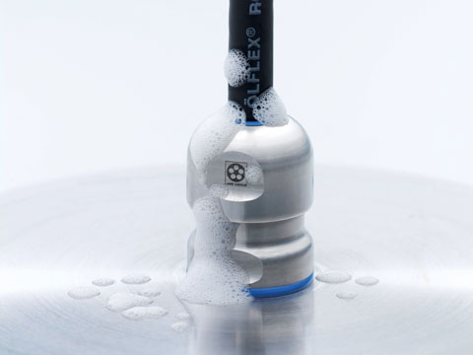
The new SKINTOP® HYGIENIC stainless steel cable gland was designed specifically for use in food production and the pharmaceutical industry

Find the image in printable quality here
www.lappkabel.com/press

About the Lapp Group:
Headquartered in Stuttgart, Germany, the Lapp Group is a leading supplier of integrated solutions and branded products in the field of cable and connection technology. The Group's portfolio includes standard and highly flexible cables, industrial connectors and screw technology, customised system solutions, automation technology and robotics solutions for the intelligent factory of the future, as well as technical accessories. The Lapp Group’s core market is in the industrial machinery and plant engineering sector. Other key markets are in the food industry as well as the energy and the mobility sector.

The Lapp Group has remained in continuous family ownership since it was founded in 1959. In the 2012/13 business year, it generated a consolidated turnover of 830 million euros. Lapp currently employs approximately 3,200 people across the world, has 18 production sites and over 40 sales companies. It also works in cooperation with around 100 foreign representatives.

