Foundation stone laid for new daycare centre
Lapp family donates € 500,000 for new “Teddy Bear Island” daycare center

Stuttgart, 23 November 2015
The Lapp business family from Stuttgart have long supported projects that help create a comfortable environment for children that allows them to develop. One organisation that is particularly close to family's hearts is the association Kind e.V, which supports companies by helping parents combine their careers with their family responsibilities. The Lapp family recently donated € 500,000 to help fund the new construction of the "Bärcheninsel" (“Teddy Bear Island”) daycare centre in the city's Dürrlewang district. Yesterday saw the ceremonial laying of the foundation stone.

"Our society is getting older and we need more children. That is why it is very important that starting a family does not present an obstacle to parents' careers. It must be possible to combine the two. The new daycare centre will be open at times that suit businesses' working hours", explains Siegbert E. Lapp, Chairman of the Supervisory Board at Lapp Holding AG. As the former chairman of Kind e.V, he contributed greatly to the growth of childcare facilities provided by the association, which was founded in 1991.

Up until October 2015, the association ran six business-friendly childcare centres in Stuttgart for children between the ages of six months and twelve years, a responsibility which it has since passed on to Kinder in Stuttgart gGmbH. Opened in 1994, Teddy Bear Island was the first daycare centre provided by Kind e.V. The original building was over 40 years old, and as a renovation was no longer seen as worthwhile, the decision was made to demolish it last June. Construction on the new building began in August. The centre is scheduled to open in summer 2016 and will offer space for 100 children. The construction costs totalling € 3.5 million are financed through the donation from the Lapp family and by investors Häuser für Kinder GmbH ("Houses for Children").

Jochen Sanguinette, current chairman of Kind e.V. and Managing Director of Trelleborg Sealing Solutions: "We are very grateful to the Lapp family for their generous support. The daycare centres will also help us boost the image of the business parks. High-quality childcare facilities close to workplaces are an important piece of infrastructure, and make members of Kind e.V more attractive employers. By better combining family and work life, they can show how they are reacting to the needs of their employees."

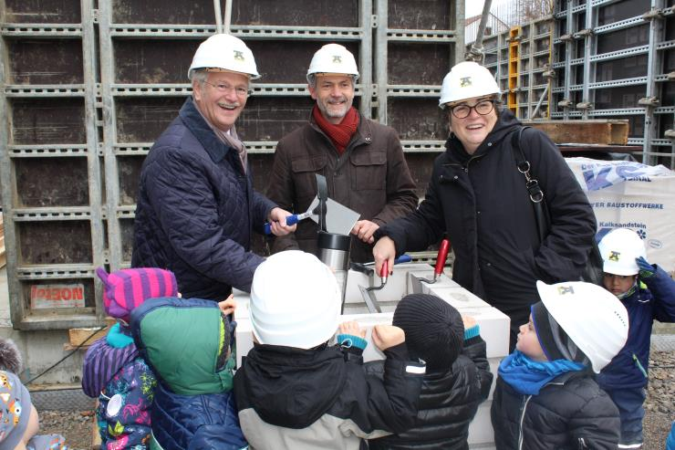
Celebrations as the foundation stone is laid for the new Teddy Bear Island daycare centre. Left to right: Siegbert E. Lapp, Chairman of the Supervisory Board at Lapp Holding AG, Theo Härtner, CEO of Häuser für Kinder GmbH, Waltraud Weegmann, CEO of Konzept-e-Netzwerk, accompanied by children from the day care centre Bärcheninsel.

Find the image in printable quality here
www.lappkabel.com/press

About the Lapp Group:
Headquartered in Stuttgart, Germany, the Lapp Group is a leading supplier of integrated solutions and branded products in the field of cable and connection technology. The Group’s portfolio includes standard and highly flexible cables, industrial connectors and screw technology, customized system solutions, automation technology and robotics solutions for the intelligent factory of the future, as well as technical accessories. The Lapp Group’s core market is in the industrial machinery and plant engineering sector. Other key markets are in the food industry as well as the energy and the mobility sector.

The Lapp Group has remained in continuous family ownership since it was founded in 1959. In the 2013/14 business year, it generated consolidated revenue of 820 million euros. Lapp currently employs approximately 3,200 people across the world, has 18 production sites and over 40 sales companies. It also works in cooperation with around 100 foreign representatives.

