The Lapp Group’s new products and unique logistics concept at InnoTrans
Full steam ahead for Lapp and the rail industry
Stuttgart, September 20, 2016
The rail industry places high requirements on quality and delivery capacity – a challenge that the Lapp Group is facing head-on. The Stuttgart-based full-range supplier of electrical cables, cable connections and accessories is showcasing a range of new products and services, including ÖLFLEX® TRAIN, at its stand at InnoTrans (hall 10.1, stand 103), the leading trade fair for transport engineering in Berlin. These cables are specifically designed for rail transport and meet numerous national and international norms and standards. Lapp is also transferring its successful logistics concept to the rail industry. The company can supply many standard products within 24 hours, even in small volumes. This is unheard of in this industry.
Short delivery times, low minimum order values
Delivery times of several months, the standard among manufacturers and assemblers of cables for locomotives, train carriages and metro trains, are a thing of the past with Lapp. Even when rare cable and accessory types need to be made to order, the traditional family company is several weeks faster than other suppliers. Another unusual bonus: customers can order small volumes of 100 metres or more from Lapp. On request, Lapp can cut the cables to the right length so that the customer saves on storage costs. Lapp also does not apply a minimum order value. This is an important advantage, particularly in the hectic phase before launching a newly developed locomotive or carriage type onto the market, because manufacturers very often have to rearrange the electrics at the last minute. “We see a major opportunity for Lapp here,” said Thorsten Grünberg, who has been Market Manager for rail at Lapp since spring.
The high delivery capacity is the result of a close-knit network of logistics centres and consistently digitalised logistics processes. The Lapp Group’s service and logistics centre in Ludwigsburg is setting standards. More than 90,000 products are stored in this 30,000 m² building in fully-automated high-rack facilities; just under one million cables are supplied from here every year.
‘Torture chamber’ quality

Lapp wants to be known for more than just delivery capacity in the rail industry – they want the renowned high quality of their products to be an influencing factor for customers. Numerous company-owned test centres in Lapp subsidiaries around the world guarantee this quality. You will find Lapp engineers putting all of the latest developments through their paces in tough endurance tests at these facilities. For instance, highly flexible cables undergo millions of bending cycles at various speeds and extreme bending radii. Lapp also performs its own tests to assess heat and cold resistance, fire behaviour and resistance to a wide range of media, thus guaranteeing that approval is obtained in the most important markets. Only products that survive this ‘torture chamber’ are good enough to be included in our product range.
An abundance of new products for the rail industry
Between 20 and 23 September, the Lapp Group is showcasing new and tried-and-tested products in hall 10.1, stand 103 at Messe Berlin.
- ÖLFLEX® TRAIN is a new product line for the rail industry. At InnoTrans, Lapp shows products from this line that were developed specifically for the European market. Those cables are manufactured in Lapp Korea’s Competence Centre and factory in Seongnam.
- UNITRONIC® and ETHERLINE® data communication systems. The UNITRONIC® products have been newly developed and tried-and-tested product lines such as ETHERLINE® have been improved for use in passenger transportation through increased fire protection according to the fire protection norm EN 45545.
- The SKINTOP® ST-HF-M is a halogen-free, extremely flame-retardant and self-extinguishing cable gland.
- EPIC® industrial connector series designed for high currents of up to 35 Ampères.
- SILVYN® HIPROJACKET is a fireproof cable protection hose system that protects the inner against flames and fluid metal up to temperatures of 1640 °C.
- FLEXIMARK® is Lapp’s marking system. For use in the rail industry the marking components comply with the strict fire protection requirements as stated in EN 45545.

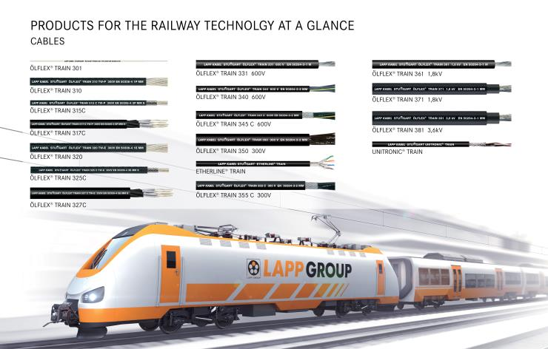
The Lapp Group showcases a range of new products and services, including ÖLFLEX® TRAIN, at its stand at InnoTrans

The image is available in printable quality here

www.lappkabel.com/press

About the Lapp Group:
Headquartered in Stuttgart, Germany, the Lapp Group is a leading supplier of integrated solutions and branded products in the field of cable and connection technology. The Group’s portfolio includes standard and highly flexible cables, industrial connectors and screw technology, customized system solutions, automation technology and robotics solutions for the intelligent factory of the future, as well as technical accessories. The Lapp Group’s core market is in the industrial machinery and plant engineering sector. Other key markets are in the food industry as well as the energy and the mobility sector.

The Lapp Group has remained in continuous family ownership since it was founded in 1959. In the 2014/15 business year, it generated consolidated revenue of 886 million euros. Lapp currently employs approximately 3,300 people across the world, has 17 production sites and over 40 sales companies. It also works in cooperation with around 100 foreign representatives.

