Highly resistant innovations from Lapp at the Hannover Messe trade fair
Some like it hot

Stuttgart, 16 February 2016

Things really heat up in power stations, blast furnaces and motors. The cables used in these areas must boast a corresponding level of heat resistance. At the Hannover Messe trade fair, Lapp will be showing off a whole range of new products that can handle high temperatures and mechanical stress: the single core ÖLFLEX® HEAT 650 SC can withstand a continuous temperature of 650 degrees Celsius, whereas the ÖLFLEX® HEAT 125 MC/C MC is intended for use in highly frequented buildings but can still withstand 125 degrees. The silicone single core ÖLFLEX® HEAT 180 SiF A with a maximum continuous temperature of 150 degrees Celsius (according to UL) is certified for the North American market. With the SKINDICHT® MINI FKM, Lapp demonstrates that even small cable bushings can cope with high temperatures. The new SKINTOP® MULTI is particularly practical – an absolutely impermeable cable bushing made of gel and suitable for a wide range of cable thicknesses within a tight space.
The new products in detail:

ÖLFLEX® HEAT 650 SC: single core with glass fibre insulation
A nickel wire and glass fibre insulation help this cable boast incredible properties: the single core can withstand 650 degrees Celsius – in continuous operation. It is therefore predestined for use in areas such as power stations, blast furnaces and motors, as well as in heating modules and cooking systems. The ÖLFLEX® HEAT 650 SC expands the single core product range to cover an extended scope of ambient temperatures and now provides users with a solution for a continuous temperature of up to 650°C, as opposed to the previous level of only 400°C.

ÖLFLEX® HEAT 180 SiF A: silicone cable for North America
Lapp rounds off its already extensive range of single cores with the ÖLFLEX® HEAT 180 SiF A. The cable features silicone insulation and, in addition to fulfilling the requirements of the USA's UL standard in terms of temperature (up to 150 degrees Celsius) and voltage (up to 1,000 volts), it is also halogen-free. Single cores can be used more flexibly than multi-core cables, and are also available in a range of colours to make cabling clearer – particularly in control cabinets.

ÖLFLEX® HEAT 125 MC/C MC: an all-rounder up to +125°C
This cable has a sheath made of electron beam cross-linked plastic that improves the fire behaviour and increases the temperature resistance up to a level of 125 degrees Celsius, as certified by Germanischer Lloyd. The plastic is halogen-free and especially suited to highly frequented areas, both in industry and in public buildings. The cable is available in two versions: unshielded (ÖLFLEX® HEAT 125 MC) or shielded (ÖLFLEX® HEAT 125 C MC).

SKINDICHT® MINI FKM: small cable bushing, big performance
A particularly heat-resistant cable is not of any use if the connectors and cable bushings are not also designed for high temperatures. The cable bushing SKINDICHT® MINI FKM offers outstanding temperature resistance: it is designed for continuous operation at temperatures of up to 200 degrees Celsius. This is made possible by a housing made of brass and seals made of FKM, a particularly temperature-resistant plastic. SKINDICHT® MINI FKM is suitable for thin cables with a diameter of 2.0 to 5.5 millimetres as deployed in measuring technology – for the purpose of cabling sensors, for example.

Here are some more particularly robust and practical innovations from Lapp at the Hannover Messe trade fair:

SKINTOP® MULTI is a new addition to the family of practical multi-cable bushings for control cabinets and automation technology. Like the related SKINTOP® CUBE and SKINTOP® CUBE MULTI, it enables multiple cables to be fed through. Whereas the SKINTOP® CUBE features a frame with interchangeable single seals and therefore offers maximum flexibility for preassembled cables, the new SKINTOP® MULTI makes an impression with its compact design and space-saving arrangement on the control cabinet. The multi-cable bushing can be used by the installer to feed in up to 22 round cables with a wide range of diameters, as well as AS-I cables, simply by piercing them through an innovative elastic gel membrane and performing quick and flexible connection. This considerably reduces the variety of types and therefore saves time and money. With the use of the gel technology, the entire system achieves large clamping ranges, a high protection rating and optimum strain relief on the entire cable bundle in order to ensure a secure cable entry in the long term.

SKINTOP® GRIP is now available in designs ranging from M16x1.5 to M32x1.5. This brass cable gland is equipped with a double saddle that provides ten times more strain relief than the standard. This cable bushing is primarily intended for use in machine and system parts that are moved, such as foot switches and push-button control units.

EPIC® ULTRA H-A 3 shows that even small rectangular connectors can be highly robust. The housings of this new series are coated with nickel for the purpose of corrosion protection and provide optimum electromagnetic compatibility thanks to their 360 degree all-round shielding. They are suitable for cramped conditions in control cabinets.

These and many other innovations from Lapp are on show at Lapp's stand at the Hannover Messe trade fair – hall 11, stand C03.
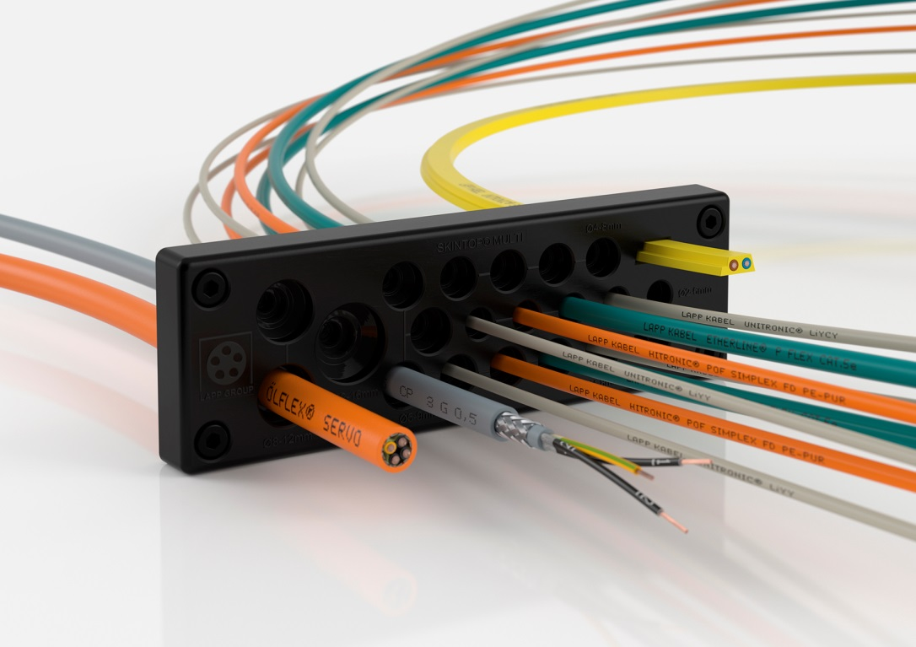
The multi-cable bushing SKINTOP® MULTI makes an impression with its compact design and space-saving arrangement on the control cabinet

You can find the image in printable quality here

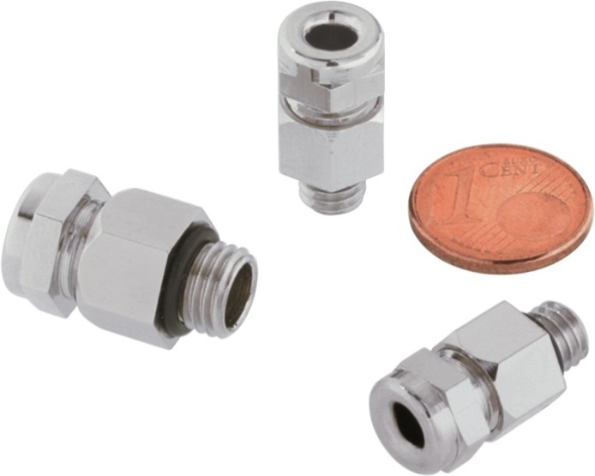
The particularly small cable bushing SKINDICHT® MINI FKM is designed for continuous operation at temperatures of up to 200 degrees Celsius

You can find the image in printable quality here

Thanks to a nickel wire and glass fibre insulation, the ÖLFLEX® HEAT 650 SC withstands 650 degrees Celsius in continuous operation

You can find the image in printable quality here

www.lappkabel.com/press

About the Lapp Group:
Headquartered in Stuttgart, Germany, the Lapp Group is a leading supplier of integrated solutions and branded products in the field of cable and connection technology. The Group’s portfolio includes standard and highly flexible cables, industrial connectors and screw technology, customized system solutions, automation technology and robotics solutions for the intelligent factory of the future, as well as technical accessories. The Lapp Group’s core market is in the industrial machinery and plant engineering sector. Other key markets are in the food industry as well as the energy and the mobility sector.

The Lapp Group has remained in continuous family ownership since it was founded in 1959. In the 2013/14 business year, it generated consolidated revenue of 820 million euros. Lapp currently employs approximately 3,200 people across the world, has 18 production sites and over 40 sales companies. It also works in cooperation with around 100 foreign representatives.

