Lapp is an associate partner in the “DC INDUSTRY” research project
Combating conversion losses
Stuttgart, 2 November 2016

The Lapp Group is an associate partner in the DC INDUSTRY (German: DC-INDUSTRIE) project which is receiving funding through the sixth energy research programme run by the Federal Ministry for Economic Affairs and Energy (BMWi).

Whether charging a mobile phone or operating machinery in a factory, many electric and electronic devices and equipment are supplied with AC voltage, even though they actually use DC voltage. Rectifiers perform the necessary conversion – you will find dozens of them in every household in the form of mains adaptors – but this process loses energy. The DC Industry research project deals with the issue of how DC networks can be established via a central conversion process as an energy-saving alternative, especially when operating machinery on production lines. Energy losses through multiple conversions are thus avoided and renewable energies are easier to integrate into the network. “At Lapp, we see major potential for DC applications in industry and are contributing our extensive expertise to the partnership,” said Georg Stawowy, Member of the Board and CTO of Lapp Holding AG. The Stuttgart-based connection specialists also intend to develop new cabling solutions for special DC application requirements.

Sunlight for electric motors
Lapp has amassed experience in connection solutions for DC applications in areas including photovoltaics, charging systems for electric vehicles and coils for large lorries. The Lapp Group will be exhibiting at the SPS IPC Drives trade fair in Nuremberg, and industrial DC applications will be an issue at the Lapp booth there.

DC networks in factories
When operating machinery on production lines, frequency converters with a DC link are being used more and more often to regulate speed. The DC INDUSTRY project aims to research how the driving force behind these machines can be supplied with power via DC networks with central voltage conversion. They can distribute power as needed with low loss levels. They also make it easier to recover braking energy and store it in batteries. In addition, photovoltaic systems can be seamlessly integrated into the network. A further advantage is that DC networks are more robust against fluctuations in electricity supply and in network quality.

Visit Lapp at SPS in Hall 6, Stand 258 to learn more.

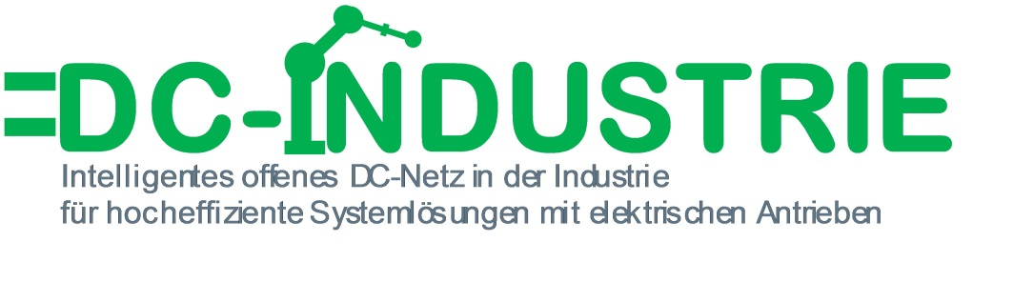
The image is available in printable quality here

www.lappkabel.com/press

About the Lapp Group:
Headquartered in Stuttgart, Germany, the Lapp Group is a leading supplier of integrated solutions and branded products in the field of cable and connection technology. The Group’s portfolio includes standard and highly flexible cables, industrial connectors and screw technology, customized system solutions, automation technology and robotics solutions for the intelligent factory of the future, as well as technical accessories. The Lapp Group’s core market is in the industrial machinery and plant engineering sector. Other key markets are in the food industry as well as the energy and the mobility sector.

The Lapp Group has remained in continuous family ownership since it was founded in 1959. In the 2014/15 business year, it generated consolidated revenue of 886 million euros. Lapp currently employs approximately 3,300 people across the world, has 17 production sites and over 40 sales companies. It also works in cooperation with around 100 foreign representatives.

