Lapp presents ÖLFLEX CONNECT CHAIN catalogue
Energy chain expertise at your fingertips

Stuttgart, 15. December 2016

The best cables deserve the best drag chains, and the Lapp Group offers both together under the name ÖLFLEX CONNECT Chain. To help users configure their own individual drag chain system, Lapp recently unveiled the ÖLFLEX CONNECT Chain catalogue at the SPS IPC Drives trade fair. It contains over 350 pages of specialist knowledge of drag chain engineering, along with a 40-page engineering guideline, a complete portfolio of drag chain-compatible branded components and a unique range of services.

Everything from one supplier
Chief Technical Officer Georg Stawowy: "The ÖLFLEX CONNECT Chain catalogue contains a detailed, eight-stage guide that makes it easy for users to plan and configure their individual drag chain assembly." The focus is always on the solution that the customer wishes to achieve. Customers will also find all Lapp components, such as data, power and signal cables, connectors, cable glands and markings, along with servo assemblies produced in a smart, semi-automatic process. It also contains the full portfolio of steel and nylon drag chains, along with chains for robotics. Frantisek Omasta, Manager Business Development Harnessing, adds: "This is no ordinary catalogue. The comprehensive engineering guideline gives our customers a huge amount of experience and knowledge of chains, FD cables and other FD components."

Knowledge online
As well as in paper form, the ÖLFLEX CONNECT Chain catalogue and engineering guideline are also available online:
Engineering guideline as white paper
ÖLFLEX CONNECT Chain catalogue in download centre
More user-friendly online services are to follow shortly.

Production and engineering expertise combined
The new catalogue follows the Lapp philosophy of: "The chain is there for the cable". As specialists for cables and components, we at Lapp know what it takes to develop a reliable cable system. This also includes planning the perfect cable layout within the drag chain, in which many different cable types, tubes and surface qualities meet. At Lapp, we combine production expertise with specialist engineering knowledge.

Testing under real conditions
Before launching these products on the market, Lapp puts both them and the most common configurations through endurance tests in our in-house test centre. Every cable and drag chain goes through a comprehensive range of tests that go well beyond the standard requirements. This testing not only helps Lapp ensure the compatibility of its components, but also makes sure that the systems work when they are used by the customer.

The ÖLFLEX CONNECT Chain is available in English and German. It is available now to download at
www.lappkabel.com/catalogues.html (English) or
www.lappkabel.de/kataloge.html (German). The engineering guideline is available at
www.lappkabel.com/oelflexconnectchain (English) or
www.lappkabel.de/oelflexconnectchain (German)

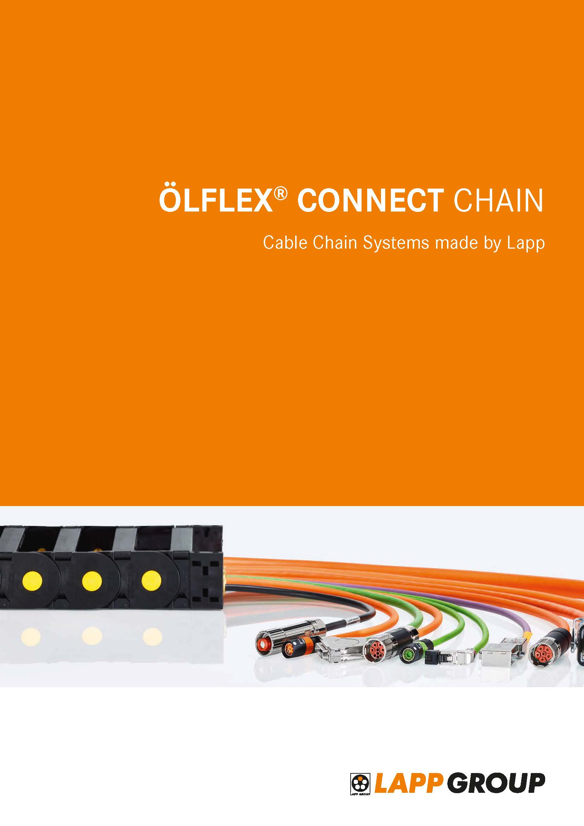
The Lapp ÖLFLEX CONNECT Chain catalogue offers drag chain expertise at your fingertips
The image is available in printable quality here

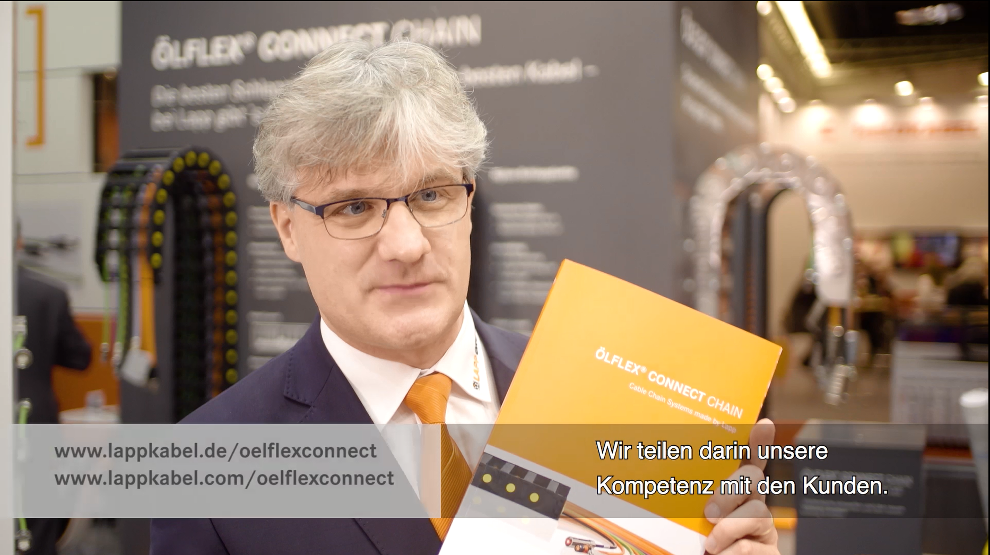
Frantisek Omasta presents the ÖLFLEX CONNECT Chain catalogue at the Lapp stand at the SPS IPC Drives 2016 trade fair. Link to video

http://www.lappkabel.com/press/latest-press-releases.html

About the Lapp Group:
Headquartered in Stuttgart, Germany, the Lapp Group is a leading supplier of integrated solutions and branded products in the field of cable and connection technology. The Group’s portfolio includes standard and highly flexible cables, industrial connectors and screw technology, customized system solutions, automation technology and robotics solutions for the intelligent factory of the future, as well as technical accessories. The Lapp Group’s core market is in the industrial machinery and plant engineering sector. Other key markets are in the food industry as well as the energy and the mobility sector.

The Lapp Group has remained in continuous family ownership since it was founded in 1959. In the 2014/15 business year, it generated consolidated revenue of 886 million euros. Lapp currently employs approximately 3,300 people across the world, has 17 production sites and over 40 sales companies. It also works in cooperation with around 100 foreign representatives.

