Lapp showcases latest robust products at trade fair
Lapp cables heat up the city of Hanover

Stuttgart, Germany, 25 April 2016

Whether it’s in power plants, blast furnaces or engines – cables must be able to withstand extreme heat and mechanical stress. To meet these kinds of challenges, the Lapp Group offers specialist cabling solutions – and it will unveil an entire range of new products at this year’s Hannover Messe trade fair. For example, the ÖLFLEX® HEAT 650 SC single core cable can withstand a sustained temperature of up to 650°C, while the ÖLFLEX® HEAT 125 MC/C MC – for buildings with a high volume of people – can tolerate up to 125°C. The silicone single core cable ÖLFLEX® HEAT 180 SiF A, which is UL-certified especially for the North American market, is able to withstand a maximum sustained temperature of 150°C. And with its SKINDICHT® MINI FKM, Lapp has proven that even the smallest cable glands can tolerate high temperatures. The new SKINTOP® MULTI is particularly practical: a watertight cable gland with a gel membrane, it is ideal for installing cables of different sizes in limited space.
Here’s a closer look at the new products:

ÖLFLEX® HEAT 650 SC: single core cable for high temperatures
This cable can withstand up to 650°C in continuous operation. It owes its amazing properties to a nickel strand and glass wool insulation – making it ideal for use in power plants, blast furnaces and engines, as well as in heating modules and cooking systems. The ÖLFLEX® HEAT 650 SC supplements the portfolio of single core cables for higher ambient temperatures, offering users a solution that can now tolerate a sustained temperature of up to 650°C rather than the previous 400°C.

ÖLFLEX® HEAT 180 SiF A: a silicone cable for North America
This cable can be deployed in a number of ways and is available in many different colours. Single core cables offer a number of advantages over multi-core cables, especially when it comes to control panels. Lapp has now rounded out its comprehensive single core portfolio with ÖLFLEX® HEAT 180 SiF A. This silicone-insulated cable is UL-certified in the US, meeting all the necessary criteria in terms of temperature (up to 150°C) and voltage (up to 1,000 V) – while also being halogen-free.

ÖLFLEX® HEAT 125 MC/C MC: ideal for public buildings
Germanische Lloyd agrees: this cable can withstand up to 125°C. Its plastic is halogen-free, so the cable is especially suitable for use in buildings with a high number of people – whether industrial or public. The cable’s jacket is made from irradiated plastic, making it more fire retardant. There are two types available: unshielded (ÖLFLEX® HEAT 125 MC) or shielded (ÖLFLEX® HEAT 125 C MC).

SKINDICHT® MINI FKM: the small cable gland with a big impact
Of course, connectors and cable glands must also be able to withstand high temperatures. And the SKINDICHT® MINI FKM cable gland meets this requirement: it is designed for continuous operation in temperatures of up to 200°C. This is possible thanks to a brass body and seals made from FKM, a particularly temperature-resistant elastomer. SKINDICHT® MINI FKM is suitable for thin cables ranging from 2.0 to 5.5 mm in diameter, such as those used in sensor technology.

Lapp is also showcasing the following robust and highly practical solutions in Hanover:

SKINTOP® MULTI is the latest addition to Lapp’s portfolio of practical cable glands for control panels and automation technology. With a compact, space-saving design, it permits the installation of multiple cables simultaneously: an engineer can easily pass 22 round cables of various diameters, as well as AS-I cables, through the innovative elastic gel membrane, and quickly connect them. This significantly reduces the number of glands required – saving both time and money. The gel membrane also offers a wide clamping range, a high level of protection and strain relief for the entire cable bundle – for a secure installation in the long term.

SKINTOP® GRIP is now available in sizes M 16 x 1.5 to M 32 x 1.5. This brass cable gland has a double bracket, offering up to 10 times the strain relief than the standard version. It is primarily intended for mobile machinery and plant components, such as foot switches and remote controls.

EPIC® ULTRA H-A 3 is a small yet robust rectangular connector. Its body is coated in corrosion-resistant nickel and, thanks to 360-degree coating, it offers excellent electromagnetic compatibility. It’s suitable for use in limited space, e.g. control panels.

These and many more Lapp innovations will be on display at Lapp’s booth at Hannover Messe (hall 11, booth C03).

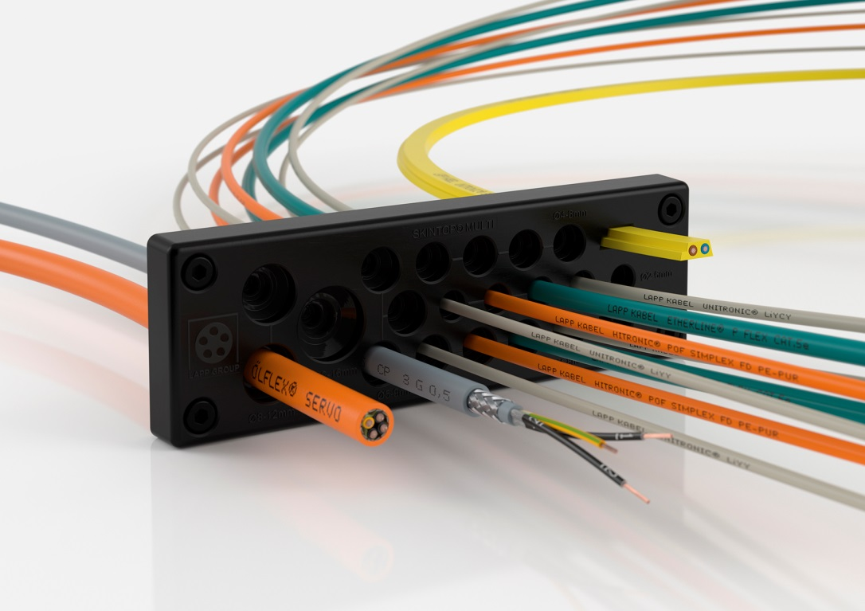
The SKINTOP® MULTI cable gland’s compact, space-saving design makes it perfect for control panels.

Find the image in printable quality here

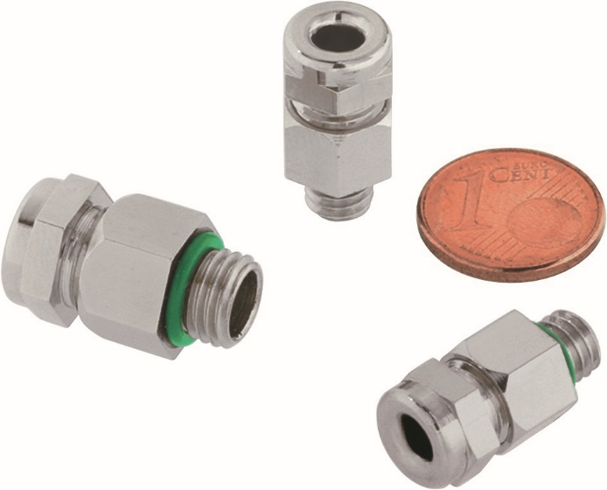
The tiny SKINDICHT® MINI FKM cable gland is designed to withstand temperatures of up to 200°C in continuous operation.

Find the image in printable quality here

The ÖLFLEX® HEAT 650 SC can withstand up to 650°C in continuous operation thanks to a nickel strand and glass wool insulation.

Find the image in printable quality here

www.lappkabel.de/presse

About the Lapp Group:
Headquartered in Stuttgart, Germany, the Lapp Group is a leading supplier of integrated solutions and branded products in the field of cable and connection technology. The Group’s portfolio includes standard and highly flexible cables, industrial connectors and screw technology, customized system solutions, automation technology and robotics solutions for the intelligent factory of the future, as well as technical accessories. The Lapp Group’s core market is in the industrial machinery and plant engineering sector. Other key markets are in the food industry as well as the energy and the mobility sector.

The Lapp Group has remained in continuous family ownership since it was founded in 1959. In the 2014/15 business year, it generated consolidated revenue of 886 million euros. Lapp currently employs approximately 3,300 people across the world, has 17 production sites and over 40 sales companies. It also works in cooperation with around 100 foreign representatives.

