New Lapp products for export-oriented industries
Solutions for unlimited opportunities

Stuttgart, 25th April 2016

Machine builders who wish to sell their products in North America are often confronted with certification specifications that differ from European standards. But manufacturers can relax, at least as far as connections technology is concerned. That’s because an increasing number of cables and plugs in the Lapp portfolio are certified to UL and thus approved for the North American market. The “Underwriters Laboratories” were founded in 1894, and are comparable with the German TÜV. In the USA they are responsible for technical safety. Connection solutions with UL certifications are of particular interest to export-oriented companies, since this allows them to address more markets with their products.

New UL-certified additions to the Lapp Portfolio are the extremely robust ÖLFLEX® CHAIN 90 P / CP single-core cables for use in drag chains, the abrasion-resistant ÖLFLEX® 409 P together with the ÖLFLEX® HEAT 180 Si A, a single-core cable with silicone insulation. In addition all the EPIC® rectangular connectors are now UL50-certified. The new products in detail:

ÖLFLEX® CHAIN 90 P / CP: Robust and flexible
This new member of the comprehensive ÖLFLEX® portfolio is a highly flexible single-core power cable for use in applications where other cables quickly break down, in particular in power chains which may demand millions of back and forth movements. And in bitterly cold conditions: The cable is suitable for constant movement at temperatures down to minus 40 degrees Celsius. The black UV-resistant polyurethane sheath is moreover extremely oil-resistant and abrasion-resistant. The cable is halogen-free and is available unshielded (ÖLFLEX® CHAIN 90 P) or shielded (ÖLFLEX® CHAIN 90 CP). Naturally, both are UL-certified and also cul-certified.

ÖLFLEX® 409 P: Tough and easy to prepare
Cables with polyurethane sheaths are resistant to high mechanical stress, mineral oil-based lubricants, dilute acids, aqueous alkaline solutions and other chemical media. Such toughness however comes at a cost of certain disadvantages: The tear-resistant and notch-resistant PUR sheath can often be hard to remove, so the cutting tool has to be set exactly to the precise depth in order not to cut too deeply and damage the underlying core insulation. The UL-certified ÖLFLEX® 409 P resolves this conflict. The black UV-resistant cable has an interstice filler functional layer with optimised tear characteristics. This protects the cores and makes cutting and removing the outer sheath easier and more reliable. The cable is also available VDE-certified in grey as ÖLFLEX® 408 P.

ÖLFLEX® HEAT 180 Si A – single-core cable with silicone insulation
Single-core cables intended especially for installation in control cabinets, available from Lapp in a wide range of variants. The new ÖLFLEX® HEAT 180 Si A has several impressive features: The cable satisfies the requirements for UL AWM Style 3644 certification in respect of temperature (up to 150 degrees Celsius) and voltage (up to 1,000 Volt). It is also halogen-free.

SKINTOP® INOX NPT: Cable glands for demanding applications
The SKINTOP® INOX NPT stainless steel cable gland with the NPT (National Pipe Thread) generally used in the USA is also new for the American market. The SKINTOP® INOX is suitable for an extremely wide variety of applications – including for example in the food and pharmaceutical industries, as its material and shape meet the high hygiene requirements of those sectors. The rounded design with few corners and edges minimises the accumulation of dust, dirt or food residues. What's more, the round shape means that the gland is really easy to clean too. Since the material used is stainless steel, oxidation is not an issue either. This most durable material also offers great benefits for other applications where the ambient conditions are harsh, such as those sited offshore.

EPIC®: UL-certified rectangular connectors
Customers need have no worries about certification for the North American market when they use EPIC® rectangular connectors. With immediate effect, all of these are UL50 certified, the standard for tightness of electrical connector housings. In addition, EPIC® H-BE inserts were certified according to UL 508A – which means they are usable for cabling in control cabinets in North America.

EPIC® ULTRA H-B: Safely closed, even when open
Even accessories that have no electrical function may require special approval for the North American market. These apply to the foodstuffs industry and the new protective cover for EPIC® connectors. The protective cover is of foodstuffs-compatible plastic, specially tailored to the requirements of the foodstuffs industry. It makes the base of the connector waterproof, even if the connections must be separated during the cleaning process. It is made from blue plastic with stainless steel anti-corrosion locking elements, and is approved by the Food and Drug Administration in the United States.

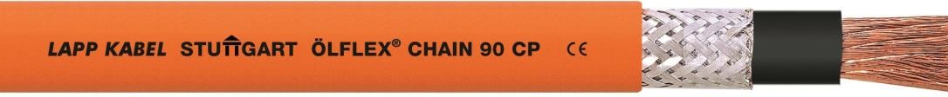
The highly flexible ÖLFLEX® CHAIN 90 P single core power cable is suitable for use in power chains even under difficult environmental conditions.
Das Bild in druckfähiger Qualität finden Sie hier

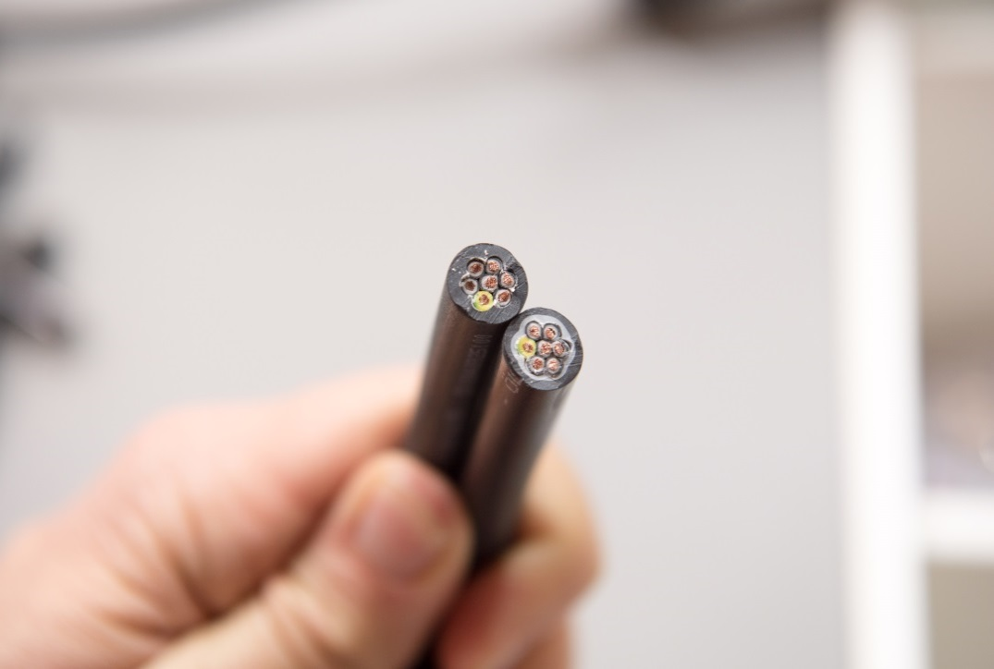
In contrast to conventional PUR cables, ÖLFLEX® 408 and 409 P feature an interstice filler functional layer with optimised tear characteristics.

Das Bild in druckfähiger Qualität finden Sie hier

www.lappkabel.com/press

About the Lapp Group:
Headquartered in Stuttgart, Germany, the Lapp Group is a leading supplier of integrated solutions and branded products in the field of cable and connection technology. The Group’s portfolio includes standard and highly flexible cables, industrial connectors and screw technology, customized system solutions, automation technology and robotics solutions for the intelligent factory of the future, as well as technical accessories. The Lapp Group’s core market is in the industrial machinery and plant engineering sector. Other key markets are in the food industry as well as the energy and the mobility sector.

The Lapp Group has remained in continuous family ownership since it was founded in 1959. In the 2014/15 business year, it generated consolidated revenue of 886 million euros. Lapp currently employs approximately 3,300 people across the world, has 17 production sites and over 40 sales companies. It also works in cooperation with around 100 foreign representatives.

