Lapp Group unveils innovations in cable assembly at Hannover Messe
The whole is greater than the sum of its parts

Stuttgart, Germany, April 26, 2016

At the 2016 Hannover Messe, the Stuttgart-based Lapp Group – a traditional family-owned business – is demonstrating that it not only manufactures cable glands and connectors of outstanding quality, but that it is also a leader in cable assembly. Lapp is now expanding its work in this area and standardizing all its global activities around the assembly of complete cable systems, including consulting, under the ÖLFLEX® CONNECT brand.

“No one knows Lapp products better than us,” explains Georg Stawowy, member of the board and CTO at Lapp Holding AG. “That’s why we’re able to select the right components and ensure that the entire system functions smoothly. And that applies around the world, with local contacts and local market expertise.” This expertise ranges from selecting the best quality resin for jackets and copper for conductors, to testing and, finally, production. The service even includes engineering bespoke solutions, where required. As a result, Lapp is able to fulfil the requirements of many of its engineering customers who want to focus more on their core competencies and hand over production of their cable systems to a specialist partner. “The demand for system solutions is growing,” says Georg Stawowy.

Of course, finished cabling can be sourced from many companies – but the Lapp approach is unique: as a manufacturer, the company has unique expertise of the cabling components. Its customers therefore enjoy tailor-made solutions of the highest quality thanks to the excellent interplay between components, as well as the expert support of Lapp engineers. “With wide-ranging expertise, Lapp has won the approval of manufacturers and industry associations in a number of sectors, including robotics and food and packaging technology,” explains Matthias Kirchherr, CSO of the Lapp Group for Latin America and EMEA. Furthermore, Lapp already has extensive engineering, production and assembly capacity, and is in the process of building capacity, in North America, Europe and Asia. Its presence grew from five sites in 2015 to 12 in 2016. This means Lapp is now even better placed to provide cable assembly worldwide, in line with customers’ requirements.

ÖLFLEX® CONNECT comprises three areas:
- ÖLFLEX® CONNECT CABLES – traditional cable assembly. This encompasses all solutions where Lapp handles cutting, marking, stripping and connecting cables – whether as standardized processes or in line with a customer’s specific requirements.
- ÖLFLEX® CONNECT SERVO –pre-assembled servo cables. At last year’s Hannover Messe, Lapp unveiled an innovative solution in which cable and connector are assembled semi-automatically, which brings advantages in respect to quality, availability and electromagnetic compatibility. Among other things, shielding is 400 percent stronger than with existing solutions. By now, these assemblies in accordance with the Siemens standard have entered series production with leading machine manufacturers. At Hannover Messe 2016, Lapp presents such assemblies also for Rockwell and SEW Eurodrive standards. These assemblies will enter series production in 2017.
- ÖLFLEX® CONNECT CHAIN – the design and assembly of complete cable carriers. Here, Lapp also handles the integration of cables and hoses – including assembly at a customer’s plant, if desired. More sophisticated solutions are also feasible: for example, several tonnes of heavy, populated steel cable tracks, which are used in a wide range of industries.
Lapp is also able to support the custom assembly of charging systems for electric cars, as well as systems with functioning parts, such as electronic components.

The complete ÖLFLEX® CONNECT portfolio and many more Lapp innovations will be showcased at Lapp’s booth at Hannover Messe (hall 11, booth C03).

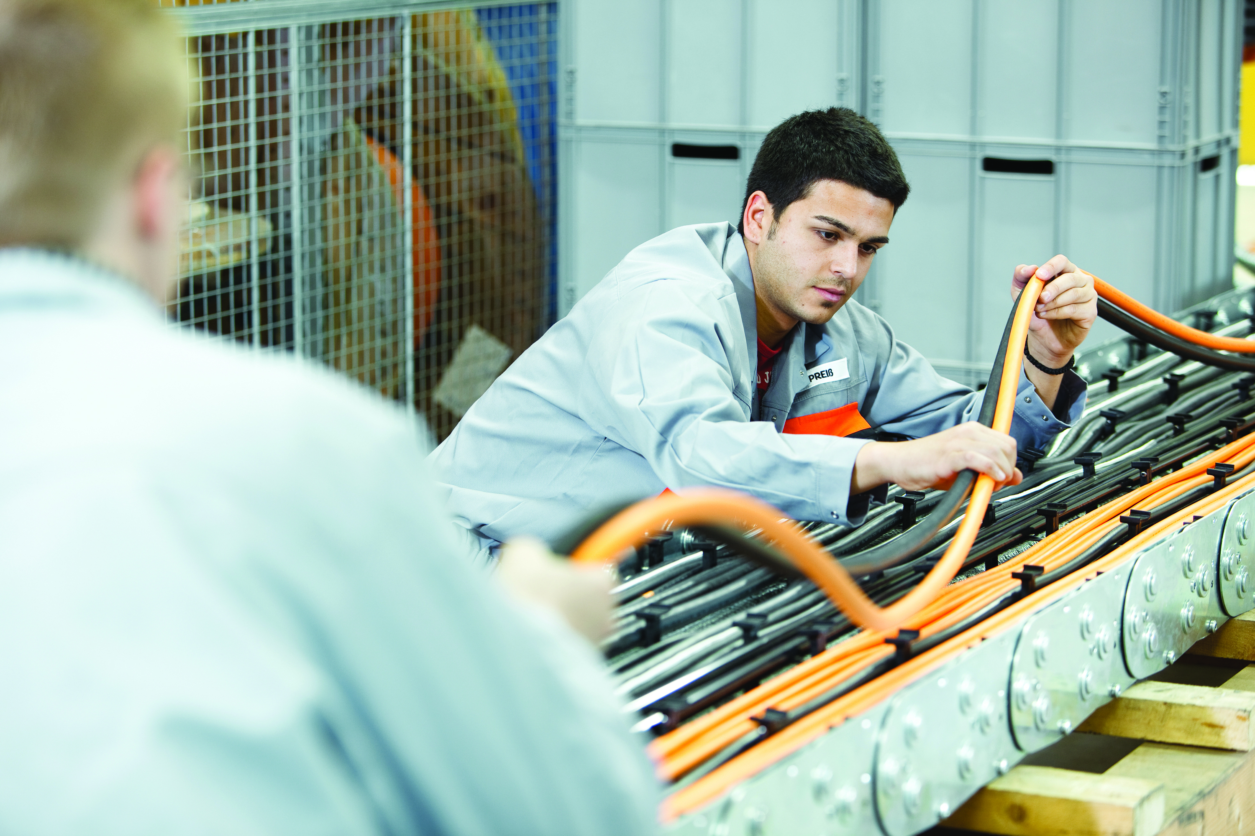
Lapp is expanding its cable assembly work and standardizing all its global activities for customers, including consulting, under the ÖLFLEX® CONNECT name.

Find the image in printable quality here

www.lappkabel.de/presse

About the Lapp Group:
Headquartered in Stuttgart, Germany, the Lapp Group is a leading supplier of integrated solutions and branded products in the field of cable and connection technology. The Group’s portfolio includes standard and highly flexible cables, industrial connectors and gland technology, customized system solutions, automation technology and robotics solutions for Industry 4.0 and the intelligent factory of the future, as well as technical accessories. The Lapp Group’s core market is in the industrial machinery and plant engineering sector. Other key markets are the food industry as well as the energy, mobility and life science sectors.

The Lapp Group has remained in continuous family ownership since it was founded in 1959. In the 2014/15 business year, it generated consolidated revenue of 886 million euros. Lapp currently employs approximately 3,300 people across the world, has 17 production sites and over 39 sales companies. It also works in cooperation with around 100 partner companies in other countries.

