Training in the commercial and technical field expanded
More apprenticeships at Lapp

Stuttgart, 5th of September 2016
The Stuttgart-based Lapp Group is stepping up its involvement in the field of training and is giving 20 young men and women their start to working life this year; two more than last year. Among the new apprentices are three refugees from Cameroon, Syria and Afghanistan.

“We mainly train people for our own needs because well-trained and qualified employees are also an important building block for the success of our company. On the other hand, we offer our employees and apprentices the prospect of building a career with us”, explains Andreas Lapp, Chairman of the Board at Lapp Holding AG. The apprentices will be able to learn nine skilled trades this year at the Lapp Group, including commercial trades such as clerk for wholesale and foreign trade, cooperative degree programmes such as Business Studies with Service Management and Logistics Management and commercial and technical trades such as being a machine and plant operator.

Lapp has already massively expanded its training, particularly in the commercial and technical field. The number of apprenticeships for machine and plant operators has thus been doubled to six places in order to give three refugees a training opportunity. Furthermore, eight young people, including six refugees, will be able to take an entry-level vocational qualification as a machine and plant operator and for IT installation and configuration.

Training is a top priorityat Lapp. The apprentices will thus be fully and completely integrated into the company from the start. In the scope of their training, they will pass through virtually all departments. And even before the training has officially started, the future apprentices will be invited to a welcome afternoon to get to know the trainers and training officers.

Their start into working life at Lapp begins today (5th of September) with an introductory training week. During this week, the new apprentices will gain their first insights into the structures and processes of the company and get an overview of training at Lapp. The company values, the sectors in which the company is active and its branded products will also be presented. Finally, a joint team building session with all apprentice year groups will take place at the Landesakademie für Jugendbildung (State Academy for Youth Education) in Weil der Stadt near Stuttgart.

In order to practise teamwork skills, the youths will be actively integrated into numerous events and projects over the duration of their training. For example, they will help organise the annual anniversary celebration, they will be actively involved in several career information events in the Stuttgart region. The apprentices are also a fixed component of the Lapp Group’s trade fair stand team at the Hannover Messe every year.

“Besides classical training, the young entrants should also learn social responsibility”, explains Anne Voigt, head of training at U.I. Lapp GmbH. The social project “Mehrwert” (“Added value”) is thus also part of the training programme. The apprentices will work for two weeks in a social work organisation that they have chosen for themselves. At the “Tüftler- und Forscherinnentag Baden-Württemberg” (Baden-Württemberg Inventors’ and Scientists’ Day) () it’s the trainees that playfully introduce Lapp to the nursery school children. Regular training weeks and team building round off the diverse training programme.

The stays abroad are particularly sought-after. This is because, at Lapp, apprentices and cooperative course students have the opportunity to work in one of the many Lapp companies around the world for four to twelve weeks. They work independently there in various departments such as Purchasing, Customer Service, Product Management or Marketing.

In all, 61 young men and women are currently receiving training at the Stuttgart site. Almost 100 percent of the apprentices have been taken on so far.

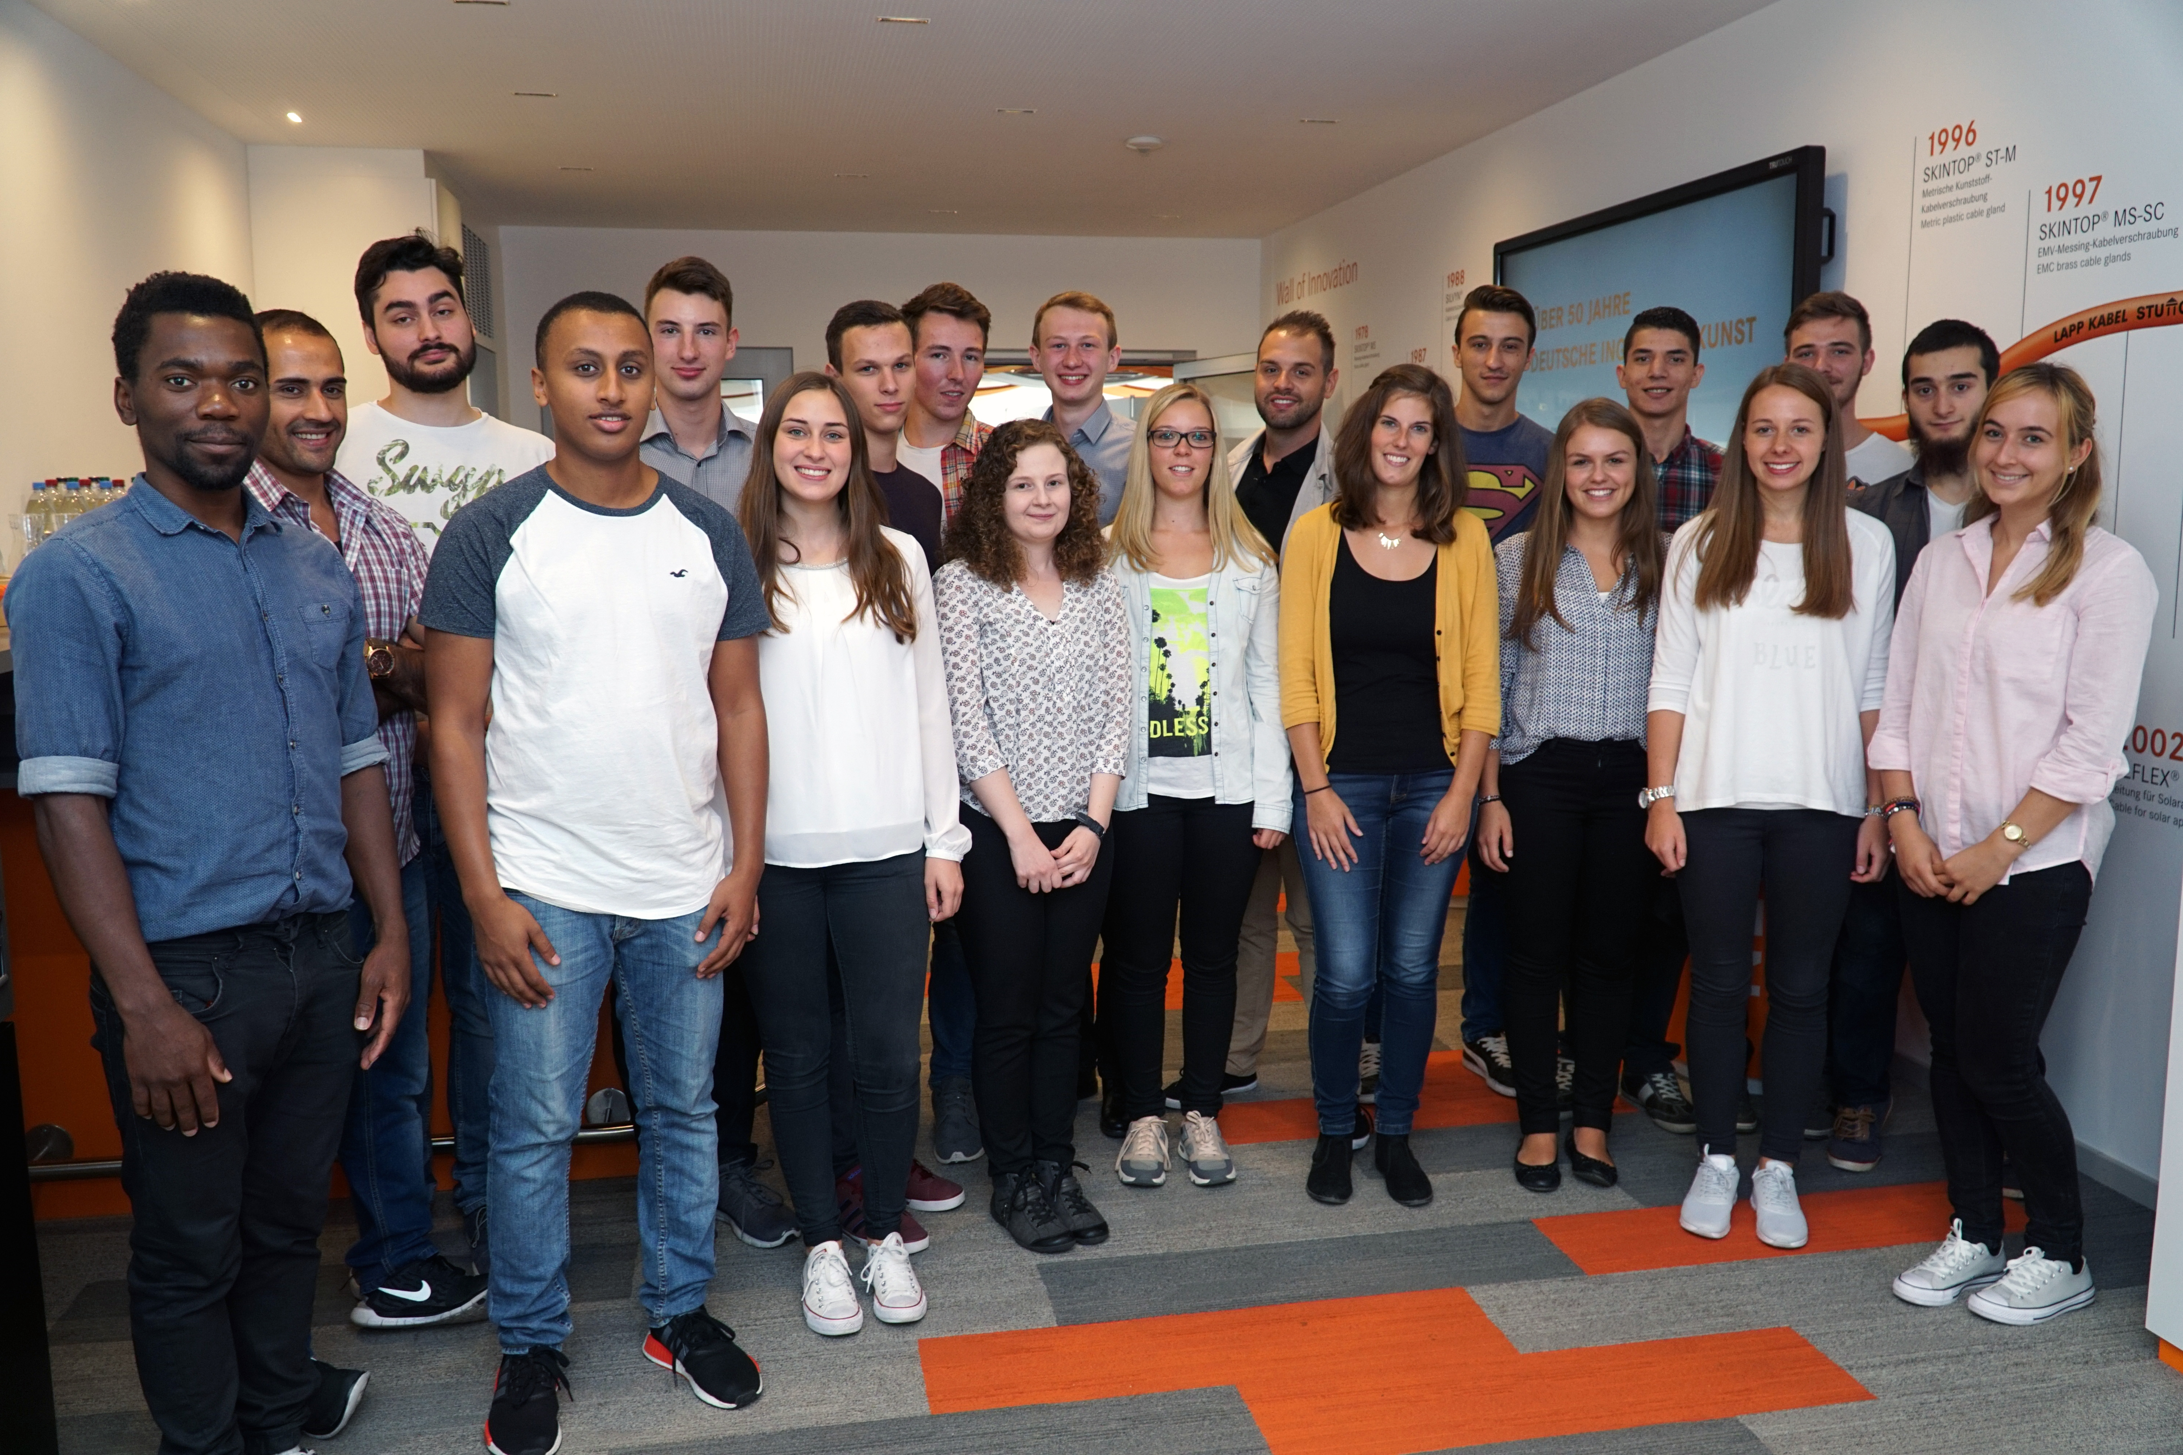
Image caption:
20 young men and women started their working lives with an introductory training week

The image is available in printable quality here

www.lappkabel.com/press

About the Lapp Group:
Headquartered in Stuttgart, Germany, the Lapp Group is a leading supplier of integrated solutions and branded products in the field of cable and connection technology. The Group’s portfolio includes standard and highly flexible cables, industrial connectors and screw technology, customized system solutions, automation technology and robotics solutions for the intelligent factory of the future, as well as technical accessories. The Lapp Group’s core market is in the industrial machinery and plant engineering sector. Other key markets are in the food industry as well as the energy and the mobility sector.

The Lapp Group has remained in continuous family ownership since it was founded in 1959. In the 2014/15 business year, it generated consolidated revenue of 886 million euros. Lapp currently employs approximately 3,300 people across the world, has 17 production sites and over 40 sales companies. It also works in cooperation with around 100 foreign representatives.

