Higher turnover, more employees, more profit
Profitable growth for the Lapp Group

Stuttgart, 1 March 2016

The Stuttgart-based Lapp Group reported significant growth in turnover in the last financial year 2014/2015 (1 October to 30 September). After two years of low turnover development, turnover in the last financial year increased by 8.1 per cent to € 886 million. Profit before tax increased by 11.3 per cent to € 41.3 million. The number of employees rose to around 3,300. Andreas Lapp, Chairman of the Stuttgart-based Lapp Holding AG, said: "We have essentially achieved our objectives and further expanded our market position. Although the German engineering association VDMA had predicted zero growth for machinery and plant engineering - Lapp Group's most important market - in 2015, we were successfully able to clearly set ourselves apart from the general trend. We are better than the industry average." The Lapp Group has managed to clearly separate itself from the mixed development and deteriorating economic situation in important markets. Initiatives in the sales area, activities in the infrastructure segment, the system business and the consistent acquisition of new market segments particularly contributed to this. The increased turnover was also positively affected by the currency development outside of the Euro area. The annual average price of copper, important for the company, only increased marginally (from € 525/100 kg to € 527/100 kg).

Positive development in all regions
Turnover development has been positive in all three Lapp Group regions.
Europe is the most important market for the Lapp Group with a 66.5 per cent share in the total turnover. Turnover rose by 2.8% to € 589.6 million (previous year: € 573.7 million). The most important single market here is Germany with a turnover share of over 30 per cent. Turnover here was € 268.5 million (previous year: € 264.8 million). Turnover development was also positive in Benelux, Austria, Romania, Poland and Italy.

America (USA, Canada, Central and South America) even managed to increase its turnover by 26.1 per cent to € 107.7 million (previous year € 85.4 million). As a result, its turnover share increased from 10.4 to 12.2 per cent. The high average exchange rate of the dollar and the initial consolidation of Cabos Lapp Brasil where Lapp has opened a new production plant had a considerable impact on this significant growth.

Asia (with Africa, Australia and New Zealand) also achieved strong turnover growth of 17.4 per cent to € 188.9 million (previous year: € 160.9 million). The turnover share increased to 21.3 per cent. In addition to currency-related effects, Lapp Korea in particular was able to considerably increase its turnover.

Healthy earnings and financial situation
The earnings and financial situation at the Lapp Group is very healthy. The number of employees increased by 3.1 per cent to 3,300. Material costs (consisting of personnel costs, depreciation and other operating expenditures minus other operating proceeds) increased from € 285.9 to 305.5 million. At the same time, the company managed to increase profit before tax by 11.3 per cent to 41.3 million. The equity ratio improved slightly to 57 per cent. Financial Director Andreas Hermann: "The Lapp Group has asserted itself very well and is in a very healthy position. We have set a course for long-term stable growth."
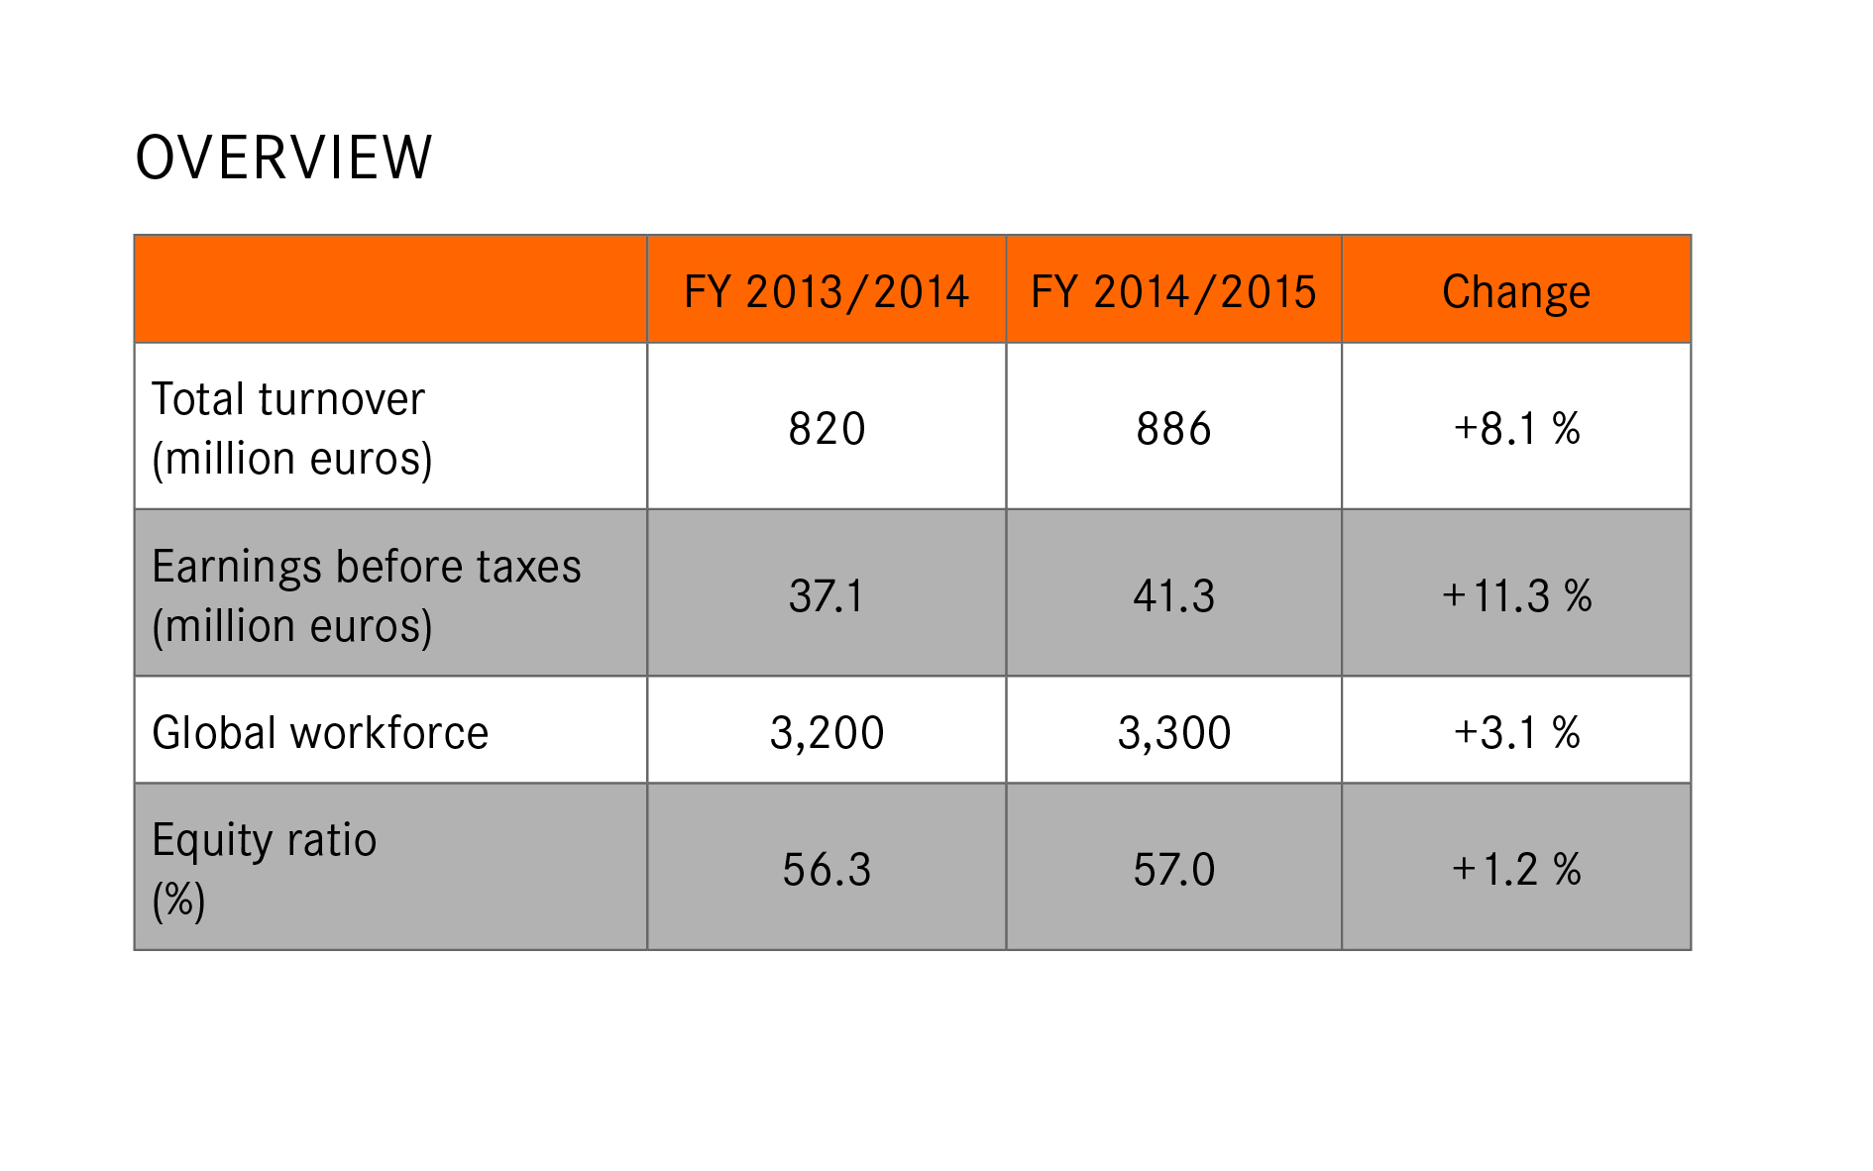
Investments for continued growth
The Lapp Group invested € 20.4 million in the 2014/2015 financial year. The biggest projects included the continued roll-out of the new SAP software ECC 6.0 and addition to capacity in important plants. For example, the production plant in Bangalore, India was almost doubled by an extension. In the French plant in Forbach, a new wire drawing machine was commissioned. The new machine will enable them to double production of copper wires. This makes Lapp a technological leader. The construction of a new administration and logistics centre was started in Russia. The construction of the new Lapp Europe headquarters in Stuttgart-Vaihingen was started in spring 2015. The new construction provides new opportunities to bundle Lapp's strengths even more effectively and to provide even better support for customers throughout Europe. The investment sum borne by Lapp Immobilien GmbH & Co. is approximately € 28 million.

Outstanding innovations & examples of application
- The Lapp Group group presented the new ÖLFLEX® CONNECT SERVO at the last Hanover Fair. This is a new generation of servo products with which the connection solutions for electrical drives are improved, made more efficient and available worldwide. Lapp has revived its portfolio of ÖLFLEX® servo cables and developed a new generation of connection systems together with the global market leader Intercontec. The cables and connection systems are processed in an automated production process developed specifically for this purpose. The Lapp Group is now constructing special production facilities in Europe, North America and Asia where new solutions are produced in consistently high quality.

- Lapp has developed a portfolio of tailored connection technology especially for the food industry. These include especially resistant cables and conduits, cable glands, connectors and accessories such as cable ties. The components meet strict international requirements, such as EHEDG design specifications or compatibility with ECOLAB® cleaning agents (see also special topic).

- At the world exhibition in Milan, Expo Milano 2015, the German pavilion grabbed the visitors' attention with its energy-generating solar trees. They integrated organic photovoltaics (OPV) technology and, unlike conventional solar modules, are made from flexible, film-integrated OPV modules. The revolutionary connection technology in this installation came from Lapp. The classic photovoltaic connection technology was especially in demand in the Asia-Pacific region.

- An ambitious project to store current for renewable power has been started by VARTA Storage GmbH together with the Technical University of Munich in Moosham, Upper Bavaria. Since October 2015, this has been home to a battery storage system boasting 200 kilowatt hours. ÖLFLEX® cables from Lapp help protect against short circuits.
- The Russian company Technomarin, based in St Petersburg and specialised in the development and production of radio navigation equipment for the maritime and aviation sector, uses Lapp products for cabling its beacons and navigation systems in the Arctic. Cables from the ÖLFLEX® HEAT series that still function reliably at cold temperatures down minus 100 degrees Celsius were used for these extreme locations.

People are the most important resource
"It is our dedicated employees that make Lapp a successful company", says Andreas Lapp. For this reason, a human resource development concept has been developed for all Lapp Group companies. Employees can obtain further qualification in various programmes. The aim is to further increase the number of managers from within the company.

Currently, 60 trainees at Lapp in Germany are learning a trade in eleven skilled trades and study courses at the cooperative university. They include for the first time a refugee from Eritrea. As a result of positive experiences, Lapp will facilitate training as a machinery and plant operator for nine recognised refugees within three years. The refugees obtain a 6-12 month IHK (Chamber of Industry and Commerce) entry qualification before the training starts.

Thanks to its family-concious business culture, three years ago the U.I. Lapp GmbH was awarded the "berufundfamilie" (work&family) certificate which is awarded under the patronage of the German Federal Ministry for Family Affairs. This certificate is currently being renewed and the U.I. Lapp GmbH is in the final round of award-winning companies again in 2016.

Positive outlook for the current financial year
The Lapp Group has had a good start. The company also expects moderate turnover growth in this financial year. Andreas Lapp: "We are expecting important impulses from Asia and America in particular, as well as from Central Europe. However, volatility in currency exchange rates and the price of copper could affect growth."
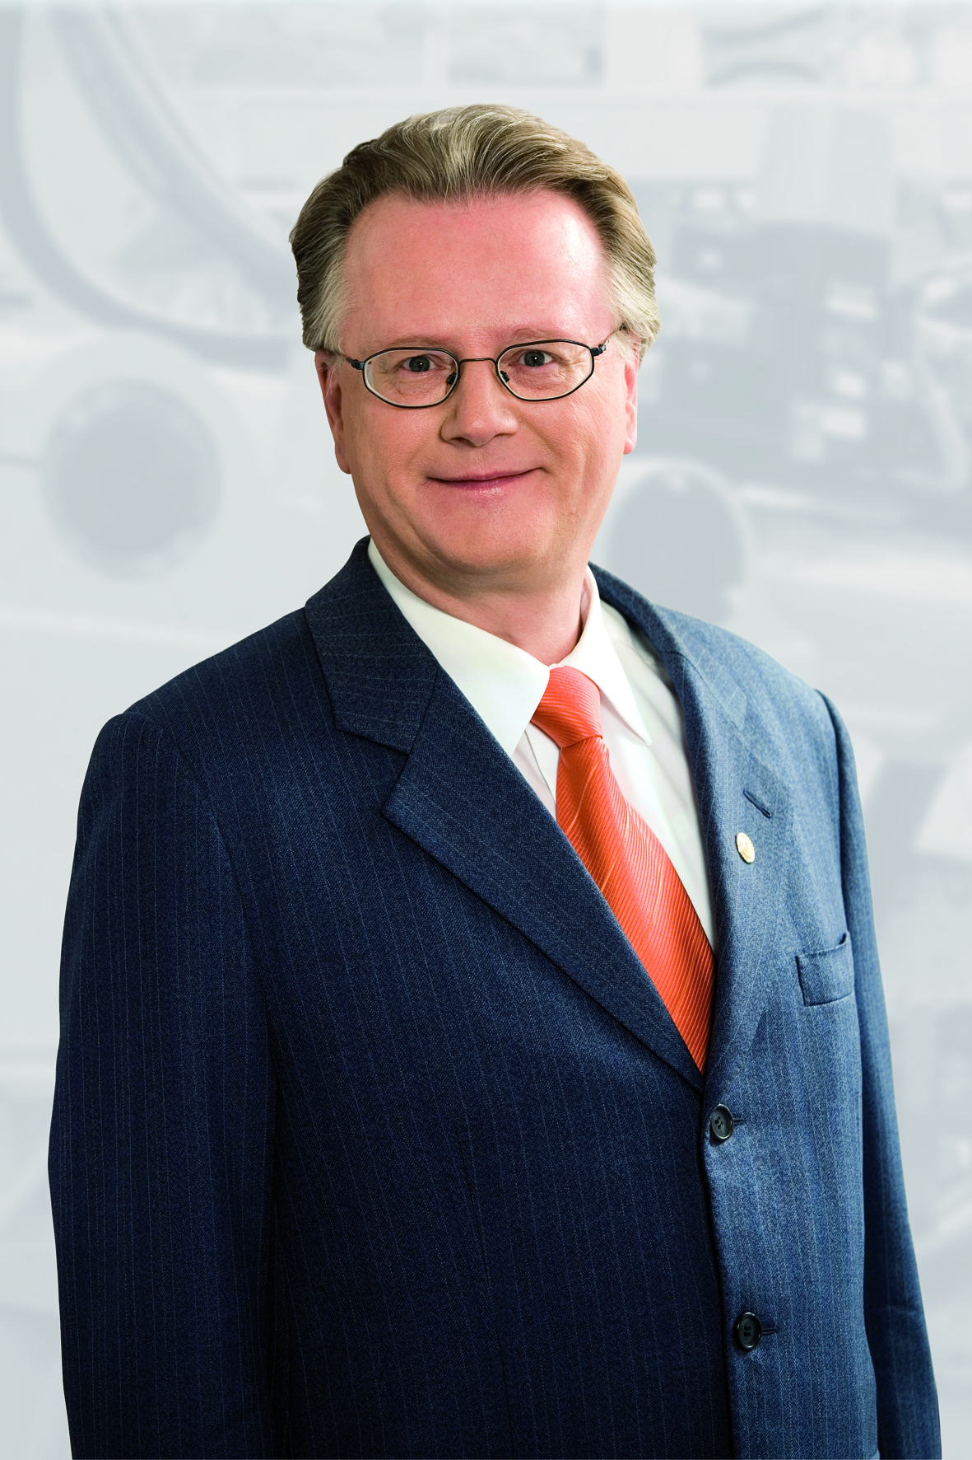
Andreas Lapp, Chairman of Lapp Holding AG
You can find the image in printable quality here

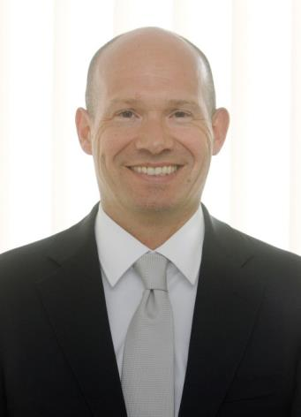
Andreas Hermann, Financial Director at Lapp Holding AG
You can find the image in printable quality here

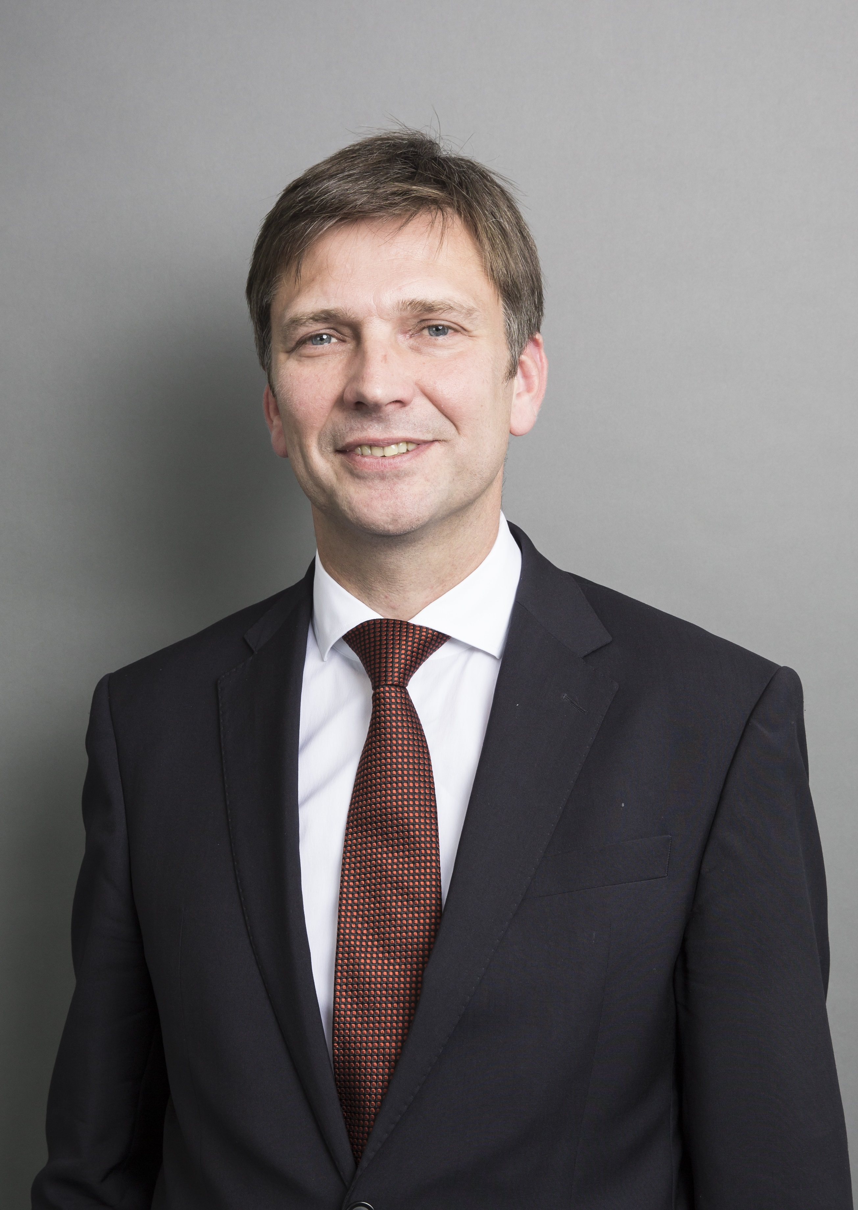
Georg Stawowy, Chief Technical Officer at Lapp Holding AG
You can find the image in printable quality here

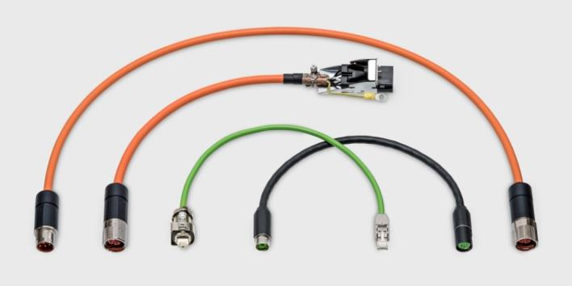
The new generation of ÖLFLEX® servo products processed in an automated production process designed specifically for this purpose
You can find the image in printable quality here

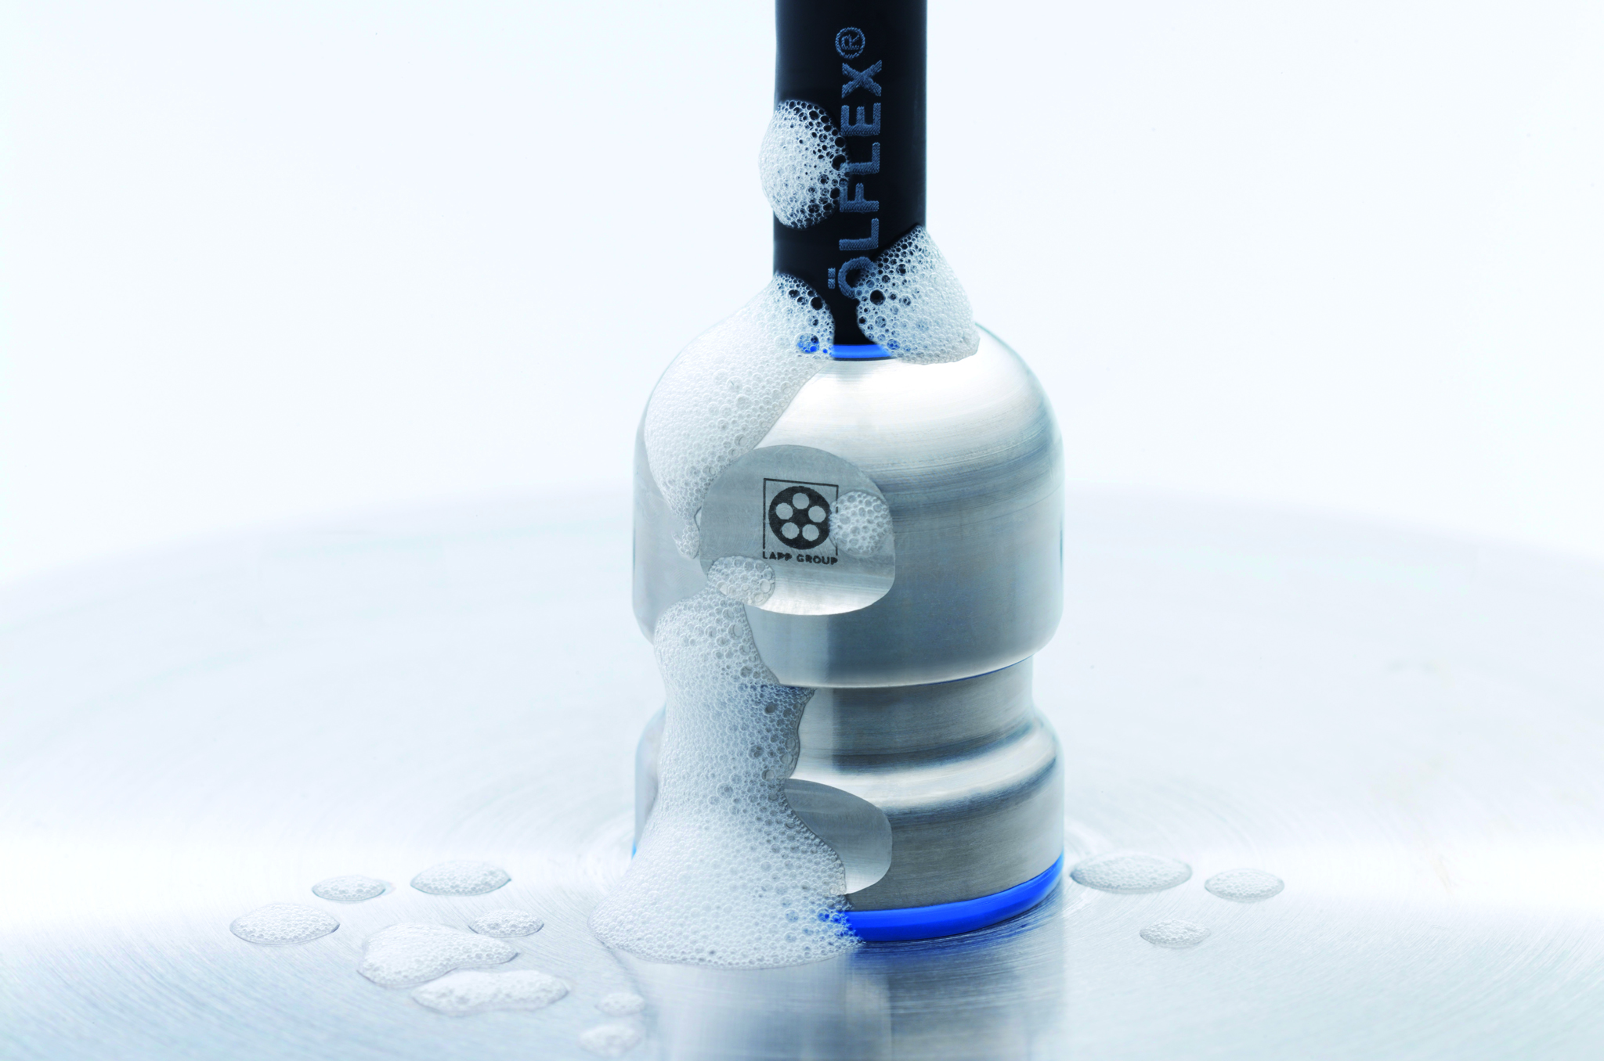
The SKINTOP® HYGIENIC has no corners or edges and is easy to clean
You can find the image in printable quality here

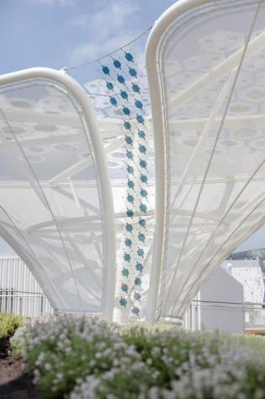
The energy-generating solar trees at the Expo with Lapp connection technology
You can find the image in printable quality here

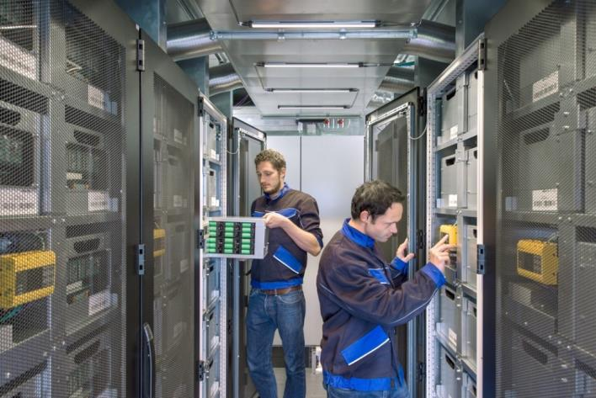
Image: Varta Storage
The modular battery storage system 'Energy Neighbor' from Varta Storage and the Technical University of Munich is intended to help generate power from wind and solar units
You can find the image in printable quality here

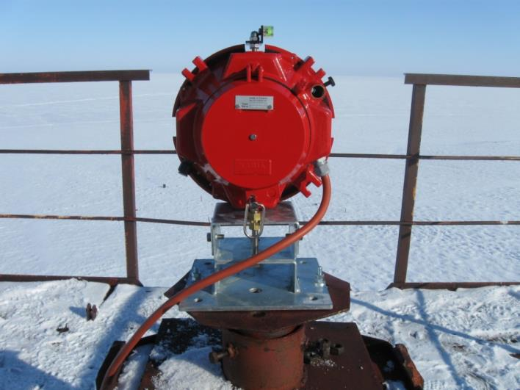
Image: Technomarin
Cables from the ÖLFLEX® HEAT series were used in the Arctic. Not only do these cables cope well with heat, they are real all-rounders when it comes to extreme temperature ranges.
You can find the image in printable quality here

www.lappkabel.com/press

About the Lapp Group:
Headquartered in Stuttgart, Germany, the Lapp Group is a leading supplier of integrated solutions and branded products in the field of cable and connection technology. The Group’s portfolio includes standard and highly flexible cables, industrial connectors and screw technology, customized system solutions, automation technology and robotics solutions for the intelligent factory of the future, as well as technical accessories. The Lapp Group’s core market is in the industrial machinery and plant engineering sector. Other key markets are in the food industry as well as the energy and the mobility sector.

The Lapp Group has remained in continuous family ownership since it was founded in 1959. In the 2014/15 business year, it generated consolidated revenue of 886 million euros. Lapp currently employs approximately 3,300 people across the world, has 17 production sites and 39 sales companies. It also works in cooperation with around 100 foreign representatives.

