For SPS 2017 – new control cable for power chains
New chain cable with lots of talents and certifications

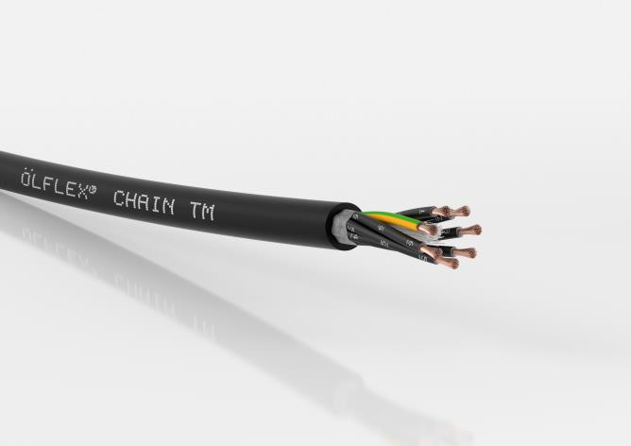
The new ÖLFLEX® CHAIN TM cable is approved for widespread use in North America by virtue of its multiple NEC and NFPA certifications.

Stuttgart, October 24th, 2017

Lapp will be showcasing its new, multi-talented ÖLFLEX® CHAIN TM power and control cable at the SPS IPC Drives 2017 trade fair in Nuremberg.
The control cable is approved for widespread use in North America by virtue of its multiple NEC and NFPA certifications. Thanks to the tried-and-tested UL and c(UL) listings for the USA and Canada (such as MTW, TC-ER, WTTC and CIC), there is less need to grapple with the often complex, time-consuming overseas approval procedures. Now, users only need to keep one multi-standard cable type in stock – a clear advantage that benefits exporters in particular.

The cable comes in the Core Line performance class and is ideally suited to continuous use in power chains with moderate to high travel paths and acceleration, in non-stationary machine parts, in linear robots and handling systems, and in wind turbines (Wind Turbine Tray Cable). The two UL listings of MTW (Machine Tool Wire) and TC-ER (Tray Cable-Exposed Run) in particular allow for flexible, standards-compliant use of the cable in industrial machines, as well as fixed installation in open cable trays with one and the same cable. The ÖLFLEX® CHAIN TM and ÖLFLEX® CHAIN TM CY are designed for North American operating voltages of 600 volts or 1,000 volts (WTTC).

Thanks to the strand made from extra-fine copper wire from conductor class 6 and the special stranding technique, the cable can be used in constantly moving applications in drag chains involving up to 5 million bending cycles, as well as moderate torsion applications in wind turbines involving rotational angles of +/- 150° per metre. On the shielded CY version, tin-plated copper braiding provides reliable protection against electromagnetic influences and ensures compliance with EMC regulations. The outer sheath is made from a specially designed thermoplastic polymer, which makes the cable resistant to mineral oil-based lubricants (UL Oil Res I/II) and other chemicals. The entire cable design is highly flame-retardant according to CSA FT4. As the cable is designed for a wide temperature range from -40 to +90 degrees Celsius in the case of fixed installation, it is also suitable for outdoor applications in harsh environments. Furthermore, the cable is UV-resistant and suitable for direct burial according to the US standard.

Visit Lapp at SPS IPC Drives from 28 to 30 November in Nuremberg in Hall 2, Stand 310.

The image is available in printable quality here

Press contact:
Dr. Markus Müller Irmgard Nille
Tel: +49(0)711/7838-5170 Tel.: +49(0)711/7838–2490
Mobil: +49(0)172/1022713 Mobil: +49(0)160/97346822
markus.j.mueller@lappgroup.com irmgard.nille@in-press.de

U.I. Lapp GmbH
Schulze-Delitzsch-Straße 25
D-70565 Stuttgart

Here you find more information: www.lappkabel.com/press

About the Lapp Group:
Headquartered in Stuttgart, Germany, the Lapp Group is a leading supplier of integrated solutions and branded products in the field of cable and connection technology. The Group’s portfolio includes standard and highly flexible cables, industrial connectors and cable entry systems, customized system solutions, automation technology and robotics solutions for the intelligent factory of the future, as well as technical accessories. The Lapp Group’s core market is in the industrial machinery and plant engineering sector. Other key markets are in the food industry as well as the energy and the mobility sector.
The Lapp Group has remained in continuous family ownership since it was founded in 1959. In the 2015/16 business year, it generated consolidated revenue of 901 million euros. Lapp currently employs approximately 3,440 people across the world, has 17 production sites and over 40 sales companies. It also works in cooperation with around 100 foreign representatives.

