Lapp Group to present products for the beverage industry at drinktec
Connection technology in hygienic design

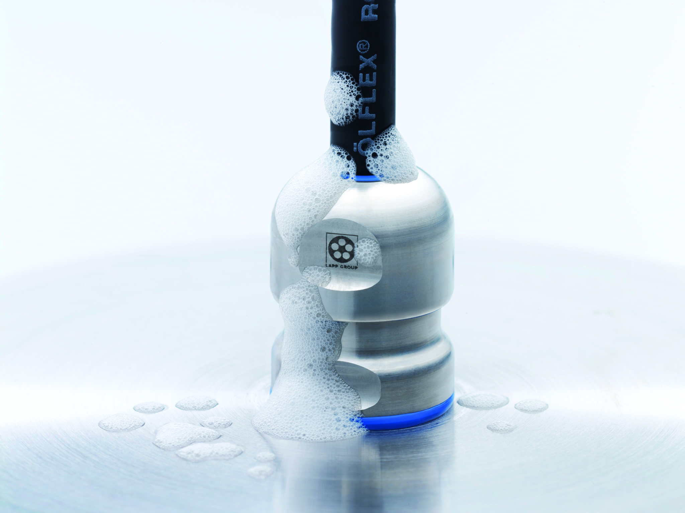
The SKINTOP® HYGIENIC meets all EHEDG design specifications and is one of the highlights in Lapp’s range of products for the food and beverage industry

Stuttgart, September 5, 2017

Hygiene is the top priority in the beverage industry. This also applies to the components used in connections. That is why the Stuttgart-based Lapp Group (stand A3.149) is presenting its full range of solutions for the food and drink sector at drinktec, the world’s leading trade fair for the beverage and liquid food industry. These products include extra-resistant cables as well as cable glands, connectors, and accessories such as cable ties and protective conduits. The components meet strict international requirements, such as EHEDG design specifications or compatibility with ECOLAB® cleaning agents.

“Lapp offers a comprehensive range of cables, connectors and accessories that meet the strict requirements of the industry. We are the only provider with the production expertise for all required cable components. If necessary, we can also work together with customers to provide customised solutions”, explains Georg Stawowy, member of the board of Lapp Holding AG for technology and innovation.

Lapp developed the ROBUST portfolio of cables specifically for this area. The cables feature sheaths made from specially optimised TPE. This material surpasses PUR or non-optimised TPE in a number of characteristics, particularly its resistance to bio-oils, fats, food acids and water. The resistant power and control cables in the ÖLFLEX® ROBUST series are perfect for these challenges. The cables are available with VDE certification and UL certification for the North American market. Material resistance and function tests to ECOLAB® standard confirm that the lines and cables can withstand regular cleaning with standard industrial cleaners and disinfectants. Among Lapp’s products for the food and beverage industry are UNITRONIC® ROBUST low-frequency data network cables, HITRONIC® ROBUST optical data transmission cables, and ETHERLINE® ROBUST cables for Industrial Ethernet. Cables in the ETHERLINE® ROBUST FR configuration are available for increased flame retardancy. Both ETHERLINE® ROBUST series are developed to the Profinet standard and are available for transfer categories from Cat. 5 to Cat. 7. This means they achieve transfer rates of up to 10 Gbit/s.

Alongside cables, the Lapp portfolio also includes components specially developed for the food industry. The SKINTOP® HYGIENIC cable gland, for example, meets the toughest hygiene standards and is certified to EHEDG specifications thanks to its shape and material. Made from stainless steel, with FKM elastomer used for the seals, it has no corners and edges to which food residues could adhere. The SILVYN® HYGIENIC conduit gland with the matching SILVYN® HYGIENIC conduit is also suitable for use in contact with food products. In addition, Lapp has developed the EPIC® ULTRA H-B protective cover to provide a watertight seal for the base of its proven EPIC® ULTRA rectangular connector. It is made from blue plastic with stainless steel anti-corrosion locking elements, and is approved by the Food and Drug Administration in the United States. The portfolio is completed with blue cable ties with metal additive. This allows any cable ties that accidentally fall into yoghurt, for example, to be easily found using a metal detector or X-ray machine.

You can find the image in printable quality here

Press contact:
Dr. Markus Müller Irmgard Nille
Tel: +49(0)711/7838-5170 Tel.: +49(0)711/7838–2490
Mobil: +49(0)172/1022713 Mobil: +49(0)160/97346822
markus.j.mueller@lappgroup.com irmgard.nille@in-press.de

U.I. Lapp GmbH
Schulze-Delitzsch-Straße 25
D-70565 Stuttgart

Here you find more information: www.lappkabel.com/press

About the Lapp Group:
Headquartered in Stuttgart, Germany, the Lapp Group is a leading supplier of integrated solutions and branded products in the field of cable and connection technology. The Group’s portfolio includes standard and highly flexible cables, industrial connectors and cable entry systems, customized system solutions, automation technology and robotics solutions for the intelligent factory of the future, as well as technical accessories. The Lapp Group’s core market is in the industrial machinery and plant engineering sector. Other key markets are in the food industry as well as the energy and the mobility sector.
The Lapp Group has remained in continuous family ownership since it was founded in 1959. In the 2015/16 business year, it generated consolidated revenue of 901 million euros. Lapp currently employs approximately 3,440 people across the world, has 17 production sites and over 40 sales companies. It also works in cooperation with around 100 foreign representatives.

