Lapp Group at Hannover Messe 2017
Ethernet with 10 GBit/s and torsion-resistant for Industry 4.0

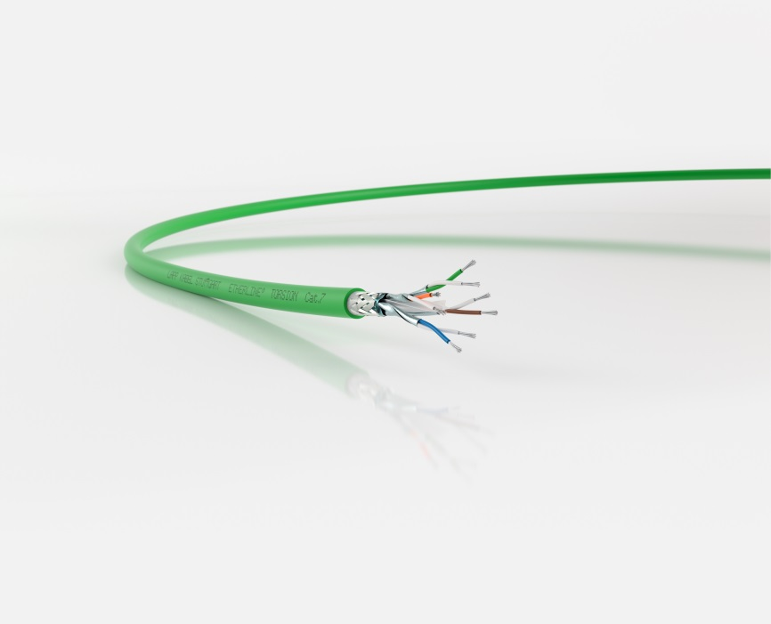

Ideal for industry 4.0: The ETHERLINE® TORSION Cat. 7 is the first
torsion resistant and PROFINET®-compliant Cat. 7 cable.

Stuttgart, April 19, 2017

In the industrial environment, large volumes of data have to be securely transferred from one device to another as quickly as possible. The Stuttgart-based Lapp Group is adding two high-speed cables for industrial Ethernet to its ETHERLINE® portfolio, including the world’s first-ever torsion-resistant and PROFINET®-compatible Cat. 7 cable. Both cables achieve Cat. 7 data transfer speeds, i.e. 10 GBit/s in a frequency range of up to 600 MHz. This is interesting for applications in the machinery and robotics segments, where large volumes of data from the likes of sensors or high-resolution cameras are commonplace – which is a key requirement for the Industrial Internet of Things. Both cables have a robust and halogen-free PUR sheath. However, they differ with respect to their internal structures and other properties.

The ETHERLINE® TORSION Cat. 7 is the first-ever torsion-resistant and PROFINET-compliant Cat. 7 cable. It can be twisted by 180° in both directions along a length of 1 m – at least 5 million times. The cable does not have any filler, and the cores are only held in place with a polyethylene cross separator, which makes the assembly process a great deal easier. During the design process, the Lapp engineers observed a particularly low tolerance of ±5% for the characteristic impedance, despite ±15% being permissible according to the standard. This improves the transfer properties even over short distances. The cable is listed according to UL CMX, so it can be used in North America for applications outside of control cabinets.

ETHERLINE® Flex Cat. 7 is listed according to AWM Style and is thus suitable in North America for applications inside control cabinets. It is flexible, even though it was not designed for continuous movement. Thanks to narrow core cross-sections, it has an outer diameter of just 6.4 mm and a bending radius of four times the outer diameter, i.e. less than 26 mm – which makes it ideal for well-stocked control cabinets where space is tight. ETHERLINE® Cat. 7 FLEX may be laid next to cables with up to 1,000 V, or without mechanical protection such as separators – thanks to the very effective shielding, there are no EMC problems even in such a scenario.

These and many other innovations from Lapp will be on show at Lapp’s stand (C03) in Hall 11 at Hannover Messe.

You will find the image in printable quality here.

Press contact
Dr Markus Müller Irmgard Nille
Tel.: +49 (0)711/7838-5170 Tel.: +49 (0)711/7838–2490
Mobile: +49 (0)172/1022713 Mobile: +49 (0)160/97346822
markus.j.mueller@lappgroup.com irmgard.nille@in-press.de

U.I. Lapp GmbH
Schulze-Delitzsch-Straße 25
70565 Stuttgart
Germany

You will find further information on this topic here: www.lappkabel.de/presse

About the Lapp Group:
The Lapp Group based in Stuttgart, Germany, is a world market leader for integrated solutions and branded products in the field of cable and connection technology. The Group’s portfolio includes standard and highly flexible cables, industrial connectors and screw technology, customized system solutions, automation technology and robotics solutions for the intelligent factory of the future, as well as technical accessories. The Lapp Group’s core market is in the industrial machinery and plant engineering sector. Other key markets are in the food industry as well as the energy and the mobility sector.
The Lapp Group has remained in continuous family ownership since it was founded in 1959. In the 2015/16 business year, it generated consolidated revenue of 901 million euros. Lapp currently employs approximately 3,440 people across the world, has 17 production sites and over 40 sales companies. It also works in cooperation with around 100 foreign representatives.

