Lapp's new European headquarters in Stuttgart
Space for the World of Work 4.0

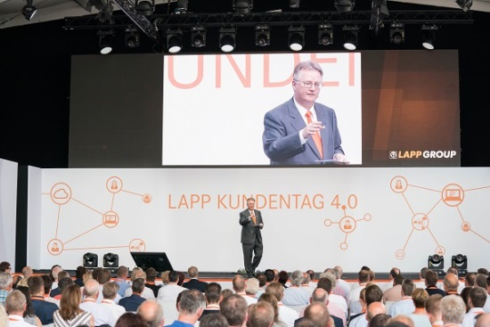
Image 1: In the presence of around 500 invited guests, Andreas Lapp opened the Lapp Group's European headquarters

Stuttgart, 27 June 2017

Faster, more flexible, more communicative - with its new European headquarters, the Lapp Group is opening the door to the future. The office concept of the building erected by the long-established company at its company's headquarters in Stuttgart-Vaihingen sets standards. The new world of work is characterised by the open space concept: Instead of separate rooms with closed-off offices, often with restricted access, everything is open in the new European headquarters. Open for more communication, collaboration, knowledge transfer and creativity. That accommodates the desire for collaborative and mobile ways of working. As such, team zones, think tanks, lounges and project zones have been set up in a number of places. Staff can also work in the espresso bar on the ground floor or on the roof terrace if they so wish.

These design innovations are not just about staff well-being – their main aim is to promote customer satisfaction. "Our customers benefit from the new openness that the modern building makes possible - we can now respond even better and quicker to our customers' requirements," promises Dr. Matthias Kirchherr, Chief Sales Officer of U.I. Lapp GmbH. Sales and all sales-related departments have now, for example, been brought together under one roof.

The European headquarters is only the kick-off for the new world of work, other office buildings of the Lapp Group in other countries should gradually adopt the concept. For partners and customers who come to Stuttgart personally for meetings, the European headquarters has another highlight in store: an exhibition featuring the history of the innovative family company with many current products and solutions.

The new Lapp European headquarters was opened on 22 June in the presence of around 500 invited guests as part of a customer open day. For its customers, Lapp put together a programme consisting of informative talks by respected experts and interesting experiences. One highlight was the keynote by the TV presenter Ranga Yogeshwar.

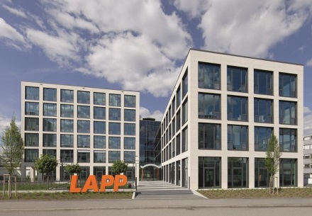
Image 2: The office concept of the building erected by the Lapp Group at its company's headquarters in Stuttgart-Vaihingen sets standards.
Image 3: Everything is open in the new European headquarters - open for more exchange, communication and creativity

You can find image 1 in printable quality here
You can find image 2 in printable quality here
You can find image 3 in printable quality here

Press contact:
Dr. Markus Müller Irmgard Nille
Tel: +49(0)711/7838-5170 Tel.: +49(0)711/7838–2490
Mobil: +49(0)172/1022713 Mobil: +49(0)160/97346822
markus.j.mueller@lappgroup.com irmgard.nille@in-press.de

U.I. Lapp GmbH
Schulze-Delitzsch-Straße 25
D-70565 Stuttgart

Here you find more information: www.lappkabel.com/press

About the Lapp Group:
Headquartered in Stuttgart, Germany, the Lapp Group is a leading supplier of integrated solutions and branded products in the field of cable and connection technology. The Group’s portfolio includes standard and highly flexible cables, industrial connectors and cable entry systems, customized system solutions, automation technology and robotics solutions for the intelligent factory of the future, as well as technical accessories. The Lapp Group’s core market is in the industrial machinery and plant engineering sector. Other key markets are in the food industry as well as the energy and the mobility sector.
The Lapp Group has remained in continuous family ownership since it was founded in 1959. In the 2015/16 business year, it generated consolidated revenue of 901 million euros. Lapp currently employs approximately 3,440 people across the world, has 17 production sites and over 40 sales companies. It also works in cooperation with around 100 foreign representatives.

