New Profinet Cables from Lapp
More Speed and Reliability for Industrial Networks

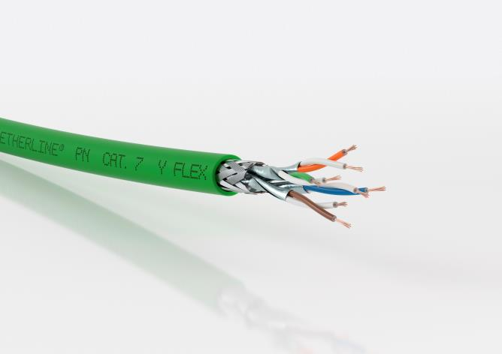
The new ETHERLINE PN Cat.7 cables cables are suitable for use wherever large amounts of data are transferred, for example from high-resolution cameras.

Stuttgart, October 25th, 2017

High speeds, secure data transfer and compliance with PROFINET® – these are the highlights of the new cables from the ETHERLINE® series, which Lapp will be presenting at SPS IPC Drives.

There are five variants of the ETHERLINE PN Cat.7 (“PN” stands for PROFINET®). For fixed installation it can be flame-retardant with a PVC sheath with the name affix “Y”, it can be halogen-free and flame-retardant with an FRNC sheath, or it can have a PUR sheath meaning it is halogen-free, flame-retardant and more mechanically robust. There are also two variants for flexible installation (“FLEX”) with a flame-retardant PVC sheath or with a halogen-free and flame-retardant FRNC sheath. The new cables are suitable for use in machines and plants or for the network infrastructure of anything where large amounts of data are transferred, for example from high-resolution cameras.

One thing that all the new PROFINET® cables have in common is their high data rate of 10 gigabit/s, thanks to their compliance with the Cat.7 standard. Cables compliant with Cat.6_{A} also achieve comparable speeds but Cat.7 cables work at a significantly higher transmission frequency of 600 MHz. This ensures performance and transmission reliability, even if cables become damaged or age during the course of their many years of use.

A further advantage is that they comply with the PROFINET® standard. This is a standard which many manufacturers have agreed on and is recording particularly high growth rates. Users benefit from the fact that these products are compatible with one another. The new PROFINET® cables from Lapp are also certified for the North American market, meaning users can use one product for all markets.

Visit Lapp at Stand 310 in Hall 2 of SPS IPC Drives in Nuremberg between 28 and 30 November.

The image is available in printable quality here

Press contact:
Dr. Markus Müller Irmgard Nille
Tel: +49(0)711/7838-5170 Tel.: +49(0)711/7838–2490
Mobil: +49(0)172/1022713 Mobil: +49(0)160/97346822
markus.j.mueller@lappgroup.com irmgard.nille@in-press.de

U.I. Lapp GmbH
Schulze-Delitzsch-Straße 25
D-70565 Stuttgart

Here you find more information: www.lappkabel.com/press

About the Lapp Group:
Headquartered in Stuttgart, Germany, the Lapp Group is a leading supplier of integrated solutions and branded products in the field of cable and connection technology. The Group’s portfolio includes standard and highly flexible cables, industrial connectors and cable entry systems, customized system solutions, automation technology and robotics solutions for the intelligent factory of the future, as well as technical accessories. The Lapp Group’s core market is in the industrial machinery and plant engineering sector. Other key markets are in the food industry as well as the energy and the mobility sector.
The Lapp Group has remained in continuous family ownership since it was founded in 1959. In the 2015/16 business year, it generated consolidated revenue of 901 million euros. Lapp currently employs approximately 3,440 people across the world, has 17 production sites and over 40 sales companies. It also works in cooperation with around 100 foreign representatives.

