SPS 2017: New ÖLFLEX CHAIN from Lapp
New Control Cable for Power Chains
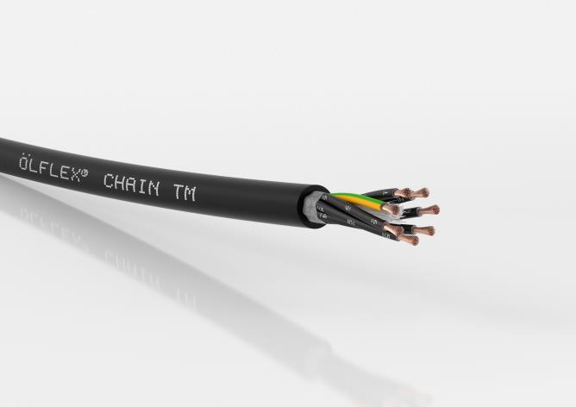
The new ÖLFLEX® CHAIN TM is approved for widespread use in North America by virtue of its multiple NEC and NFPA certifications.

Stuttgart, November 23, 2017

More standards, fewer costs. The new ÖLFLEX® CHAIN TM power and control cable from Lapp helps make parts and inventory management easier. The new cable will be presented at the SPS IPC Drives 2017 trade fair in Nuremberg (hall 2, stand 310). NEC and NFPA certifications for North America mean that the control cable is approved for a wide range of applications. For users, this reduces the need to grapple with complex and time-consuming overseas approval procedures. Now, users only need to keep one multi-standard cable type in stock – a clear advantage that benefits exporters in particular. This is thanks to the tried-and-tested UL and c(UL) listings for the USA and Canada, such as MTW, TC-ER, WTTC and CIC.

The cable belongs to the Core Line performance class and is ideally suited to continuous use in power chains with moderate to high travel paths and accelerations. Other potential applications include non-stationary machine parts, linear robots or handling systems, and wind turbines (Wind Turbine Tray Cable). The two UL listings of MTW (Machine Tool Wire) and TC-ER (Tray Cable-Exposed Run) for North America allow for both flexible use in industrial machinery and fixed installation in open cable trays. The ÖLFLEX® CHAIN TM and ÖLFLEX® CHAIN TM CY are designed for North American operating voltages of 600 volts or 1,000 volts (WTTC).

The wire is made from fine, conductor class 6 copper. Special stranding technology allows for use in continuously flexing applications like drag chains with up to five million bending cycles. It is also suitable for moderate torsion in wind turbines with rotation angles of +/- 150° per metre. In the shielded CY version, tin-plated copper braiding provides reliable protection against electromagnetic interference and ensures compliance with EMC regulations. The outer sheath is made from a specially designed thermoplastic polymer. The cable can withstand oil-based lubricants (UL Oil Res I/II) and other chemicals, and is also highly flame resistant in line with CSA FT4. The temperature range in fixed installation ranges from -40 to +90 °C, making the cable suitable for use in tough ambient conditions outdoors. Resistance to UV radiation is also par for the course, along with suitability for direct underground installation in line with US standards.

You can find the image in printable quality here

Press contact:
Dr. Markus Müller Irmgard Nille
Tel: +49(0)711/7838-5170 Tel.: +49(0)711/7838–2490
Mobil: +49(0)172/1022713 Mobil: +49(0)160/97346822
markus.j.mueller@lappgroup.com irmgard.nille@in-press.de

U.I. Lapp GmbH
Schulze-Delitzsch-Straße 25
D-70565 Stuttgart

Here you find more information: www.lappkabel.com/press

About the Lapp Group:
Headquartered in Stuttgart, Germany, the Lapp Group is a leading supplier of integrated solutions and branded products in the field of cable and connection technology. The Group’s portfolio includes standard and highly flexible cables, industrial connectors and cable entry systems, customized system solutions, automation technology and robotics solutions for the intelligent factory of the future, as well as technical accessories. The Lapp Group’s core market is in the industrial machinery and plant engineering sector. Other key markets are in the food industry as well as the energy and the mobility sector.
The Lapp Group has remained in continuous family ownership since it was founded in 1959. In the 2015/16 business year, it generated consolidated revenue of 901 million euros. Lapp currently employs approximately 3,440 people across the world, has 17 production sites and over 40 sales companies. It also works in cooperation with around 100 foreign representatives.

