23 apprentices, including six refugees, start their careers today
Lapp strengthens its commitment to education

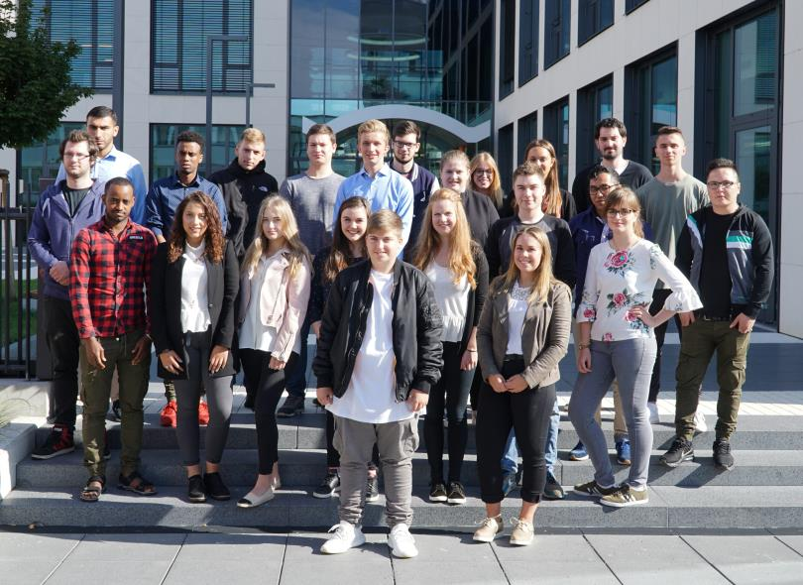
23 young men and women started their working lives at Lapp with an introductory training week

Stuttgart, 4 September
At the start of the new 2017/2018 apprenticeship year, 23 young men and women started their careers at Lapp Group’s main site in Stuttgart, Germany. This is three more than in the previous year. “As a family business, we take our social responsibility very seriously. We want to give young people good opportunities for the future. A good apprenticeship forms the foundation of this”, explains Matthias Lapp, CEO of U.I. Lapp GmbH. “We mainly train people for our own needs, as well-trained and qualified employees help secure the success of our company for the long term.”

Lapp currently offers ten different training programmes. These range from apprenticeships in commercial careers such as industrial administration or warehouse logistics, as well as those for technical roles such as machinery and systems operators or mechatronics technicians. Cooperative study programmes are another option, such as business services and logistics management or electrical engineering management. This year, the 23 new apprentices include six refugees from Afghanistan, Eritrea, Kosovo and Somalia. After completing their 12-month entry qualification, they are now starting their apprenticeships as machinery and systems operators and business IT specialists. This is part of Lapp’s participation in the German government’s project to help integrate refugees in the country. In 2018, another six refugees will be given the chance of an apprenticeship at Lapp.

The apprenticeship at Lapp begins with an introductory training week, in which the new apprentices get their first insight into the company’s structures, processes and characteristics. Following this, a joint team building session with all apprentice year groups takes place at the State Academy for Youth Education in the nearby town of Weil der Stadt.

“We place a great deal of value on apprenticeships here. During their training, the apprentices will pass through virtually every department. There are regular training weeks and team training sessions, alongside countless events and projects in which the apprentices can get involved”, reports Anne Voigt, Apprenticeships Supervisor at U.I. Lapp GmbH. These include the organisation of the annual company birthday party, careers trade fairs for local school leavers, or science and technology events for inventive young children. The apprentices are also a key part of the Lapp Group’s trade fair stand team at the Hannover Messe every year.

Social responsibility is also an important element of their training. For two weeks, they work in a social institution of their choice as part of a project. Apprentices were also involved in the “Multi-generation management at Lapp” workshop.

As a globally active company, Lapp also allows its apprentices and students to spend time working abroad. For four to twelve weeks, they have the choice of either working in one of Lapp’s international subsidiaries or taking part in the EU’s ERASMUS+ programme. Here, they do an internship at a different company and take language classes. This year, 17 of Lapp’s apprentices have taken up this opportunity.

In all, 64 young men and women are currently receiving training at the Stuttgart site. So far, almost 100 percent of the apprentices have been taken on permanently after their training.

The image is available in printable quality here

Press contact:
Dr. Markus Müller Irmgard Nille
Tel: +49(0)711/7838-5170 Tel.: +49(0)711/7838–2490
Mobil: +49(0)172/1022713 Mobil: +49(0)160/97346822
markus.j.mueller@lappgroup.com irmgard.nille@in-press.de

U.I. Lapp GmbH
Schulze-Delitzsch-Straße 25
D-70565 Stuttgart

Here you find more information: www.lappkabel.com/press

About the Lapp Group:
Headquartered in Stuttgart, Germany, the Lapp Group is a leading supplier of integrated solutions and branded products in the field of cable and connection technology. The Group’s portfolio includes standard and highly flexible cables, industrial connectors and cable entry systems, customized system solutions, automation technology and robotics solutions for the intelligent factory of the future, as well as technical accessories. The Lapp Group’s core market is in the industrial machinery and plant engineering sector. Other key markets are in the food industry as well as the energy and the mobility sector.
The Lapp Group has remained in continuous family ownership since it was founded in 1959. In the 2015/16 business year, it generated consolidated revenue of 901 million euros. Lapp currently employs approximately 3,440 people across the world, has 17 production sites and over 40 sales companies. It also works in cooperation with around 100 foreign representatives.

