Lapp Group at Hannover Messe 2017
Rapid solutions for drives, export and automation
Stuttgart, 15 February 2017

The Lapp Group is further expanding its range. The world market leader for integrated cabling and connection solutions from Stuttgart is presenting numerous innovations at Hannover Messe 2017, including various ÖLFLEX servo and motor cables for drive systems. Here, the focus is on cables with UL certification in accordance with the North American standard, which will thus be of interest primarily to export-orientated industry.

There are also innovations in the ETHERLINE portfolio, the data cables for factory automation. Here, Lapp are presenting two new cables with a rapid 10 Gbit/s in accordance with the Cat. 7 standard. One variant is Profinet-compliant and is particularly suited to moving applications with torsion. It has a long service life and withstands up to five million cycles with twists of +/-180 degrees per metre. The second new variant is a particularly flexible Ethernet cable that is just 6.4 millimetres thick, and is hence particularly suited to installation in control cabinets where space is at a premium.

The UNITRONIC range has also been expanded: a new CAN bus cable is conceived for use in commercial vehicle bodies, such as fire brigade vehicles, low loaders, snowploughs or bulldozers. The cable fulfils the highest requirements of temperature resistance (-40 to +105 degrees Celsius) and robustness: it withstands oil, petrol, diesel, lubricants, UV light and of course wind and weather.

A further highlight at the Lapp stand is the modular multi-frame rectangular connectors EPIC MH, which can accept any connector modules for energy, signals and data. The mix of different functions makes the system extremely flexible, and it is also compatible with the market standard.
You will find Lapp at Hannover Messe Industrie in Hall 11, Stand C03.

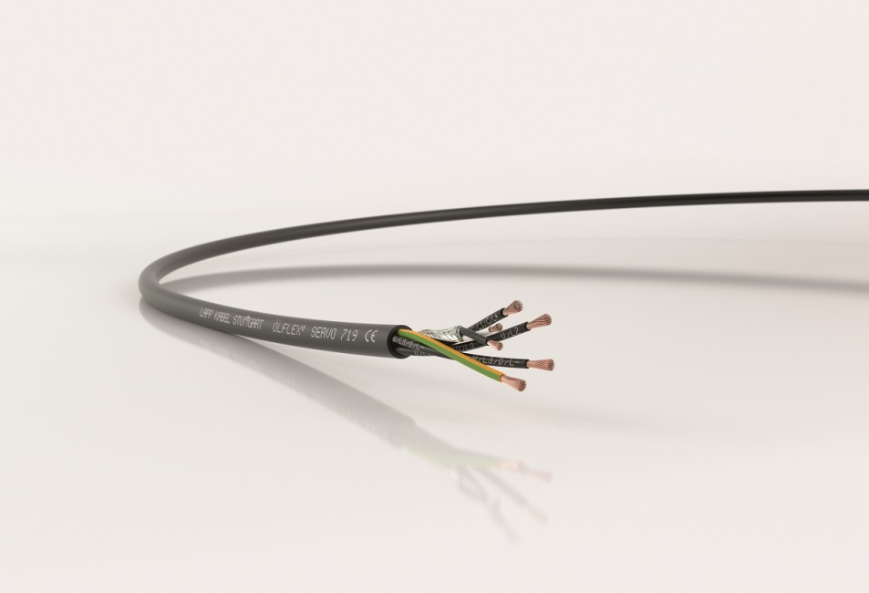
The Lapp Group is presenting numerous innovations at Hannover Messe 2017, including various ÖLFLEX servo and motor cables for drive systems.
The image is available in printable quality here

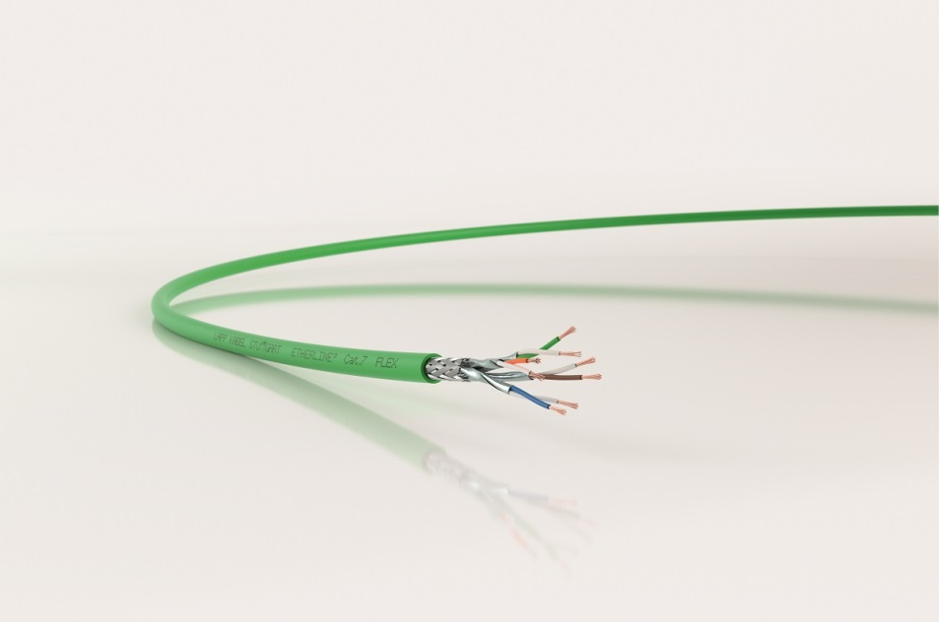
Lapp are also presenting two new ETHERLINE cables with a rapid 10 Gbit/s in accordance with the Cat. 7 standard.
The image is available in printable quality here

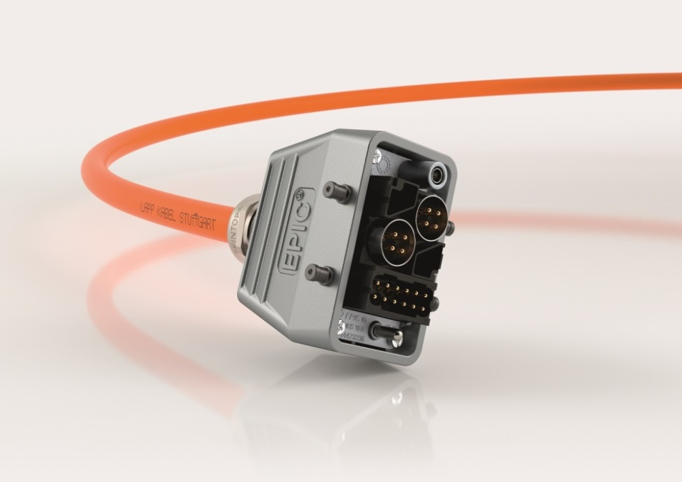
The modular multi-frame rectangular connectors EPIC MH can accept any connector modules for energy, signals and data and is compatible with the market standard.
The image is available in printable quality here

www.lappkabel.com/press

About the Lapp Group:
Headquartered in Stuttgart, Germany, the Lapp Group is a leading supplier of integrated solutions and branded products in the field of cable and connection technology. The Group’s portfolio includes standard and highly flexible cables, industrial connectors and screw technology, customized system solutions, automation technology and robotics solutions for the intelligent factory of the future, as well as technical accessories. The Lapp Group’s core market is in the industrial machinery and plant engineering sector. Other key markets are in the food industry as well as the energy and the mobility sector.

The Lapp Group has remained in continuous family ownership since it was founded in 1959. In the 2014/15 business year, it generated consolidated revenue of 886 million euros. Lapp currently employs approximately 3,300 people across the world, has 17 production sites and over 40 sales companies. It also works in cooperation with around 100 foreign representatives.

