For SPS 2017
New servo cables for Europe and North America

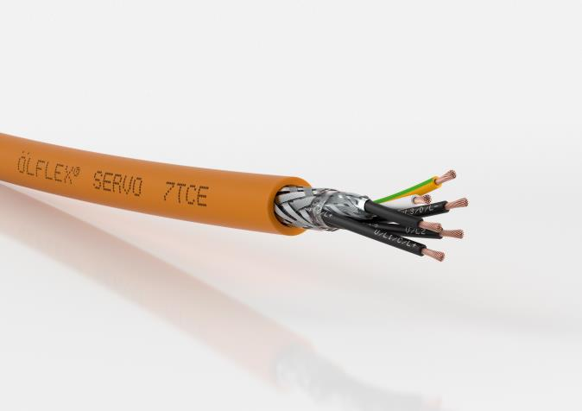
The new ÖLFLEX® SERVO 7TCE from Lapp makes it possible to bypass particularly large distances between servo controllers and motors.

Stuttgart, October 18, 2017

An important feature of servo cables is their low-capacitance and low-attenuation design as this enables them to bridge long distances without any loss of power. The two new cables are exemplary in this regard and they will be presented by LAPP at the SPS IPC Drives 2017 trade fair in Nuremberg in hall 2, stand 310.

ÖLFLEX® SERVO 7TCE: The servo cable is suitable for servo drives from many leading manufacturers and has UL TC-ER and Flexible Motor Supply listings. The internal structure is complex with a core insulation made of XLPE and an outer sheath made of a special thermoplastic elastomer. This results in a low-capacitance design which enables large distances to be bypassed between the servo controller and the motor. The cable fulfils various requirements for oil resistance, flame retardance and UV resistance, all in accordance with North American standards.

ÖLFLEX® SERVO 728 CY: The shielded encoder cable is suitable for most analogue and incremental rotary encoders in servo drives from leading manufacturers. Its core insulation made of polypropylene has low attenuation and also enables large transmission distances. The shielded cable is oil-resistant and is therefore suitable for many mechanical engineering applications with fixed installation. Nevertheless, it is still thin and light.

You can find the image in printable quality here

Press contact
Dr Markus Müller Irmgard Nille
Tel.: +49 (0)711/7838-5170 Tel.: +49 (0)711/7838–2490
Mobile: +49 (0)172/1022713 Mobile: +49(0)160/97346822
markus.j.mueller@lappgroup.com irmgard.nille@in-press.de

U.I. Lapp GmbH
Schulze-Delitzsch-Strasse 25
70565 Stuttgart, Germany

You will find further information on this topic here: www.lappkabel.com/press

About the Lapp Group:
Based in Stuttgart, Germany, the Lapp Group is the global market leader in integrated solutions and branded products in the field of cable and connection technology. The Group's portfolio includes standard and highly flexible cables, industrial connectors and screw technology, customised system solutions, automation technology and robotics solutions for Industry 4.0 and the Smart Factory. The Lapp Group’s core market is in the industrial machinery and plant engineering sector. Other important sales markets include the food, energy, mobility and life sciences industries.
The Lapp Group has remained in continuous family ownership since it was founded in 1959. In the 2015/16 business year, it generated a consolidated turnover of 901 million euros. Lapp currently employs approximately 3,440 people across the world and has 17 production sites and 40 distribution companies; the company also works in cooperation with around 100 foreign representatives.

