Andreas Lapp receives the Order of Merit of the state of Baden-Württemberg

A great honour for a committed businessman

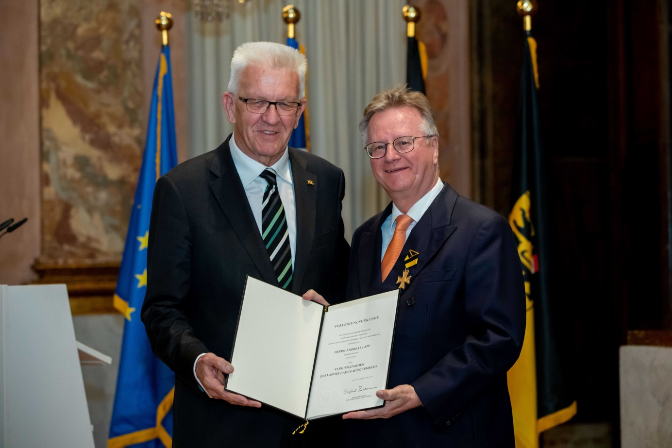
Minister President Winfried Kretschmann awarded Andreas Lapp the Order of Merit of the state of Baden-Württemberg. Photo: State Ministry

Stuttgart, 2 May 2018

A great honour for Andreas Lapp – the LAPP Chairman of the Board was awarded the Order of Merit of the state of Baden-Württemberg by Winfried Kretschmann, Minister President of the state of Baden-Württemberg, in late April.

The Minister President explained the decision to honour Andreas Lapp – "Andreas Lapp has long been setting international industry standards with his company and is a pioneer of cable technology. The increasing level of digitalisation certainly challenges us to look more to the future and recognise and meet new needs. Mr Lapp and his company are very innovative in the way they do this. LAPP products do not just connect the world; they connect people."

The Minister President also highlighted the fact that Andreas Lapp has been building bridges towards active intercultural understanding for many years. As honorary consul of the Republic of India for Baden-Württemberg and Rheinland-Pfalz, he has managed to get countless cultural and commercial projects off the ground and has therefore created numerous links between the countries and cultures. It was down to him that Baden-Württemberg entered into a partnership with the Indian state of Maharashtra in 2015. Mr Kretschmann continued: "It is so good to learn, time and time again, that global economic successes can go hand in hand with absolute commitment to your employees. Only when these two components are in harmony can companies and their employees increase the relevance of their business location."

Andreas Lapp said – "The Order of Merit is a huge honour – not just for me, but for all LAPP colleagues. It shows the trust that our customers place in us. After all, without the trust of our customers and our employees’ commitment we could not be so successful."

The Order of Merit is the highest honour of the state of Baden-Württemberg. It is presented by the Minister President for outstanding services to the state of Baden-Württemberg, particularly in the political, social, cultural and economic realms. The Order of Merit is usually presented during an annual ceremony.

Find the image in printable quality here

Press contact:
Dr. Markus Müller Irmgard Nille
Tel: +49(0)711/7838-5170 Tel.: +49(0)711/7838–2490
Mobil: +49(0)172/1022713 Mobil: +49(0)160/97346822
markus.j.mueller@lappgroup.com irmgard.nille@in-press.de

U.I. Lapp GmbH
Schulze-Delitzsch-Straße 25
D-70565 Stuttgart

Find more information here: www.lappkabel.com/press

About LAPP:
Headquartered in Stuttgart, Germany, LAPP is a leading supplier of integrated solutions and branded products in the field of cable and connection technology. The company’s portfolio includes standard and highly flexible cables, industrial connectors and cable entry systems, customized system solutions, automation technology and robotics solutions for the intelligent factory of the future, as well as technical accessories. LAPP’s core market is in the industrial machinery and plant engineering sector. Other key markets are in the food industry as well as the energy and the mobility sector.
LAPP has remained in continuous family ownership since it was founded in 1959. In the 2016/17 business year, it generated consolidated revenue of 1,027 million euros. LAPP currently employs approximately 3,770 people across the world, has 17 production sites and around 40 sales companies. It also works in cooperation with around 100 foreign representatives.

