New ETHERLINE® Profinet cables from Lapp
High-speed ETHERLINE® cables make assembly even easier

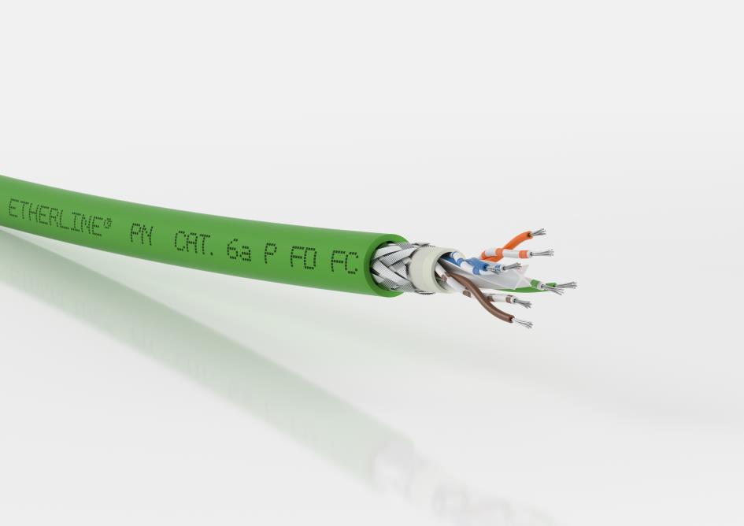
The ETHERLINE® PN CAT.6_{A} Fast Connect combines quick and easy assembly with high data transmission rates.
Stuttgart, 16 February 2018

Minimum work when connecting devices, easy assembly with a single tool and a high data transmission rate: The ETHERLINE® PN CAT.6_{A} Fast Connect from Lapp combines all these important properties. The new high-speed cable is ideal for customers in the machinery, plant and equipment manufacturing sector and can be used in industrial and building networking wherever large data volumes have to be transmitted.

If a cable ages or is damaged in a machine or control cabinet, it usually has to be replaced quickly to prevent production stoppages or more severe consequential damage. But replacing a cable takes time. Lapp has addressed this problem: Thanks to its Fast Connect technology, the new ETHERLINE® PN CAT.6_{A} Fast Connect has clear advantages over other cables when it comes to installation and assembly. Thanks to a cross separator that separates the four pairs of wires and an inner sheath the cable does not need pair screening. Unlike with conventional cables, there is no need to remove a film screen from all four pairs of wires. As a result, Fast Connect cables are quick and easy to assemble. The special tool from Lapp, which prepares the cable optimally for connector assembly in a single operation, saves even more time. The new shielding also ensures a long service life.

At 10 gigabits per second, the ETHERLINE® PN CAT.6_{A} achieves the current maximum transmission rate for copper cables in an industrial environment. All Lapp Profinet cables are compatible with one another and with those from other manufacturers. In addition to compliance with the PROFINET standard, the Lapp solution has certification for the North American market (UL certification) so no additional approval is required.

The ETHERLINE® PN Cat.6_{A} is available in seven versions: three for fixed installation (Type A) with flame retardant PVC sheath, halogen-free and flame retardant with FRNC sheath or with PUR sheath (halogen-free, flame retardant and with increased mechanical strength). In addition, Lapp supplies two versions for flexible use (Type B) with PVC sheath or halogen-free and flame retardant FRNC sheath, as well as two solutions for highly flexible use (Type C) with PVC sheath or PUR sheath. Four further versions have reduced dimensions for use in constricted applications. The different sheath designs and diameters allow the cables to be used in a huge range of applications.

The image is available in printable quality here

Press contact:
Dr. Markus Müller Irmgard Nille
Tel: +49(0)711/7838-5170 Tel.: +49(0)711/7838–2490
Mobil: +49(0)172/1022713 Mobil: +49(0)160/97346822
markus.j.mueller@lappgroup.com irmgard.nille@in-press.de

U.I. Lapp GmbH
Schulze-Delitzsch-Straße 25
D-70565 Stuttgart

Find more information out the Lapp Group here: www.lappkabel.com/press

About the Lapp Group:
Headquartered in Stuttgart, Germany, the Lapp Group is a leading supplier of integrated solutions and branded products in the field of cable and connection technology. The Group’s portfolio includes standard and highly flexible cables, industrial connectors and screw technology, customized system solutions, automation technology and robotics solutions for the intelligent factory of the future, as well as technical accessories. The Lapp Group’s core market is in the industrial machinery and plant engineering sector. Other key markets are in the food industry as well as the energy and the mobility sector.
The Lapp Group has remained in continuous family ownership since it was founded in 1959. In the 2015/16 business year, it generated consolidated revenue of 901 million euros. Lapp currently employs approximately 3,440 people across the world, has 17 production sites and over 40 sales companies. It also works in cooperation with around 100 foreign representatives.

