News from the Lapp Group at Hanover Messe 2018
Innovative power chain cables with added value

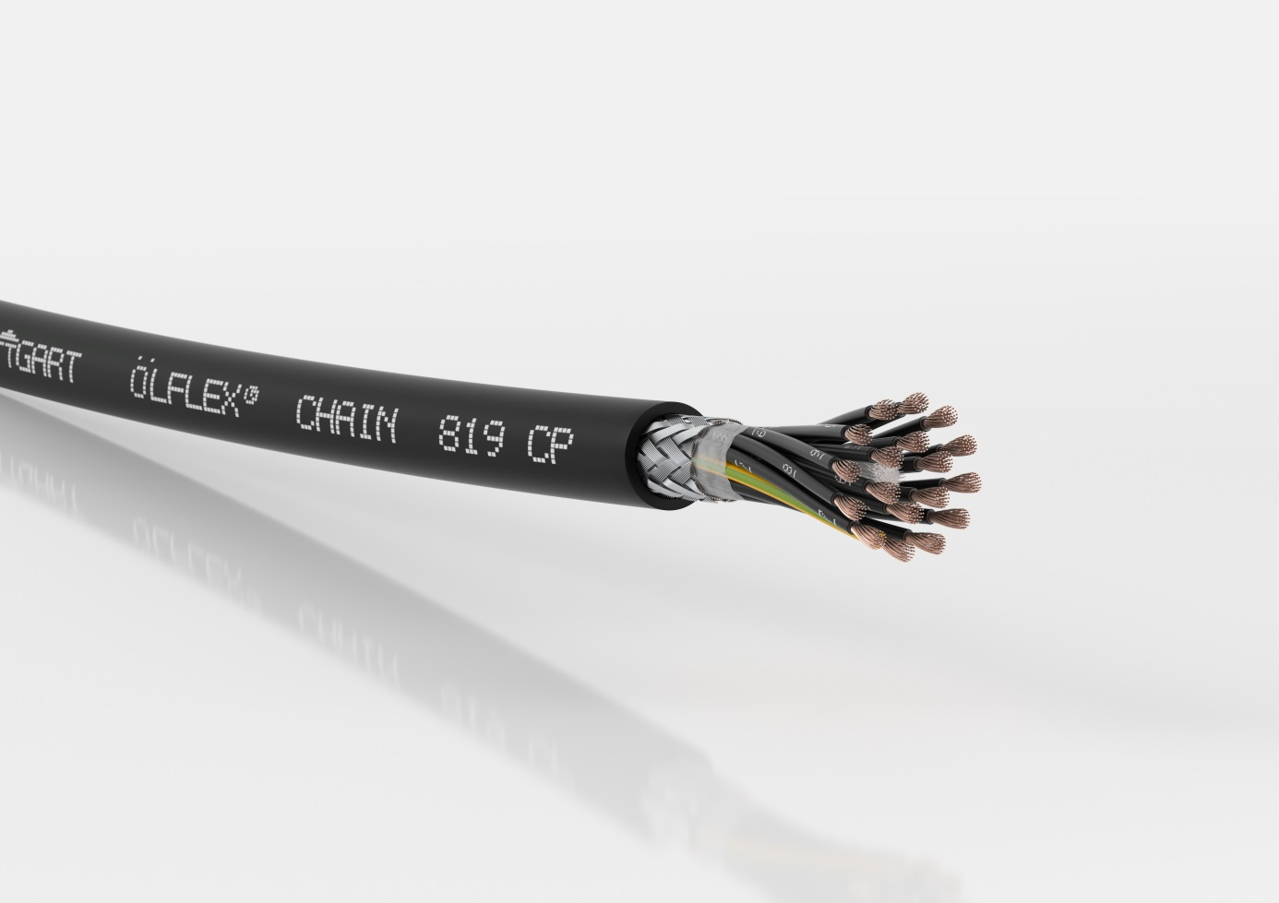
Thanks to an innovative Lapp PU special compound, the ÖLFLEX® CHAIN 819 P and ÖLFLEX® CHAIN 819 CP have material properties similar to PUR.

Stuttgart, 15 March 2018

At the Hanover Messe 2018 (Hall 11, Stand C03), the Lapp Group will be presenting several innovative connection solutions for power chains from the ÖLFLEX® and UNITRONIC® brand families.

Added benefits with Lapp PU special compound
The ÖLFLEX® CHAIN 819 P and the shielded ÖLFLEX® CHAIN 819 CP version are highly flexible control cables with a robust, exceptionally oil resistant outer sheath, designed for up to five million alternate bending cycles. They represent the basic line performance class for moderate travel distances or accelerations and are UL/cUL AWM certified for use in North America. They are replacing the two previous basic line power chain cables, the ÖLFLEX® CHAIN 808 P and ÖLFLEX® CHAIN 808 CP.

Robustness and flame retardance are achieved by an innovative Lapp PU special compound. This has material properties similar to PUR and the necessary flame retardance stipulated for UL certification.

The PU special compound results in several advantages for users. On the one hand, the new power chain cables are more economical and are UL certified. On the other hand, the more abrasion-proof sheath material extends the maintenance intervals for the drag chain. In addition, exporters can reduce their inventories as the new cables can be used both for 600 V or 1000 V voltage requirements in North America and in Europe.

PROFINET-compliant power chain connecting cable
To strengthen its position in the market as a complete supplier of PROFINET-compliant cables, Lapp is extending its already comprehensive range in this area with the highly flexible PROFINET-compliant ÖLFLEX® CHAIN PN connecting cable for connection of PROFINET® distributors and switches. In the basic line performance class, it is designed for light to medium stresses in power chains, is flame retardant and - thanks to the UL/cUL certified product properties - is approved for use in North America. A heat resistant PVC sheath allows use up to +90 degrees Celsius, while the cable is also oil resistant and ideal for applications in harsh environments. The ÖLFLEX® CHAIN PN will be particularly interesting for users in the automotive industry and their suppliers, as they design their systems to be PROFINET-compliant and thus prefer to use PROFINET-compliant components.

Higher data rates thanks to special PE
The new UNITRONIC® FD Li 2YCY (TP), a low frequency data cable is also suitable for use in drag chains. It is UV and ozone resistant, while its special PE core insulation has low capacitance and low attenuation. This allows higher data rates or use over longer distances than cables with conventional PVC core insulation. The cores are also twisted in pairs and the copper shielding protects against electromagnetic interference. The new cable is suitable for data transmission in measurement and control technology and costs less than the shielded and twisted pair UNITRONIC® FD CP (TP) plus data cable with polyurethane sheath.

The image is available in printable quality here

Press contact:
Dr. Markus Müller Irmgard Nille
Tel: +49(0)711/7838-5170 Tel.: +49(0)711/7838–2490
Mobil: +49(0)172/1022713 Mobil: +49(0)160/97346822
markus.j.mueller@lappgroup.com irmgard.nille@in-press.de

U.I. Lapp GmbH
Schulze-Delitzsch-Straße 25
D-70565 Stuttgart

Here you find more information: www.lappkabel.com/press

About the Lapp Group:
Headquartered in Stuttgart, Germany, the Lapp Group is a leading supplier of integrated solutions and branded products in the field of cable and connection technology. The Group’s portfolio includes standard and highly flexible cables, industrial connectors and cable entry systems, customized system solutions, automation technology and robotics solutions for the intelligent factory of the future, as well as technical accessories. The Lapp Group’s core market is in the industrial machinery and plant engineering sector. Other key markets are in the food industry as well as the energy and the mobility sector.
The Lapp Group has remained in continuous family ownership since it was founded in 1959. In the 2016/17 business year, it generated consolidated revenue of 1,027 million euros. Lapp currently employs approximately 3,770 people across the world, has 17 production sites and around 40 sales companies. It also works in cooperation with around 100 foreign representatives.

