LAPP at Innotrans 2018

On the right track for high-speed logistics

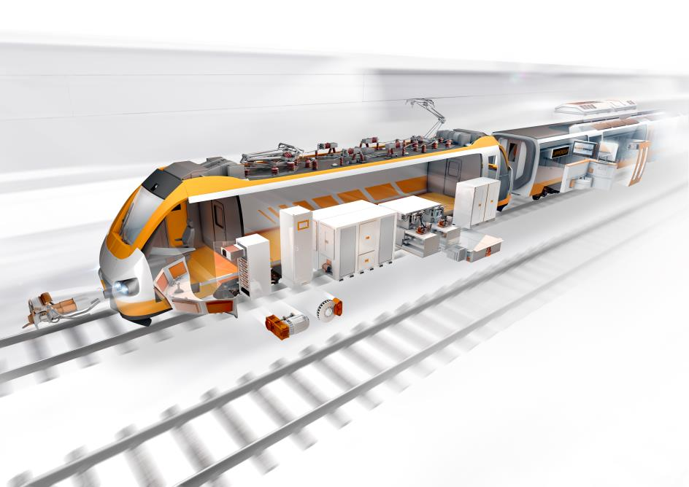

LAPP supplies cables, connectors and accessories to the global railway industry promptly off the shelf and in record time, with no minimum order quantities.
Stuttgart, September 17th, 2018

The railway technology market has grown significantly in recent years - and for manufacturers of locomotives, carriages, metro trains and trams that’s both a blessing and a curse. The high demand is pushing suppliers to their absolute capacity limits, resulting in delivery bottlenecks and long lead times. But LAPP proves that things can be different. The global market leader in integrated connection solutions supplies cables, connectors and accessories worldwide promptly, off the shelf and on short notice, with no minimum order quantities. From September 18 to 21, visitors to Innotrans 2018 in Berlin will be able to visit LAPP on Stand 210 in Hall 10.1 to find out about this logistics concept and to see a cross-section of the range of cables for the railway industry, including the new ÖLFLEX® TRAIN HT, for themselves. This hugely flexible single-core silicone cable, designed for nominal voltages of 1.8 or 3.6 kV, can withstand temperatures of up to 150°C, making it the perfect solution for use in applications with high temperatures, such as traction inverters, resistors or transformers.

Huge variety of products
The long-established company from Stuttgart only began supplying the European railway industry two years ago, but thanks to its customer-friendly concept has already won contracts with several manufacturers, including Talgo, Bombardier, Softronic, CMZO elektronika, EVPU and Matisa, a Swiss manufacturer of large track construction machines. The specialist railway product lines - ÖLFLEX® TRAIN, UNITRONIC® TRAIN and ETHERLINE® TRAIN - include more than 500 cable types, with accessories also available from the SILVYN®, SKINTOP® and FLEXIMARK® lines. All LAPP railway products satisfy the highest national and international standards and requirements, and represent uncompromising safety, quality and functionality.

Unrivalled delivery times
LAPP currently has around a million metres of cable for the railway industry in stock. Within Germany, customers receive their order within 24 hours, with a delivery time of just 72 hours to other European countries. Worldwide, delivery times of less than a week are the norm, several weeks faster than the standard delivery times offered by other cable producers. This represents a huge time saving for manufacturers of rail vehicles, but also for assemblers, who supply the cables ready for installation. This pays off if modifications are made to the electrical system shortly before delivery of a new vehicle model due to last-minute requests from the customer, which tends to be the rule rather than the exception. It also means that railway manufacturers and their assemblers no longer have to store large quantities of unused cables.

On Stand 210 in Hall 10.1 of the Berlin exhibition site, experts from different European countries will be on hand to provide information about LAPP’s range of products and services, and to explain the advantages of the LAPP logistics concept to anyone interested in finding out more.

You can find the image in printable quality here

Press contact
Dr Markus Müller Irmgard Nille
Tel.: +49 (0)711/7838-5170 Tel.: +49 (0)711/7838–2490
Mobile: +49 (0)172/1022713 Mobile: +49(0)160/97346822
markus.j.mueller@lappgroup.com irmgard.nille@in-press.de

U.I. Lapp GmbH
Schulze-Delitzsch-Strasse 25
70565 Stuttgart, Germany

You will find further information on this topic here: www.lappkabel.de/presse

About LAPP:
With its headquarters in Stuttgart, Germany, LAPP is a leading supplier of integrated solutions and branded products in the field of cable and connection technology. The company’s portfolio includes standard and highly flexible cables, industrial connectors and screw technology, customised system solutions, automation technology and robotics solutions for the intelligent factory of the future, as well as technical accessories. LAPP’s core market is machine and equipment manufacture. Other key markets are in the food industry as well as the energy and the mobility sector.
The company has remained in continuous family ownership since it was founded in 1959. In the 2016/17 business year, it generated a consolidated turnover of € 1,027 million. LAPP currently employs approximately 3,770 people around the world and has 17 production sites and 40 distribution companies; the company also works in cooperation with around 100 international representatives.

