Innovations from LAPP at Motek 2018

Online Cable Chain Configuration

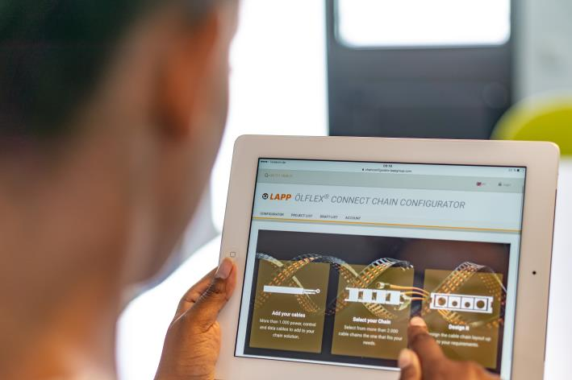
The ÖLFLEX® CONNECT CHAIN configurator allows for the quick and easy online configuration of complete cable chains. It will be one of the highlights at the LAPP stand at Motek 2018 trade fair.

Stuttgart, August 30th 2018

System solutions are a major trend in connection technology. Fully assembled, ready-to-connect connection systems from a single source deliver high quality and save time. Machine and equipment manufacturers will find an extensive range on the LAPP stand at Motek 2018. It features everything from custom cable assemblies to servo assemblies for connection of servo drives in compliance with leading manufacturers’ standards through to ready-to-install cable chain systems. The new ÖLFLEX® CONNECT CHAIN configurator is one of the highlights on the LAPP stand (Hall 8, Stand 8117). This enables users to engineer a cable chain digitally online with just a few clicks of the mouse. In the past, configuring cable chains has been a complex task and less expert users can easily make mistakes. The configurator makes the design much easier and automatically excludes all the sources of errors.

Everything fits together
The digital ÖLFLEX® CONNECT CHAIN configurator guides you step by step through the choice of cable chain, cables and appropriate accessories. When the configuration is complete, the customer can request an individual quotation. At each stage of the selection process, the ÖLFLEX® CONNECT CHAIN configurator makes sure all the components are compatible. A critical factor for cable chains is the minimum bending radius of the cables. If this is not taken into account, malfunctions can occur and the service life of the cables is reduced. Therefore, the bending radius is determined by the cables used. If the minimum bending radius of the cables is undershot, the configurator generates an error message and offers the user alternative cable chain types. Cables are selected based on the travel distance, acceleration, temperature profile, shielding and other parameters. The configurator automatically excludes cables that are not suitable for the application. If required, it can position vertical and horizontal separators and makes sure that the weight of the cables is evenly distributed in the cable chain. Finally, the customer chooses whether they want to purchase the cable chain fully assembled by LAPP or as individual components, with the option of having the cables pre-cut to the appropriate length. If they choose the first option, they have the security of knowing that all components will be assembled using expert know-how and supplied ready for use - and that not just the individual components but the fully assembled chain will be 100 percent tested. The ÖLFLEX® CONNECT CHAIN configurator can be accessed at https://chainconfigurator.lappgroup.com.

Global presence
Unlike most suppliers, LAPP’s system solutions are available worldwide - always in the same high quality that LAPP customers expect. In addition to the competence centre in Stuttgart, the company has two other competence centres in the USA and Singapore, as well as a global network of production sites for ÖLFLEX® CONNECT and other products. No matter where in the world they are working, LAPP customers benefit from short delivery times and proximity to experts who are totally familiar with their local conditions. Also of interest for export-oriented customers is LAPP’s constantly increasing range of multi-standard products, which are UL certified and thus approved for use in North America. LAPP will be exhibiting a selection of these products at Motek in Hall 8, Stand 8117.

You can find the image in printable quality here

Press contact
Dr Markus Müller Irmgard Nille
Tel.: +49 (0)711/7838-5170 Tel.: +49 (0)711/7838–2490
Mobile: +49 (0)172/1022713 Mobile: +49(0)160/97346822
markus.j.mueller@lappgroup.com irmgard.nille@in-press.de

U.I. Lapp GmbH
Schulze-Delitzsch-Strasse 25
70565 Stuttgart, Germany

You will find further information on this topic here: www.lappkabel.com/press

About LAPP:
With its headquarters in Stuttgart, Germany, LAPP is a leading supplier of integrated solutions and branded products in the field of cable and connection technology. The company’s portfolio includes standard and highly flexible cables, industrial connectors and screw technology, customised system solutions, automation technology and robotics solutions for the intelligent factory of the future, as well as technical accessories. LAPP’s core market is machine and equipment manufacture. Other key markets are in the food industry as well as the energy and the mobility sector.
The company has remained in continuous family ownership since it was founded in 1959. In the 2016/17 business year, it generated a consolidated turnover of € 1,027 million. LAPP currently employs approximately 3,770 people around the world and has 17 production sites and 40 distribution companies; the company also works in cooperation with around 100 international representatives.

