SKINTOP HYGIENIC now available with NPT thread

Hygienic design for plant engineers in Europe and North America

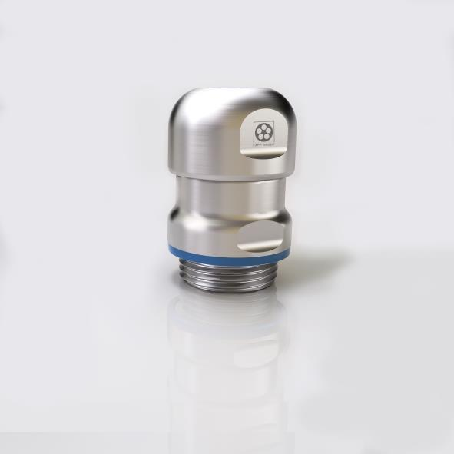

The SKINTOP HYGIENIC NPT cable gland is now also available with NPT thread and certified to NSF/ANSI 169 for “food zone non contact”.

Stuttgart, September 12th, 2018

When it comes to hygiene, the food and beverage industry sets high demands. This is reflected in the corresponding standards for firms that build plants for food processing, although these standards vary greatly between continents. The directives of the European Hygienic Engineering and Design Group (EHEDG) that are accepted in Europe are virtually unknown in North America. There is also UL certification for compliant use of components in plants and machinery. LAPP increasingly offers connection systems that meet all standards, in order to make choosing the right components easier. The latest all-rounder in its product range is the SKINTOP HYGIENIC NPT cable gland, which is now also available with NPT thread and certified to NSF/ANSI 169 for “food zone non contact”. This makes it suitable for areas in North American food production where especially tough hygiene rules apply. The cable gland can be used for filling systems in dairies or breweries, as well as in the chemical and pharmaceutical sectors.

Multiple standards, one product
What makes the SKINTOP HYGIENIC NPT special is the combination of hygienic design with an NPT connection thread. Most self-sealing pipe threads produced to the American NPT standard (NPT = National Pipe Thread) usually have a gap at the intermediate connection, while part of the outer thread remains visible. This feature clearly runs counter to the principles of hygienic design, which calls for surfaces to be as smooth as possible, without edges, corners and above all gaps in which food could settle and allow bacteria to develop. LAPP’s engineers came up with a smart design that creates an NPT thread with no gap and no visible thread.

The cable gland therefore meets the latest directives of the European Hygienic Engineering and Design Group (EHEDG). It is also resistant to cleaning agents in line with the requirements of ECOLAB, a provider of products and services for industrial cleaning. The fact that the new SKINTOP HYGIENIC NPT also meets the standards of the American National Sanitation Foundation (NSF) and is UL certified makes it an all-round product suitable for both export-focused plant engineering firms in Europe and those based abroad.

Also available in EMC version
As is standard for LAPP, the SKINTOP HYGIENIC NPT is available in all standard diameters with the corresponding counter nuts. An EMC version that reliably conducts away unwanted emissions, the SKINTOP HYGIENIC SC NPT, is also available. LAPP also offers the SKINTOP INOX NPT, a more compact variant with NPT thread that is suitable for plants in which the cable gland is only used in the spray zone or non-product zone. This variant is also available with EMC protection as the SKINTOP HYGIENIC SC NPT.

Find the image in printable quality here

Press contact:
Dr. Markus Müller Irmgard Nille
Tel: +49(0)711/7838-5170 Tel.: +49(0)711/7838–2490
Mobil: +49(0)172/1022713 Mobil: +49(0)160/97346822
markus.j.mueller@lappgroup.com irmgard.nille@in-press.de

U.I. Lapp GmbH
Schulze-Delitzsch-Straße 25
D-70565 Stuttgart

Find more information here: www.lappkabel.com/press

About LAPP:
Headquartered in Stuttgart, Germany, LAPP is a leading supplier of integrated solutions and branded products in the field of cable and connection technology. The company’s portfolio includes standard and highly flexible cables, industrial connectors and cable entry systems, customized system solutions, automation technology and robotics solutions for the intelligent factory of the future, as well as technical accessories. LAPP’s core market is in the industrial machinery and plant engineering sector. Other key markets are in the food industry as well as the energy and the mobility sector.
LAPP has remained in continuous family ownership since it was founded in 1959. In the 2016/17 business year, it generated consolidated revenue of 1,027 million euros. LAPP currently employs approximately 3,770 people across the world, has 17 production sites and around 40 sales companies. It also works in cooperation with around 100 foreign representatives.

