LAPP establishes its own presence in Switzerland
LAPP acquires Swiss partner Volland

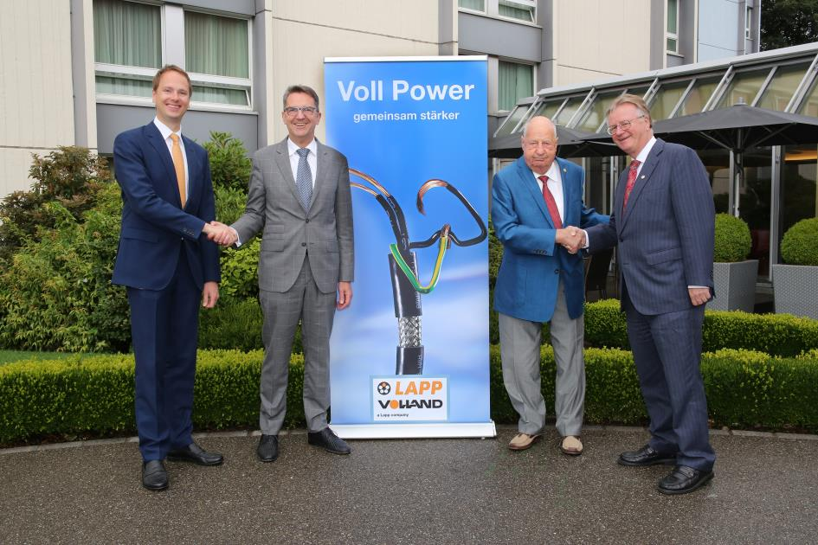
Sealing the deal: Andreas Lapp (CEO of the LAPP Group; full right) and Matthias Lapp (CEO of LAPP for Latin America, Europe, the Middle East and Africa; Full left) purchase Volland AG from Managing Director Reto Volland (left) and President of the Board of Directors Rudolf Volland (right).

Stuttgart/Rümlang, 9 July 2018

LAPP, a global market leader for integrated cable and connection technology solutions, has acquired its long-term Swiss distribution partner Volland. Company founder Rudolf Volland and Managing Director Reto Volland signed the purchase agreement with Andreas Lapp, Chairman of the Board of LAPP Holding, and Matthias Lapp, CEO of LAPP for Latin America, Europe, the Middle East and Africa, in Rümlang, Switzerland on 3 July 2018.

Andreas Lapp is over the moon: “This step is the result of a successful long-term partnership and compatible corporate philosophies. This will help LAPP to continue increasing our presence in the very innovative and demanding Swiss market and provide an even better and more seamless service for customers in Switzerland and all over the world.”

Volland AG, which is headquartered in Rümlang, has been one of LAPP’s distribution partners since the company was founded in 1960, making them our first international distributor. The Swiss company is a system provider of cable technology, and currently employs 35 staff. Reto Volland, who has been Managing Director of Volland AG for 32 years, will continue to run the new LAPP company.

Company founder and President of the Board of Directors Rudolf Volland said: “Our aim, after just shy of six decades in business, is to make sure that Volland AG has a secure and innovative future. We want to maintain the trust of our customers and all employees, gain additional market shares and transform Volland AG into a LAPP site in Switzerland. We are restructuring early to ensure continuity and new prospects for the future.”

Matthias Lapp, CEO of LAPP for Latin America, Europe, the Middle East and Africa, believes the acquisition is an important step for LAPP: “Switzerland has always been a major market for us. We joined forces with Volland almost six decades ago and have seen so much success here. Now is the right time to take the next step.”

Reto Volland sees major opportunities in selling his company to LAPP. As he emphatically stated: “With the power of LAPP as a global player behind us, we can offer our customers in Switzerland an even faster and better service.” By incorporating Volland into the LAPP network, we intend for customers to benefit from an even wider array of products, higher stock availability and faster deliveries, all with LAPP’s trusted innovative capacity.

The acquisition is subject to approval from the relevant authorities.

Find the image in printable quality here

Press contact:
Dr. Markus Müller Irmgard Nille
Tel: +49(0)711/7838-5170 Tel.: +49(0)711/7838–2490
Mobil: +49(0)172/1022713 Mobil: +49(0)160/97346822
markus.j.mueller@lappgroup.com irmgard.nille@in-press.de

U.I. Lapp GmbH
Schulze-Delitzsch-Straße 25
D-70565 Stuttgart

Find more information here: www.lappkabel.com/press

About LAPP:
Headquartered in Stuttgart, Germany, LAPP is a leading supplier of integrated solutions and branded products in the field of cable and connection technology. The company’s portfolio includes standard and highly flexible cables, industrial connectors and cable entry systems, customized system solutions, automation technology and robotics solutions for the intelligent factory of the future, as well as technical accessories. LAPP’s core market is in the industrial machinery and plant engineering sector. Other key markets are in the food industry as well as the energy and the mobility sector.
LAPP has remained in continuous family ownership since it was founded in 1959. In the 2016/17 business year, it generated consolidated revenue of 1,027 million euros. LAPP currently employs approximately 3,770 people across the world, has 17 production sites and around 40 sales companies. It also works in cooperation with around 100 foreign representatives.

Volland AG
As a Swiss system provider of electrical products for well-known industrial manufacturers, Volland draws on its near 60 years of experience to understand what the modern market needs. Volland’s high availability for delivery and broad range of services (picking and pre-assembling ready-made cables) make it an attractive partner. To Volland AG, “systematic cable technology” means acting as a one-stop shop to offer customers a complete and future-oriented range of electrical products. Managing Director Reto Volland and his team of 34 employees are guaranteed to be excellent business partners to LAPP.

