Oskar Lapp Foundation promotes young scientists in cardiovascular research

Oskar Lapp Research Prize and Grant 2018

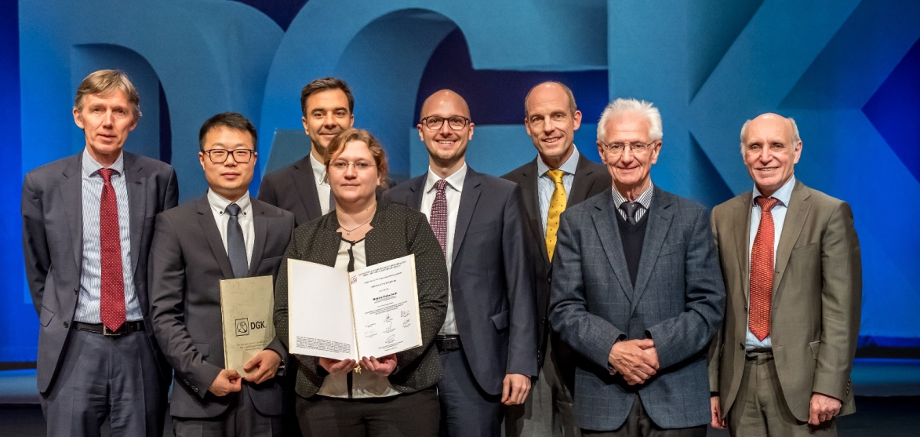

Presentation with ceremony, left to right Prof. Dr. Thomas Eschenhagen, Dr. Jiong Hu, Prof. Dr. Steffen Massberg (accepting the prize on behalf of Dr. Florian Gärtner), Dr. Melanie Ricke-Hoch, Alexander Lapp, Prof. Dr. Thomas Nordt, Prof. Dr. Anton Both, Prof. Dr. Hugo A. Katus. Photo: DGK/Thomas Hauss
Stuttgart, May 2nd, 2018

At the 84th annual convention of the German Cardiac Society (DGK) in Mannheim, the Oskar Lapp Foundation once again awarded important sponsorship prizes to young cardiac researchers. The Oskar Lapp Research Prize 2018 has been split and awarded to two cardiac scientists: Dr. Florian Gärtner and Dr. Jiong Hu. The total prize money is 12,000 Euro.

Dr. Florian Gärtner is a medical assistant and head of the “Morphodynamics of blood platelets” research group at Medical Clinic I at the Klinikum Großhadern in Munich. In his research work, he looks at migrating blood platelets, which collect and bundle bacteria in an infection. He identified the mechanism behind migration-dependent platelet/bacteria interaction and laid the foundation for the development of new pharmacological strategies for treating inflammatory tissue damage.

Dr. Jiong Hu is junior group leader at the Institute for Vascular Signalling, part of the Centre for Molecular Medicine at the Johann Wolfgang Goethe University in Frankfurt am Main. He researches diabetic retinopathy, which is a cause of blindness in adults. In a model with mice, he established that increased activity of the enzyme epoxide hydrolase (sEH) and the associated formation of a particular form of fatty acid has an influence on diabetic retinopathy. Therefore, inhibiting sEH could prevent the progression of the disease and represents a very promising therapy.

The Oskar Lapp Grant 2018 went to Dr. Melanie Ricke-Hoch, from the Hanover Medical School, Centre of Internal Medicine. She works there as an academic assistant and is the deputy leader of the molecular cardiology working group under Prof. Denise Hilfiker-Kleiner. Dr. Ricke-Hoch is researching the rare heart disease peripartum cardiomyopathy (PPCM). This occurs in previously healthy women in the period between the last month of pregnancy and six months after birth. Dr. Ricke-Hoch is aiming to explain the mechanisms that lead to the occurrence of PPCM and to make a contribution to testing new therapeutic methods in a model system, in order to improve the chances of recovery for PPCM patients with a poor prognosis. The grant is worth €20,000 and is to be used for material resources. It offers up to a two-year period of sponsorship.

The Oskar Lapp Foundation was founded in 1992 in honour of the Stuttgart-based businessman Oskar Lapp, who died on 25 April 1987 as a result of a heart attack. His widow, Ursula Ida Lapp, is chair of the foundation’s board of trustees. The foundation aims to provide young scientists with incentives to effectively engage them in cardiovascular research. "There is a lot of work to be done in cardiovascular research. There is still a need for much better research into prophylaxis, diagnostics, therapy and rehabilitation for coronary heart disease,” said Ursula Ida Lapp, explaining the ongoing commitment of the Lapp family.

Along with the founding family, the members of the Oskar Lapp Foundation Board of Trustees are Prof. Gunther Arnold (former Director of the German Cardiac Society), Prof. Anton Both (retired Medical Director, Klinikum Stuttgart, Katharinenhospital), Dr Rolf Thieringer (former Lord Mayor of the state capital of Stuttgart), Prof. Roderich C. Thümmel (lawyer), Prof. Thomas Nordt (Medical Director, Klinikum Stuttgart, Katharinenhospital) and Konstantinos Papoutsis (Director of the German Cardiac Society).

For donations, the Oskar Lapp Foundation's bank details are as follows: IBAN: DE68 6005 0101 0002 0760 87, BIC: SOLADEST600.

Find the image in printable quality here

Press contact:
Dr. Markus Müller Irmgard Nille
Tel: +49(0)711/7838-5170 Tel.: +49(0)711/7838–2490
Mobil: +49(0)172/1022713 Mobil: +49(0)160/97346822
markus.j.mueller@lappgroup.com irmgard.nille@in-press.de

U.I. Lapp GmbH
Schulze-Delitzsch-Straße 25
D-70565 Stuttgart

Find more information here: www.lappkabel.com/press

About LAPP:
Headquartered in Stuttgart, Germany, LAPP is a leading supplier of integrated solutions and branded products in the field of cable and connection technology. The company’s portfolio includes standard and highly flexible cables, industrial connectors and cable entry systems, customized system solutions, automation technology and robotics solutions for the intelligent factory of the future, as well as technical accessories. LAPP’s core market is in the industrial machinery and plant engineering sector. Other key markets are in the food industry as well as the energy and the mobility sector.
LAPP has remained in continuous family ownership since it was founded in 1959. In the 2016/17 business year, it generated consolidated revenue of 1,027 million euros. LAPP currently employs approximately 3,770 people across the world, has 17 production sites and around 40 sales companies. It also works in cooperation with around 100 foreign representatives.

