Hannover Messe 2019

Chancellor Dr. Angela Merkel and Swedish Prime Minister Stefan Löfven visit LAPP at Hannover Messe

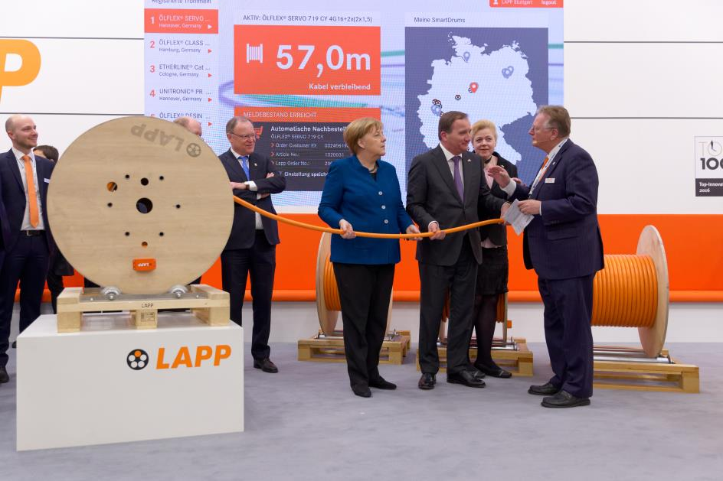
Impressed by the digital solution at the LAPP booth: German Chancellor Dr. Angela Merkel and Swedish Prime Minister Stefan Löfven - right/left in the picture Andreas Lapp.

Hanover, 02 April 2019

German Chancellor Dr. Angela Merkel and Swedish Prime Minister Stefan Löfven visited the LAPP stand in Hall 11 on their tour of the halls of the Hannover Messe 2019. There they were impressed by the latest digital developments of the Stuttgart-based company.
Andreas Lapp, CEO of Stuttgart-based LAPP Holding AG, took the opportunity to briefly introduce his company to the guests: "We are a hidden champion and world market leader in the field of cable and connection technology. LAPP has 18 production sites worldwide, 44 international sales companies and 4,245 employees. "LAPP is also very successful in Scandinavia. In Sweden we employ more than 100 people".

Digital demonstration object: Smart Cable Drum
Digitalization and Industry 4.0, summarized at LAPP under the term "Industrial Data Communication", are very important topics for his company, according to the CEO. As an example of how digitization automates and accelerates processes, he demonstrated a prototype of the Smart Cable Drum, which LAPP is developing together with Schildknecht.
"With the help of a sensor and electronics with radio transmission, the current cable inventory is determined and transmitted to a data portal in a cloud. This opens up a wide range of applications, for example, it can significantly simplify warehousing: Once a predefined minimum stock level has been reached on the cable reel, the system automatically triggers a repeat order. Another possible function is theft protection: The cable drum can also be equipped with a GPS module - if a movement is registered at a time when no work is being done, this could automatically trigger a theft alarm. New business models are also conceivable: LAPP could make the cable drums available to its customers as commission goods in the form of pay-per-use and bill consumption according to the values determined using Smart Cable Drum technology, while at the same time ensuring timely subsequent delivery. "In this way, we offer our customers real added value through digitalization," emphasizes Andreas Lapp. At Hannover Messe, the company wants to talk to potential customers and sound out possible concrete fields of application.

For LAPP, the eminent visitors on the morning of the first day of the fair was a tailor-made prelude, according to Andreas Lapp. "All in all, the first day of the fair was extremely successful for us. We are very confident that this will be the beginning of an outstanding Hannover Messe 2019".

Find LAPP at the Hannover Messe, in Hall 11, booth C03.

Find the image in printable quality here
Find a video of the eminent visit here

Press contact:
Dr. Markus Müller Irmgard Nille
Tel: +49(0)711/7838-5170 Tel.: +49(0)711/7838–2490
Mobil: +49(0)172/1022713 Mobil: +49(0)160/97346822
markus.j.mueller@lappgroup.com irmgard.nille@in-press.de

U.I. Lapp GmbH
Schulze-Delitzsch-Straße 25
D-70565 Stuttgart

Find more information here: www.lappkabel.com/press

About LAPP:
Headquartered in Stuttgart, Germany, LAPP is a leading supplier of integrated solutions and branded products in the field of cable and connection technology. The company’s portfolio includes standard and highly flexible cables, industrial connectors and cable entry systems, customized system solutions, automation technology and robotics solutions for the intelligent factory of the future, as well as technical accessories. LAPP’s core market is in the industrial machinery and plant engineering sector. Other key markets are in the food industry as well as the energy and the mobility sector.
LAPP has remained in continuous family ownership since it was founded in 1959. In the 2017/18 business year, it generated consolidated revenue of 1,153 million euros. LAPP currently employs approximately 4,245 people across the world, has 18 production sites and around 44 sales companies. It also works in cooperation with around 100 foreign representatives.

