New LAPP products at Hannover Messe 2019

All you Need is ÖLFLEX

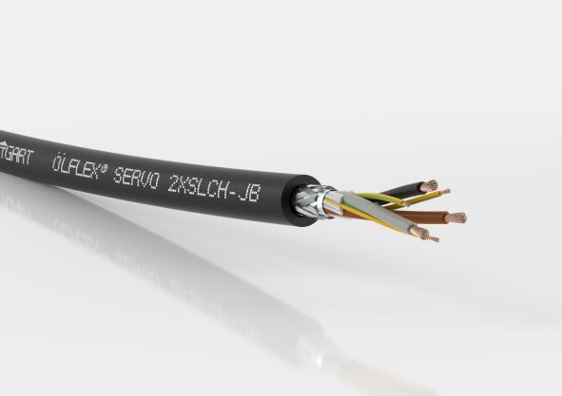
Image 1: At Hannover Messe 2019, LAPP will show a firework display of new ÖLFLEX products.

Hannover/Stuttgart, March 27th, 2019

ÖLFLEX is the longest-standing brand in the LAPP portfolio: it has been synonymous with the very highest quality in control cables since 1957. Not that the brand’s cables will be ready for the scrap heap any time soon! LAPP will show a firework display of new products in Hall 11, Stand C03 at Hannover Messe 2019:

ÖLFLEX SERVO 2XSLCH-JB: halogen-free and fire safe
Wherever people dwell or material assets are at risk of being damaged in a fire, cables are required that will not rapidly spread a fire and not emit poisonous fumes if a fire were to break out. Take the ÖLFLEX SERVO 2XSLCH-JB, for example. It is halogen-free to IEC 60754-1 and flame resistant to IEC 60332-1-2 and IEC 60332-3-24/-25. It has passed the smoke density test as per IEC 61034-2 and is non-toxic in accordance with EN 60305. Just like the ÖLFLEX SERVO 2YSLCY-JB and ÖLFLEX SERVO 9YSLCY-JB cables, which are already on the market, the ÖLFLEX SERVO 2XSLCH-JB features double screening for the very best electromagnetic compatibility. It is available in two versions, one with the conventional four-core version and one in the 3+3 core version. In the latter, the green and yellow earth wire consists of three cores with interstice filler, so they sit symmetrically between the three power cores. This improves the cable’s electrical properties and reduces harmful bearing currents, as does the low-capacitance insulation through XLPE.

ÖLFLEX CLASSIC 128 H BK 0.6/1kV: fireproof for buildings
This new control cable is also excellent at preventing fires, making it suitable for systems in public buildings and industry where people and material assets need to be protected. It complies with all important regulations, such as flame resistance as per IEC 60332-1-2 and reduced fire propagation in accordance with IEC 60332-3-24 and IEC 60332-3-25. It is halogen free as per IEC 60754-1, has passed the corrosion test in line with IEC 60754-2 and has a low emission of corrosive gases when affected by fire in accordance with IEC 61034-2. Despite all these outstanding features, the cable remains affordable. It is also available in a shielded version for EMC-critical environments under the name ÖLFLEX CLASSIC 128 CH BK 0.6/1kV. This version does not have an inner sheath, so the cable remains thin, flexible and easy to install.

LAPP will be showcasing its entire portfolio of ÖLFLEX cables at Hannover Messe 2019. Visit LAPP in Hall 11, Stand C03 for more information.

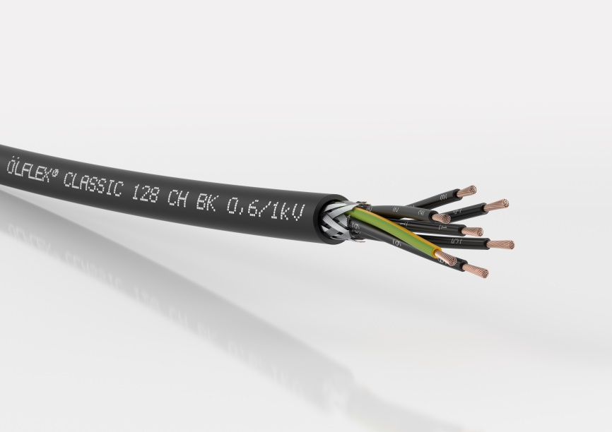
Image 2: The ÖLFLEX CLASSIC 128 H BK 0.6/1kV is especially suitable for systems in public buildings and industry where people and material assets need to be protected.

Find image 1 in printable quality here
Find image 2 in printable quality here

Press contact:
Dr. Markus Müller Irmgard Nille
Tel: +49(0)711/7838-5170 Tel.: +49(0)711/7838–2490
Mobil: +49(0)172/1022713 Mobil: +49(0)160/97346822
markus.j.mueller@lappgroup.com irmgard.nille@in-press.de

U.I. Lapp GmbH
Schulze-Delitzsch-Straße 25
D-70565 Stuttgart

Find more information here: www.lappkabel.com/press

About LAPP:
Headquartered in Stuttgart, Germany, LAPP is a leading supplier of integrated solutions and branded products in the field of cable and connection technology. The company’s portfolio includes standard and highly flexible cables, industrial connectors and cable entry systems, customized system solutions, automation technology and robotics solutions for the intelligent factory of the future, as well as technical accessories. LAPP’s core market is in the industrial machinery and plant engineering sector. Other key markets are in the food industry as well as the energy and the mobility sector.
LAPP has remained in continuous family ownership since it was founded in 1959. In the 2017/18 business year, it generated consolidated revenue of 1,153 million euros. LAPP currently employs approximately 4,245 people across the world, has 18 production sites and around 44 sales companies. It also works in cooperation with around 100 foreign representatives.

