LAPP innovations at SPS 2019
Connection solutions for confined spaces from LAPP

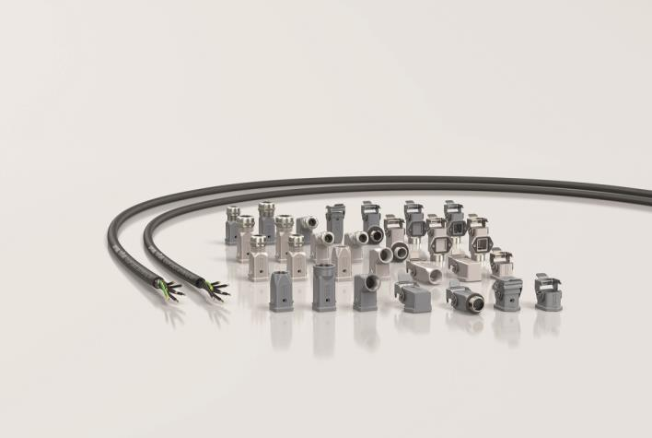
LAPP expands its range of particularly space-saving connectivity solutions

Stuttgart, November 5th, 2019

Space has always been scarce in factories and with continuing rapid electrification and digitization, things are getting even tighter in machines, robots and control cabinets. This has an impact also on connection solutions: Cables must become thinner, connectors slimmer, peripherals more compact. LAPP has been keeping an eye on this trend for quite some time and in recent years has launched particularly space-saving products on the market, such as the first single-pair Ethernet cables and a range of hybrid cables. At SPS 2019, the world market leader for integrated connection solutions is expanding this range.

EPIC® H-A 3 rectangular connector housings: Compact and easy to install
Can larger enclosures take up less space? This is possible with the three new versions with integrated SKINTOP® screw connection of the EPIC® H-A 3 rectangular connectors.
The design of the housings is significantly smaller compared to the versions where the cable gland is added separately. The robust die-cast zinc housings in the long version also permit more flexible assembly with small and large inserts and accommodate cables with up to 30% larger cross-sections. All this can add up to save a considerable amount of space.
Other new housing designs such as the screw-in housing in straight and angled designs can be attached directly to the control cabinet. The wall gasket for the redesigned bulkhead mounting and base housings is now fixed in the flange so that it cannot be lost, making installation much easier. In addition, the orientation arrow integrated into the housing contour enables easy and safe plugging, even in inaccessible places.

EPIC® ULTRA H-A 3: EMC-protected all around
The new space-saving H-A 3 enclosures are also available in particularly robust and EMC-safe EPIC® ULTRA versions. The integrated SKINTOP® BRUSH cable gland comes with a 360° shield contact connecting the shield of the cable all around to the connector housing, which itself acts as a Faraday cage. This perfect EMC protection ensures high transmission reliability. The stainless steel brackets and fixing screws as well as the nickel-plated surfaces guarantee high corrosion resistance.

ÖLFLEX® CLASSIC 128 H BK 0.6/1kV: Slim and fireproof
Since 1957, ÖLFLEX® has stood for control cables of the highest quality. This slim connection and control cable with special fire protection properties proves that even the oldest brand in the LAPP portfolio can still be innovative. It is suitable for systems in public buildings where people and property must be protected and meets all important regulations regarding flame retardance, fire propagation and freedom from halogen. The LAPP developers have not bought the extra fire protection with additional protective layers - on the contrary. The cable is slimmer than some comparable types on the market. Under the designation ÖLFLEX® CLASSIC 128 CH BK 0.6/1kV it is also available as a shielded variant for EMC-critical environments. Among other things, this cable is surprisingly thin and therefore easy to install due to the fact that it does not have an inner sheath.

EPIC® DATA DIN Adapter
These adapters for connecting fiber optic cables with SC, LC and SC-RJ connectors are clipped into the DIN rail. They are particularly compact and take up very little space in the control cabinet.

LAPP will show its complete portfolio of space-saving connectivity solutions at SPS Messe 2019 in Hall 2, Booth 310.

Find the image in printable quality here

Press contact:
Dr. Markus Müller Irmgard Nille
Tel: +49(0)711/7838-5170 Tel.: +49(0)711/7838–2490
Mobil: +49(0)172/1022713 Mobil: +49(0)160/97346822
markus.j.mueller@lappgroup.com irmgard.nille@in-press.de

U.I. Lapp GmbH
Schulze-Delitzsch-Straße 25
D-70565 Stuttgart

Find more information here: www.lappkabel.com/press
About LAPP:
Headquartered in Stuttgart, Germany, LAPP is a leading supplier of integrated solutions and branded products in the field of cable and connection technology. The company’s portfolio includes standard and highly flexible cables, industrial connectors and cable entry systems, customized system solutions, automation technology and robotics solutions for the intelligent factory of the future, as well as technical accessories. LAPP’s core market is in the industrial machinery and plant engineering sector. Other key markets are in the food industry as well as the energy and the mobility sector.
LAPP has remained in continuous family ownership since it was founded in 1959. In the 2017/18 business year, it generated consolidated revenue of 1,153 million euros. LAPP currently employs approximately 4,245 people across the world, has 18 production sites and around 44 sales companies. It also works in cooperation with around 100 foreign representatives.

