Digitalising inventory management
LAPP Presents the Smart Cable Drum

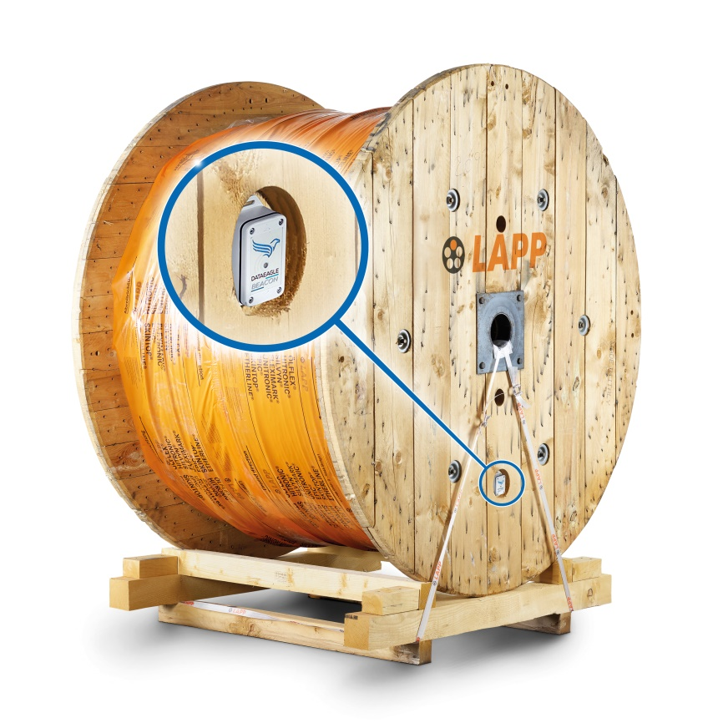
At Hannover Messe 2019, LAPP and Schildknecht will present the smart cable drum.

Stuttgart, March 21st, 2019

An innovation from LAPP is expected to revolutionise the efficiency of cable storage. The global market leader in integrated connection solutions will present the smart cable drum at Hannover Messe (Hall 11, Stand C03). The smart cable drum was developed in cooperation with Schildknecht AG, the wireless specialists for industrial applications.

“We want to assist our customers in making Industry 4.0 a reality in their company. The smart cable drum helps digitalise inventory management by using an accurate method to adjust warehouse stock to actual needs. This saves costs and warehouse capacities,” explains Ralf Moebus, Product Manager Industrial Data Communication at LAPP.

Fitted with a sensor and an electronic radio transmitter, the smart cable drum can calculate the current cable stock and send this information to a data portal in the cloud via the company network or global 2G-4G mobile technology. “The smart cable drum combines user benefits and innovative technology to form an IIoT business model of the future,” explains Elena Eberhardt, Business Development & Marketing Manager at Schildknecht AG, adding: “Normal cable drums can be replaced with smart ones through the use of low-cost robust sensors with Bluetooth 5 or mobile broadband technology. And what is more, the eSIM card with global availability makes international use easy to implement. Together with the right cloud solution, the system can be quickly scaled for various applications, as standard interfaces such as RESTful API are available.”

This results in several benefits for the customer: The smart cable drum helps to automate inventory management in the warehouse, and stock levels can be reduced by accessing information on cable stock and the current location of the cable drum at any time via the cloud. The smart cable drum can send its data directly to LAPP or, alternatively, to the company’s internal network. Another user benefit is the built-in theft protection mechanism provided through an optional built-in GPS module that provides information on the current location of the smart cable drum. So cable theft can be detected early and prevented by sending a warning when unusual activity occurs.

This could also result in new business models: LAPP could make the cable drums available to customers as goods on consignment on a pay-per-use basis and charge based on the values calculated by the smart cable drum technology, while also ensuring timely replenishment.

Find the image in printable quality here

Press contact:
Dr. Markus Müller Irmgard Nille
Tel: +49(0)711/7838-5170 Tel.: +49(0)711/7838–2490
Mobil: +49(0)172/1022713 Mobil: +49(0)160/97346822
markus.j.mueller@lappgroup.com irmgard.nille@in-press.de

U.I. Lapp GmbH
Schulze-Delitzsch-Straße 25
D-70565 Stuttgart

Find more information here: www.lappkabel.com/press

About LAPP:
Headquartered in Stuttgart, Germany, LAPP is a leading supplier of integrated solutions and branded products in the field of cable and connection technology. The company’s portfolio includes standard and highly flexible cables, industrial connectors and cable entry systems, customized system solutions, automation technology and robotics solutions for the intelligent factory of the future, as well as technical accessories. LAPP’s core market is in the industrial machinery and plant engineering sector. Other key markets are in the food industry as well as the energy and the mobility sector.
LAPP has remained in continuous family ownership since it was founded in 1959. In the 2017/18 business year, it generated consolidated revenue of 1,153 million euros. LAPP currently employs approximately 4,245 people across the world, has 18 production sites and around 44 sales companies. It also works in cooperation with around 100 foreign representatives.

