New LAPP products at Hannover Messe 2019

LAPP solar connector systems: designed for high voltage

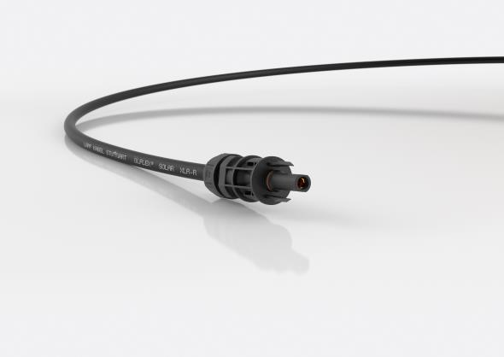

The EPIC SOLAR 4PLUS connector for high-performance photovoltaic units

Stuttgart, March 27th, 2019

Solar power is one of the key elements in environmentally friendly energy production. All the more so as the modern photovoltaic units of today are much more powerful than they were a few years ago. However, their high system voltage requires equally capable connections. And a PV system will ideally run smoothly for 20+ years with constant exposure to wind and weather conditions, so their components need to be extremely weatherproof.

LAPP has designed its EPIC SOLAR 4PLUS 4mm connector system with double locking hook for precisely this purpose. It is designed for photovoltaic units and solar trackers that work with up to 1.5kV system voltage in crystalline and thin-film constructions.

One of the new connection’s most important properties is its low contact resistance, which ensures efficient power transmission. For safe assembly on site, huge currents and long cable lengths, the developers at LAPP have fitted the system with high-quality crimp termination (max. 10mm²) boasting many excellent properties, including a very long lifespan. The connector also features protection against accidental opening in line with the American NEC standard – in other words, the connection can only be loosened with a tool. The EPIC SOLAR 4PLUS is tested to IEC 62852, the standard applicable to connectors in DC applications in photovoltaic systems. The system can be used with many ÖLFLEX SOLAR cables.

LAPP will be showcasing the new EPIC SOLAR 4PLUS connector system for ultra-high-performance photovoltaic units in Hall 11, Stand C03 at Hannover Messe 2019.

Find the image in printable quality here

Press contact:
Dr. Markus Müller Irmgard Nille
Tel: +49(0)711/7838-5170 Tel.: +49(0)711/7838–2490
Mobil: +49(0)172/1022713 Mobil: +49(0)160/97346822
markus.j.mueller@lappgroup.com irmgard.nille@in-press.de

U.I. Lapp GmbH
Schulze-Delitzsch-Straße 25
D-70565 Stuttgart

Find more information here: www.lappkabel.com/press

About LAPP:
Headquartered in Stuttgart, Germany, LAPP is a leading supplier of integrated solutions and branded products in the field of cable and connection technology. The company’s portfolio includes standard and highly flexible cables, industrial connectors and cable entry systems, customized system solutions, automation technology and robotics solutions for the intelligent factory of the future, as well as technical accessories. LAPP’s core market is in the industrial machinery and plant engineering sector. Other key markets are in the food industry as well as the energy and the mobility sector.
LAPP has remained in continuous family ownership since it was founded in 1959. In the 2017/18 business year, it generated consolidated revenue of 1,153 million euros. LAPP currently employs approximately 4,215 people across the world, has 18 production sites and around 44 sales companies. It also works in cooperation with around 100 foreign representatives.

