Circular multi-bushing with gel technology

No pre-pricking necessary!

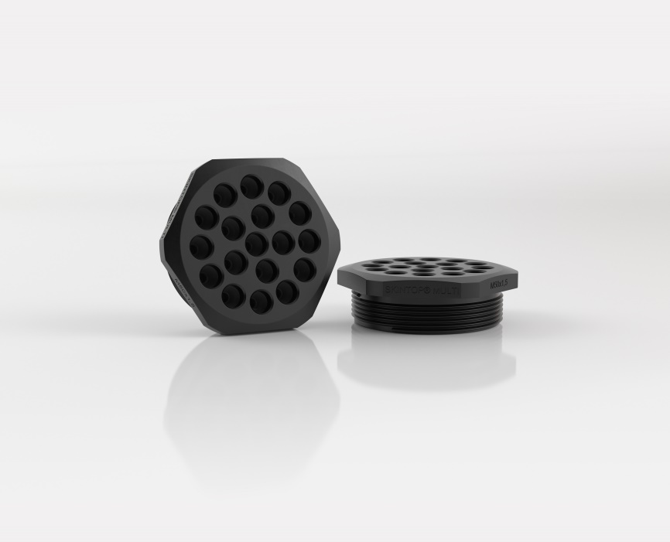
The SKINTOP® MULTI-M simplifies the routing of cables and conductors thanks to innovative gel technology.

Stuttgart, May 16th, 2019
Multi cable bushing systems are extremely convenient as they allow many cables to be inserted in a compact bushing. This saves a great deal of space, especially where installation dimensions are limited. However, when mounting cables and conductors in multiple entries a pre-pricking is usually necessary for the feed-through of cables and conductors. This means not only additional installation work but also a potential risk factor for the safe sealing of the cables.

However, this does not have to be the case. With the SKINTOP MULTI-M with metric connection thread developed by LAPP no such pre-pricking is necessary thanks to a highly elastic gel technology which makes it possible to insert cables with variable outside diameters of 2-6mm into entry point. This makes the SKINTOP MULTI-M a logical addition to LAPP's existing product portfolio which already includes various rectangular multi bushings and the classical round cable gland. The SKINTOP MULTI-M now offers the connection of both by enabling the insertion of a large number of cables in a round cable gland with metric connection thread. The gel is firmly connected to a plastic outer shell which defines the possible feed-through points. Thanks to the high elasticity of the gel the conductors can be routed directly without having to pierce the gel beforehand. The gel adapts optimally to the cable diameter and thus guarantees a high IP protection class (IP 68).

At the same time the innovative gel technology ensures that unused entry points remain securely sealed against the ingress of foreign bodies but they can also be used directly for insertion if cabling should subsequently required. This makes the round SKINTOP MULTI-M multiple entry system with metric connection thread particularly suitable for feeding through unassembled cables and conductors as well as media-conducting hoses. This ensures quick and easy installation of the cables even with the highest packing density.

Find the image in printable quality here

Press contact:
Dr. Markus Müller Irmgard Nille
Tel: +49(0)711/7838-5170 Tel.: +49(0)711/7838–2490
Mobil: +49(0)172/1022713 Mobil: +49(0)160/97346822
markus.j.mueller@lappgroup.com irmgard.nille@in-press.de

U.I. Lapp GmbH
Schulze-Delitzsch-Straße 25
D-70565 Stuttgart

Find more information here: www.lappkabel.com/press

About LAPP:
Headquartered in Stuttgart, Germany, LAPP is a leading supplier of integrated solutions and branded products in the field of cable and connection technology. The company’s portfolio includes standard and highly flexible cables, industrial connectors and cable entry systems, customized system solutions, automation technology and robotics solutions for the intelligent factory of the future, as well as technical accessories. LAPP’s core market is in the industrial machinery and plant engineering sector. Other key markets are in the food industry as well as the energy and the mobility sector.
LAPP has remained in continuous family ownership since it was founded in 1959. In the 2017/18 business year, it generated consolidated revenue of 1,153 million euros. LAPP currently employs approximately 4,245 people across the world, has 18 production sites and around 44 sales companies. It also works in cooperation with around 100 foreign representatives.

