LAPP conducts research into direct current for industry

The next energy revolution – direct current
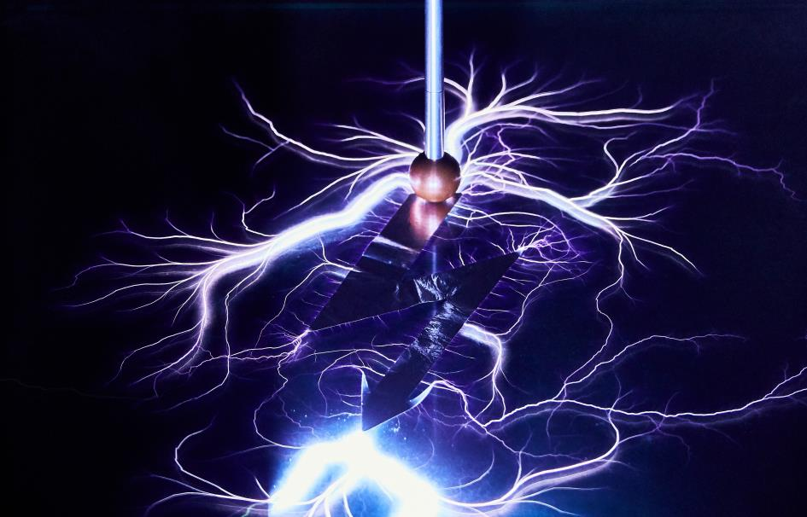
Source: LAPP
Image 1: Switching energy distribution to direct current could unlock enormous savings.
Find the image in printable quality here

Stuttgart, 12 February 2019

From factories and processing centres to households, in future, electrical energy could be conveyed via direct current (DC for short). The advantage of this is that many electrical consumers, from LED lamps and industrial drives to electric vehicles, already consume direct current. But this first needs to be converted from alternating current (AC) from the socket. Furthermore, increasing numbers of DC-generating systems, above all photovoltaics, are feeding into an increasingly decentralised power grid. Around 30 per cent of the energy is lost in the process of conversion from alternating current to direct current. In Germany, switching consistently to direct current would allow us to shut down two large coal-fired power stations and save significant quantities of CO₂.

Support for DC research from LAPP
Industry is playing an important role here. Initial pilot projects, such as those in production cells in the automotive industry, show the potential of direct-current energy supply. It could result in energy savings of up to 20 per cent. Using direct current would not only make conversion losses a thing of the past, but would also allow more energy to be fed into the grid or storage when braking machinery. LAPP focused on the topic early on and was the first company to question whether conventional AC cables were also suitable for direct current. Previously, most experts said that they were.

LAPP wanted a more precise answer and began a research project together with Prof. Frank Berger from the Ilmenau University of Technology. LAPP is also providing the working group with test cables and test benches. The tests show there really is a major difference. The electrical field of direct current has a different effect on the cable’s plastic insulation to that of alternating current. Although it is too early to draw final conclusions, Prof. Berger emphasises that: “It is already apparent that certain applications using direct current will require different materials than they would under alternating current.” Further practical experiments aim to deliver clarity. These include the project “DC-Industrie” supported by Germany’s Federal Ministry for Economic Affairs and Energy, in which LAPP is also participating as an associate partner.

First LAPP DC cables
LAPP has been working on the topic of direct current for several years. Last year, it launched the world’s first standard cable specially developed for DC applications: the ÖLFLEX DC 100. Further ÖLFLEX DC products will be presented at the Hannover Messe 2019, including a cable for controlling servo drives and a cable with TPE insulation specially designed for flexible use in energy chains. The decision to offer products in this area is backed up by Prof. Berger’s research. “LAPP is a pioneer in developing cables for low-voltage DC networks”, explains Georg Stawowy, Member of the Board for Technology and Innovation at LAPP Holding AG. “LAPP customers can rest assured that our DC cables meet the same high quality standards as all of our products.”

Source: LAPP
Image 2: Georg Stawowy, Member of the Board for Innovation and Technology
Find the image in printable quality here

Press contact:
Dr. Markus Müller Irmgard Nille
Tel: +49(0)711/7838-5170 Tel.: +49(0)711/7838–2490
Mobil: +49(0)172/1022713 Mobil: +49(0)160/97346822
markus.j.mueller@lappgroup.com irmgard.nille@in-press.de

U.I. Lapp GmbH
Schulze-Delitzsch-Straße 25
D-70565 Stuttgart

Find more information here: www.lappkabel.com/press

About LAPP:
Headquartered in Stuttgart, Germany, LAPP is a leading supplier of integrated solutions and branded products in the field of cable and connection technology. The company’s portfolio includes standard and highly flexible cables, industrial connectors and cable entry systems, customized system solutions, automation technology and robotics solutions for the intelligent factory of the future, as well as technical accessories. LAPP’s core market is in the industrial machinery and plant engineering sector. Other key markets are in the food industry as well as the energy and the mobility sector.
LAPP has remained in continuous family ownership since it was founded in 1959. In the 2017/18 business year, it generated consolidated revenue of 1,153 million euros. LAPP currently employs approximately 4,215 people across the world, has 18 production sites and around 44 sales companies. It also works in cooperation with around 100 foreign representatives.

