Over 1,200 applications, ten training occupations, focus on digitialisation
21 new apprentices at LAPP

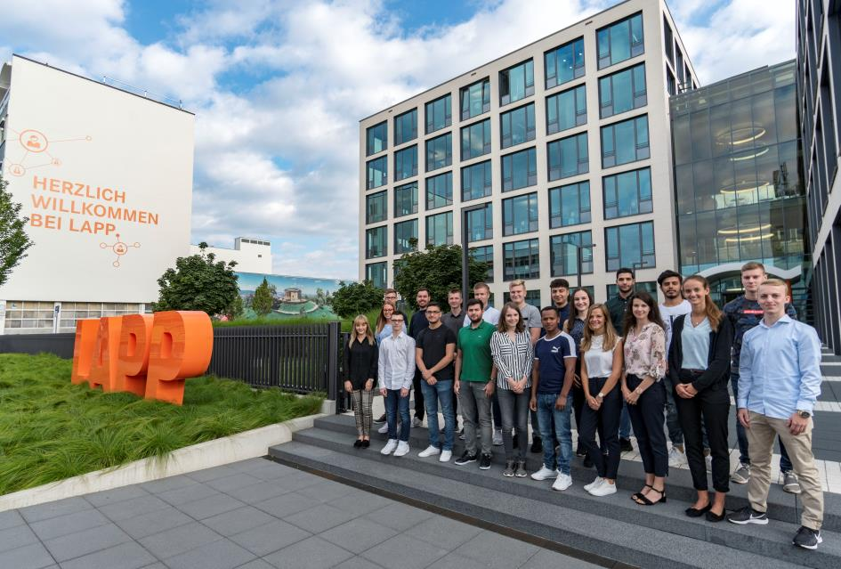
The new trainees at LAPP start with an introductory training week.

Stuttgart, September 2nd, 2019

With an introductory training week and team training, the professional lives of 21 young men and women begin today at LAPP. The world market leader for integrated solutions in cable and connection technology offers ten training paths at its Stuttgart location. A new feature is the dual training program for IT specialists (m/f/d) in application development. Further dual training occupations are specialist (m/f/d) for warehouse logistics, industrial clerk (m/f/d), wholesale and foreign trade clerks (m/f/d) with focus on wholesale, machine and plant operator (m/f/d) with focus on metal and plastics technology and mechatronics technician (m/f/d). LAPP also offers dual courses of study, such as Business Administration Service Management, specialising in Logistics and Supply Chain Management, Business Administration focused on Industry, Industrial Engineering specialising in Electrical Engineering, and Business Informatics specialising in Application Management. LAPP continues to acknowledge its responsibility for the integration of young refugees. Therefore, among the 21 new trainees there are also four refugees who are learning the profession of machine and plant operator as well as specialist for warehouse logistics at LAPP.

Currently, 68 young men and women are being trained at LAPP. Over 90 percent of the trainees have been taken on in recent years. "Qualified training is very important to us. We want to assume social responsibility towards the younger generations and give them career prospects for the future, and of course training is also an important instrument for securing young talent and long-term employee loyalty to the company. Not to mention the many fresh ideas that young people bring to the company," emphasizes Matthias Lapp, CEO of U.I. Lapp GmbH.

The training at LAPP is very diverse. The programme includes regular training weeks and team trainings. In addition, the trainees can participate in numerous events and projects such as organising the annual employees’ anniversary celebration, trade fair appearances such as "HORIZON Stuttgart" or "vocatium Stuttgart" or events for children such as the "Tüftler- und Forscherinnentag Baden-Württemberg" (“Young Researchers’ Day”). Even at Hannover Messe they are in action for LAPP. Another important learning content is the assumption of social responsibility. All trainees therefore spend two weeks doing social work in an institution of their choice. One example is the social project "Open up! for apprentices". The trainees were also involved in a workshop on "Multi-generational management at LAPP".

The trainees and dual students are also allowed and encouraged to work abroad for four to twelve weeks: Either in one of the 62 LAPP sales and production companies worldwide, or through the EU's "ERASMUS+" funding programme, they are given the opportunity to visit an external company - including a language course. In 2018 and 2019 alone, 40 trainees took advantage of this opportunity and worked in LAPP companies in Singapore, the USA, Russia and Italy.

Another important focal point of training at LAPP is digitialisation. All trainees work with the same digital tools and processes as all other LAPP employees in the commercial and industrial/technical areas. "Unfortunately, however, the German Chambers of Industry and Commerce are only gradually adapting the job descriptions to the topic of digitization, which is why we are supplementing the current training courses with many LAPP-specific topics and contents on our tools, processes and, of course, products," says Anne Voigt, Head of Training at LAPP in Germany. For example, e-learning is increasingly being used to impart knowledge. Important topics driven by digitalisation include the use of SAP ECC 6.0, the use of scanners or touch control panels on machines in production and logistics, the use of 3D printers in technology and development, and driverless transport systems.

The number of applications has continued to rise this year. A total of 1,219 (previous year: 1,117) young women and men applied to LAPP. "Word of the great opportunities offered by LAPP in training has spread among young people," explains Anne Voigt. For example, LAPP is present at training fairs and supports vocational orientation campaigns such as "Girls' Day", "MINT Dialog Days" and "Pupils in the executive chair". LAPP also maintains educational partnerships with the Anne Frank Community School and Realschule Stuttgart as well as with the Hegel Gymnasium Stuttgart, and there are educational partnerships with four other Stuttgart schools.

Find the image in printable quality here

Press contact:
Dr. Markus Müller Irmgard Nille
Tel: +49(0)711/7838-5170 Tel.: +49(0)711/7838–2490
Mobil: +49(0)172/1022713 Mobil: +49(0)160/97346822
markus.j.mueller@lappgroup.com irmgard.nille@in-press.de

U.I. Lapp GmbH
Schulze-Delitzsch-Straße 25
D-70565 Stuttgart

Find more information here: www.lappkabel.com/press

About LAPP:
Headquartered in Stuttgart, Germany, LAPP is a leading supplier of integrated solutions and branded products in the field of cable and connection technology. The company’s portfolio includes standard and highly flexible cables, industrial connectors and cable entry systems, customized system solutions, automation technology and robotics solutions for the intelligent factory of the future, as well as technical accessories. LAPP’s core market is in the industrial machinery and plant engineering sector. Other key markets are in the food industry as well as the energy and the mobility sector.
LAPP has remained in continuous family ownership since it was founded in 1959. In the 2017/18 business year, it generated consolidated revenue of 1,153 million euros. LAPP currently employs approximately 4,245 people across the world, has 18 production sites and around 44 sales companies. It also works in cooperation with around 100 foreign representatives.

