LAPP focuses on industrial data communication
State-of-the-Art Learning Offers for Customers and Employees

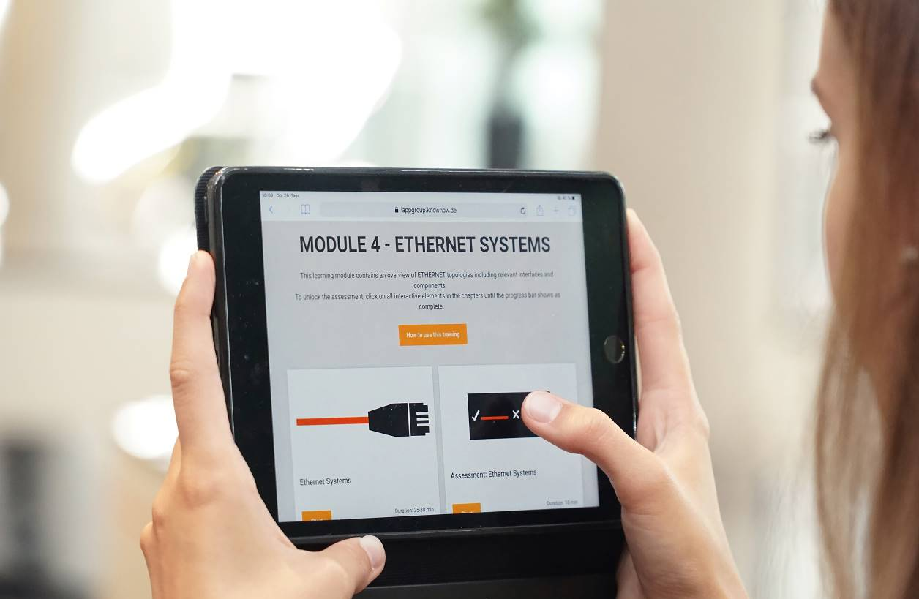

Stuttgart, 30 September 2019

LAPP makes its employees, partners and customers fit for the future: The world market leader for integrated connectivity solutions has launched a comprehensive and worldwide qualification offensive on the topic of industrial data communication. The e-learning modules from the initiative are not only available for employees, but also for customers and partners. LAPP thus makes its employees experts and supports its customers in finding their way through the jungle of technologies and protocols. To this end, further measures have been taken such as webinars, classic classroom seminars, boot camps and a certified two-year program specially developed for the LAPP Group's global experts in industrial data communication.

A clear view of industrial data communication
The trend towards a networked smart factory poses new challenges to many different groups of users, from electricians to factory planners and operators. Depending on the complexity of the challenge, the LAPP Qualification Initiative offers various options. The demands placed on LAPP employees are also changing: new opportunities and increasing complexity mean that LAPP customers are looking for more intensive, in-depth support. The goal of LAPP is to enable sales staff to accurately analyse customer needs and help them find holistic, consistent solutions. To do this, they need much more technological and systemic expertise than in the past, especially when it comes to industrial data communication. Delivering this expertise in a timely, engaging and efficient manner is a key objective of LAPP's Industrial Data Communications Qualification Initiative. "Many of our customers are talking to us about industrial data communication and the challenges it poses. It is therefore essential to keep our employees up to date on this topic," says Georg Stawowy, Member of the Executive Board of Lapp Holding AG for Technology and Innovation.

The basic modules on the subject of industrial data communication are accessible to all employees who are in contact with customers. The focus is on understanding application challenges and being able to provide professional advice as early as possible. In view of the number of participants, however, it was clear that "holding face-to-face courses with frontal instruction for thousands of employees on various continents is not a solution," says Dr. Hilmar Döring, Board Member for Human Resources and Organisational Development. "This makes no sense logistically, it would take too long and it does not correspond to our ideas of how knowledge should be conveyed in this day and age". For this reason, LAPP relies on e-learnings with modules on topics such as "Fundamentals of Automation", "Components of Automation", "Fieldbus" or "Ethernet". LAPP developed the e-learnings in cooperation with the Fraunhofer Institute for Embedded Systems and Communication Technology. All modules are available in ten languages. They are available online for all interested parties.

Sharing knowledge - preparing customers and employees for the future
As part of the initiative, experts from LAPP product management also offer partners and employees webinars and boot camps in which the topics are discussed in depth and illustrated in a practical way. "The feedback is very good," reports Georg Stawowy. "We have a graduation rate of over 85 percent in e-learning, the webinars are very well received and are establishing themselves as a learning medium in the company. Our boot camps are particularly well received because they have great practical relevance and always include a gamification component, so they are fun too. This shows us that we have hit the right note and that our customers, partners and employees are ready to embark on new paths and content."

The certified global programme for experts in industrial data communications addresses another target group within the company. LAPP developed the modules of the programme in cooperation with the Institute for Control Engineering of Machine Tools and Manufacturing Units at the University of Stuttgart. The target group are the experts at LAPP. LAPP employees from 15 countries have been nominated and specifically trained to help customers with tasks that require special expertise in the field of industrial data communication. "We believe in the principle of lifelong learning," says Dr. Hilmar Döring. "Our world is becoming ever more complex and is constantly changing, and digitization is a key driver. It is important to us to enable our employees to keep pace with these developments in their knowledge and skills. In this way, we not only enable them to do good work on a sustainable basis, but also give them an understanding of the big picture on which we are all working. It is just as important to us to share this knowledge with our customers. It is our mission to understand our customers better than anyone, and this is part of it."

The e-learnings on industrial data communication can be found at www.lappgroup.com/elearning.

Find the image in printable quality here

Media contact:
Dr. Markus Müller Irmgard Nille
Tel: +49(0)711/7838-5170 Tel.: +49(0)711/7838–2490
Mobil: +49(0)172/1022713 Mobil: +49(0)160/97346822
markus.j.mueller@lappgroup.com irmgard.nille@in-press.de

U.I. Lapp GmbH
Schulze-Delitzsch-Straße 25
D-70565 Stuttgart

Find more information here: www.lappkabel.com/press

About LAPP:
Headquartered in Stuttgart, Germany, LAPP is a leading supplier of integrated solutions and branded products in the field of cable and connection technology. The company’s portfolio includes standard and highly flexible cables, industrial connectors and cable entry systems, customized system solutions, automation technology and robotics solutions for the intelligent factory of the future, as well as technical accessories. LAPP’s core market is in the industrial machinery and plant engineering sector. Other key markets are in the food industry as well as the energy and the mobility sector.
LAPP has remained in continuous family ownership since it was founded in 1959. In the 2017/18 business year, it generated consolidated revenue of 1,153 million euros. LAPP currently employs approximately 4,245 people across the world, has 18 production sites and around 44 sales companies. It also works in cooperation with around 100 foreign representatives.

