LAPP Innovations at SPS 2019
New LAPP Cables Certified for North America

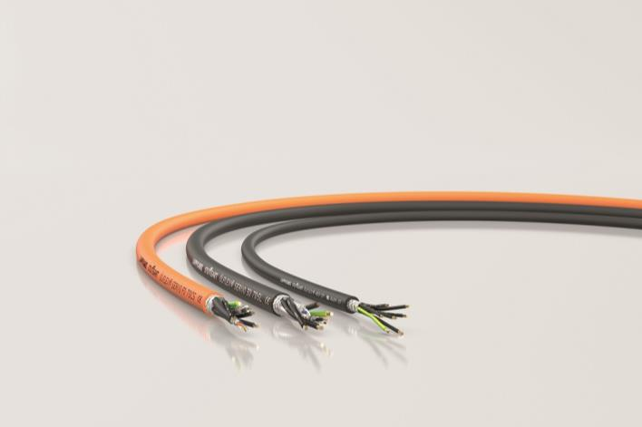
At SPS, LAPP presents new cables with certification for the North American market

Stuttgart, November 7th, 2019
The very special standards and guidelines for machines in the North American market are a constant headache for European companies. Some help themselves by equipping their machines for export to North America with other components that are specially certified for this market. But this is costly and time-consuming in terms of parts management. LAPP relieves its customers of this cabling burden. The world leader in integrated solutions for cable and connection technology is offering more and more products that are approved for both Europe and North America. This means that they have both vde and UL/cUL AWM certifications. Three more cables will be added at SPS 2019:

ÖLFLEX® SERVO FD 7OCS: Hybrid cable for one-cable drive systems
These highly flexible hybrid cables for use in drag chains make the connection of a servo drive to the frequency inverter child's play. They contain all cables in one sheath: power cores, protective conductors and, depending on the drive system, optional control pairs or triplets for the electrical brake and temperature monitoring as well as special data pairs, star quad or coax cores which transmit the encoder values and serve to communicate with the motor feedback system. The elimination of the usual feedback cable reduces cabling and connection costs, as well as saving space and weight. The ÖLFLEX® SERVO FD 7OCS is available with different cable structures for a variety of one-cable systems such as SCS Open Link and ACURO®link, for HIPERFACE DSL® motor feedback systems and for other standards. With UL/cUL-AWM certification, these universal cables are ideal for connecting servo drives - worldwide.

ÖLFLEX® SERVO 3D 7DSL: Movable in any direction
The abbreviation "3D" in the name already indicates it: This servo hybrid cable is suitable for three-dimensional movements on robot arms. This cable is also suitable for servo connections with HIPERFACE DSL®, SCS Open Link and ACURO®link. And of course it is also UL/cUL AWM certified for standard-compliant use in North America.

ÖLFLEX® 409 CP:
The abrasion-resistant and oil-resistant control cable with PUR sheath is specially designed for harsh use in industrial and machine tools - also in North America thanks to UL/cUL AWM certification. In addition to the previously available unshielded ÖLFLEX® 409 P, the new variant is also shielded with a copper braid and is therefore ideally suited for EMC-critical environments.

LAPP will present its extensive portfolio of cables with UL/cUL-AWM certification at SPS Messe 2019 in Hall 2, Stand 310.

Find the image in printable quality here

Press contact:
Dr. Markus Müller Irmgard Nille
Tel: +49(0)711/7838-5170 Tel.: +49(0)711/7838–2490
Mobil: +49(0)172/1022713 Mobil: +49(0)160/97346822
markus.j.mueller@lappgroup.com irmgard.nille@in-press.de

U.I. Lapp GmbH
Schulze-Delitzsch-Straße 25
D-70565 Stuttgart

Find more information here: www.lappkabel.com/press

About LAPP:
Headquartered in Stuttgart, Germany, LAPP is a leading supplier of integrated solutions and branded products in the field of cable and connection technology. The company’s portfolio includes standard and highly flexible cables, industrial connectors and cable entry systems, customized system solutions, automation technology and robotics solutions for the intelligent factory of the future, as well as technical accessories. LAPP’s core market is in the industrial machinery and plant engineering sector. Other key markets are in the food industry as well as the energy and the mobility sector.
LAPP has remained in continuous family ownership since it was founded in 1959. In the 2017/18 business year, it generated consolidated revenue of 1,153 million euros. LAPP currently employs approximately 4,245 people across the world, has 18 production sites and around 44 sales companies. It also works in cooperation with around 100 foreign representatives.

