Dr. Holger Winkels researches the causes of atherosclerosis
Oskar Lapp Research Award for Young Heart Scientists

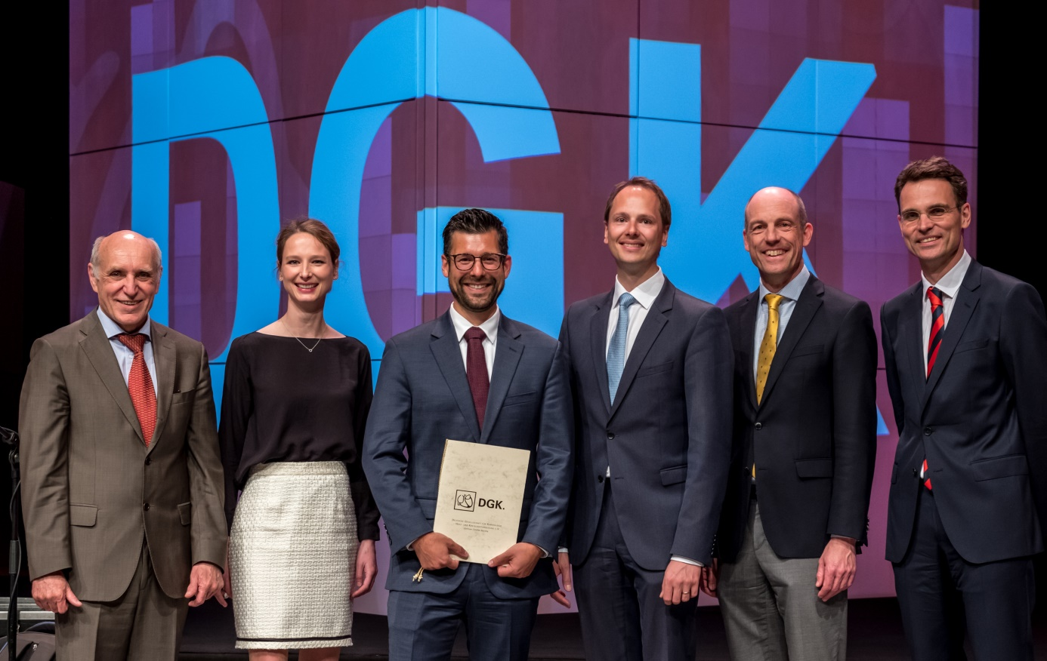
Award ceremony with (from left to right) Prof. Dr. Hugo A. Katus, Nele Marlena Lapp, Dr. Holger Winkels, Matthias Lapp, Prof. Dr. Thomas Nordt and Prof. Dr. Stephan Baldus Photo: DGK/Thomas Hauss

Stuttgart/Mannheim, May 23rd, 2019
In the presence of about 8700 cardiac specialists from all over the world, the Oskar Lapp Research Prize 2019 was awarded at the 85th annual conference of the German Society for Cardiology - Heart and Circulatory Research e.V. (Deutsche Gesellschaft für Kardiologie - Herz- und Kreislaufforschung e.V., DGK) in Mannheim. The prize is awarded every year by the Oskar Lapp Foundation and this year went to the heart scientist Dr. Holger Winkels (33), who conducts research at the La Jolla Institute for Allergy and Immunology in San Diego (USA). The prize is endowed with a total of 12,000 euros.

In his research, Dr. Holger Winkels dealt with the "Definition of the immune cell atlas in murine atherosclerosis using single-cell RNA sequencing and mass cytometry". This involves further research into the causes of atherosclerosis, a chronic inflammation of the vessels that can lead to heart attacks and strokes. For the first time, he identified a detailed immune cell atlas on aortic vessels of healthy and atherosclerotic mice using the latest high-resolution technologies. He found that not only the distribution but also the characteristics of the leukocyte populations of diseased and healthy mouse aortae differ. The deeper understanding of the immune system in atherosclerosis has the potential to develop new and more specific treatment methods for sick people.

The Oskar Lapp Foundation was established in 1992 in honour of the Stuttgart entrepreneur Oskar Lapp, who died of a heart attack on 25th April 1987. His widow, Ursula Ida Lapp, is chairwoman of the foundation's board of trustees. The foundation wants to offer young scientists additional incentives to become involved in cardiovascular research. "With his research work, Mr. Winkels has made an important contribution to further research into cardiovascular diseases and I very much hope that this will soon lead to new treatment methods for people suffering from atherosclerosis," explains Ursula Ida Lapp. Every two years, an Oskar Lapp fellowship is also awarded, which is endowed with up to 20,000 euros for material resources. The funding period is up to two years.

In addition to the Lapp family, the board of trustees of the Oskar Lapp Foundation includes Prof. Dr. Gunther Arnold (former managing director of the German Society for Cardiology - Heart and Circulatory Research), Prof. Dr. Anton Both (retired medical director, Stuttgart Clinical Centre), Dr. Rolf Thieringer (formeFirst Mayor of the State Capital Stuttgart), Prof. Dr. Roderich C. Thümmel (lawyer), Prof. Dr. Thomas Nordt (Medical Director, Stuttgart Clinical Centre) and Konstantinos Papoutsis (Managing Director of the German Society for Cardiology - Heart and Circulatory Research).

The donation account of the Oskar Lapp Foundation is: IBAN: DE68 6005 0101 0002 0760 87, BIC: SOLADEST600.

Find the image in printable quality here

Press contact:
Dr. Markus Müller Irmgard Nille
Tel: +49(0)711/7838-5170 Tel.: +49(0)711/7838–2490
Mobil: +49(0)172/1022713 Mobil: +49(0)160/97346822
markus.j.mueller@lappgroup.com irmgard.nille@in-press.de

U.I. Lapp GmbH
Schulze-Delitzsch-Straße 25
D-70565 Stuttgart

Find more information here: www.lappkabel.com/press

About LAPP:
Headquartered in Stuttgart, Germany, LAPP is a leading supplier of integrated solutions and branded products in the field of cable and connection technology. The company’s portfolio includes standard and highly flexible cables, industrial connectors and cable entry systems, customized system solutions, automation technology and robotics solutions for the intelligent factory of the future, as well as technical accessories. LAPP’s core market is in the industrial machinery and plant engineering sector. Other key markets are in the food industry as well as the energy and the mobility sector.
LAPP has remained in continuous family ownership since it was founded in 1959. In the 2017/18 business year, it generated consolidated revenue of 1,153 million euros. LAPP currently employs approximately 4,245 people across the world, has 18 production sites and around 44 sales companies. It also works in cooperation with around 100 foreign representatives.

