LAPP innovations at SPS 2019
Extra Tough: Connection Solutions from Lapp
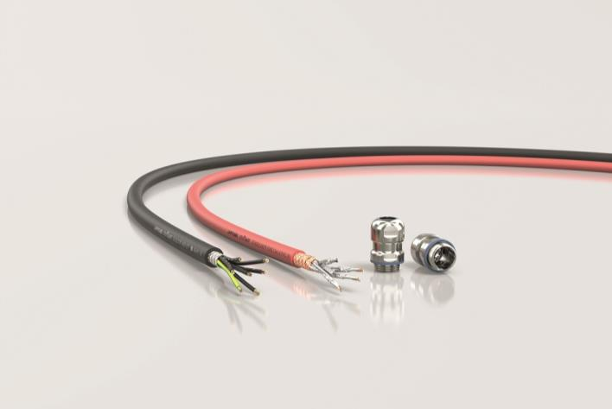
LAPP will bring a number of innovations to SPS 2019 which still work even long after other components have quit service.

Stuttgart, November 6th, 2019

Dirt, heat, oil, bacteria, millions of movements: Cables have to withstand a lot in industry. LAPP has been a pioneer in robust connection systems for over 60 years. And the company will also be bringing a number of innovations to SPS 2019 which still work even long after other components have quit service:

ETHERLINE® FIRE Cat.6: Takes the heat
The best way to keep emergency circuits functioning in the event of fire is to use the proven ETHERLINE® FIRE from LAPP. It is now also available in a Cat.6 version for very high data transmission rates of up to 10 Gbit/s with high signal quality up to cable lengths of 100 meters. Polyolefin-based core insulation and a special anti-fire tape wrapped around the cores block flames for at least 120 minutes - enough time for the fire fighters to get the fire under control. There is no additional health hazard for the emergency services, as the outer sheath is halogen-free and therefore does not release any corrosive gases.

SKINTOP® HYGIENIC M32 / M40: Germ-free even with thick cables
Bacteria are the natural enemy of food production. LAPP has created a broad portfolio of connection components for hygiene applications so that germs cannot settle in the first place and detergents can easily drip off. The SKINTOP® HYGIENIC cable gland made of stainless steel has proven its worth. It was designed according to the specifications, and also evaluated and certified by the European Hygienic Engineering and Design Group (EHEDG). On top of that, it is certified according to ECOLAB®. The robust stainless steel cable gland in hygienic design is now also available for cables up to 27mm outside diameter, also as a shielded version with optimum EMC protection.

LAPP will present its extensive portfolio of robust cables for industry at SPS Messe 2019 in Hall 2, Stand 310.

Find the image in printable quality here

Press contact:
Dr. Markus Müller Irmgard Nille
Tel: +49(0)711/7838-5170 Tel.: +49(0)711/7838–2490
Mobil: +49(0)172/1022713 Mobil: +49(0)160/97346822
markus.j.mueller@lappgroup.com irmgard.nille@in-press.de

U.I. Lapp GmbH
Schulze-Delitzsch-Straße 25
D-70565 Stuttgart

Find more information here: www.lappkabel.com/press

About LAPP:
Headquartered in Stuttgart, Germany, LAPP is a leading supplier of integrated solutions and branded products in the field of cable and connection technology. The company’s portfolio includes standard and highly flexible cables, industrial connectors and cable entry systems, customized system solutions, automation technology and robotics solutions for the intelligent factory of the future, as well as technical accessories. LAPP’s core market is in the industrial machinery and plant engineering sector. Other key markets are in the food industry as well as the energy and the mobility sector.
LAPP has remained in continuous family ownership since it was founded in 1959. In the 2017/18 business year, it generated consolidated revenue of 1,153 million euros. LAPP currently employs approximately 4,245 people across the world, has 18 production sites and around 44 sales companies. It also works in cooperation with around 100 foreign representatives.

