Current study on the quality of education
LAPP is one of "Germany's best trainers”

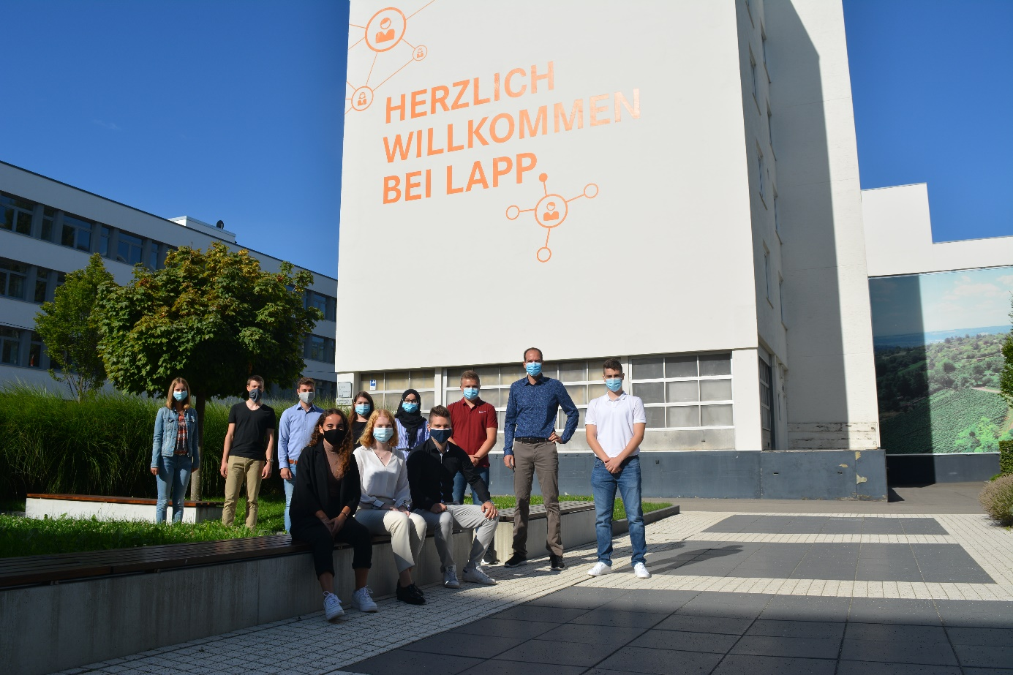
The training 2020 started with an introductory week. Because of Corona, the trainees were divided into two groups. Here the group 2
Stuttgart, the 26th October 2020

The subject of training is of great importance at LAPP. This year alone, the number of apprenticeships has been significantly increased once again to give even more young people a professional perspective. According to a joint study by the business magazine CAPITAL, the talent platform Ausbildung.de and the personnel marketing experts from TERRITORY EMBRACE, LAPP is now also one of "Germany's best trainers 2020".

"We are very proud of this award. It shows us that we are setting standards with our commitment to training. This also supports us in our search for young talent. At LAPP, training in particular is one of the key elements in winning over and inspiring employees for LAPP," says Matthias Lapp, CEO of U.I. Lapp GmbH.

With a score of 5 out of 5 possible stars in the training category and 4 out of 5 possible stars in the dual studies category, U.I. Lapp GmbH was awarded very good and good results. A total of 666 companies took part in the study, including Dax corporations, large public authorities, many medium-sized companies and craft enterprises. The study provides a Germany-wide overview of the "Best Trainers in Germany" by region and occupational group. Companies that employ at least five trainees or three students on the dual system were eligible to participate.

At LAPP, a total of 70 young people are currently being trained in a total of eleven training programs. In recent years, over 90 percent of the trainees have been taken on. Training at LAPP is very varied and starts with an introductory training week. In addition to training and study relevant content, trainees at LAPP can also get involved in internal and cross-departmental projects, LAPP events and trade fairs. "We want to inspire young people for their future professions and hope that we can offer the same diversity in Corona times as in previous years. We will do everything we can to ensure that the quality of training does not suffer even in difficult times," emphasizes Anne Voigt, Head of Training at LAPP.

Find the image in printable quality here

Press contact:
Irmgard Nille
Tel.: +49(0)711/7838–2490
Mobil: +49(0)160/97346822
irmgard.nille@in-press.de

U.I. Lapp GmbH
Schulze-Delitzsch-Straße 25
D-70565 Stuttgart

Find more information here: www.lappkabel.com/press

About LAPP:
Headquartered in Stuttgart, Germany, LAPP is a leading supplier of integrated solutions and branded products in the field of cable and connection technology. The company’s portfolio includes standard and highly flexible cables, industrial connectors and cable entry systems, customized system solutions, automation technology and robotics solutions for the intelligent factory of the future, as well as technical accessories. LAPP’s core market is in the industrial machinery and plant engineering sector. Other key markets are in the food industry as well as the energy and the mobility sector.

LAPP has remained in continuous family ownership since it was founded in 1959. In the 2018/19 business year, it generated consolidated revenue of 1,222 million euros. LAPP currently employs approximately 4,650 people across the world, has 18 production sites and around 44 sales companies. It also works in cooperation with around 100 foreign representatives.

