New SKINTOP® products for a secure connection

Tailored cable gland solutions from LAPP

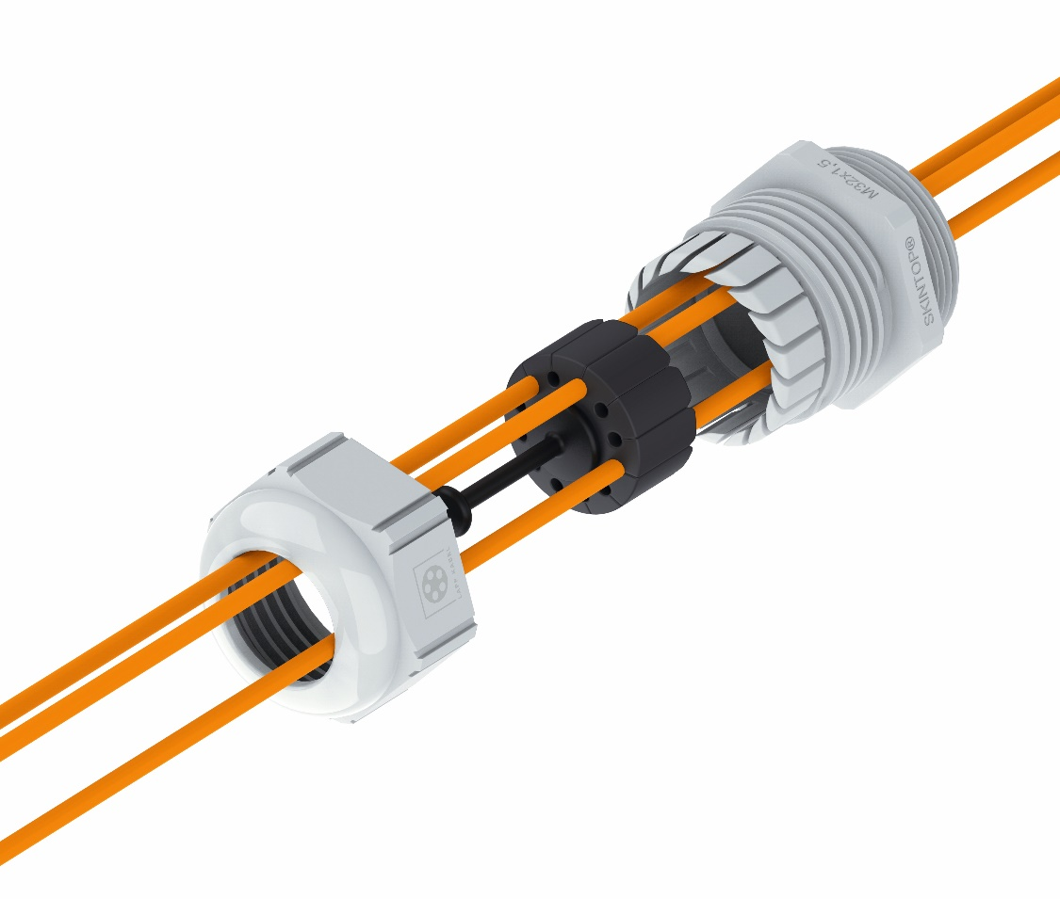
The SKINTOP® FIBER enables up to twelve fibre optic cables to be inserted into one housing at the same time.

Stuttgart, 11th November 2020
In control cabinets or installation boxes, nothing works without cable glands. They protect cables and wires from mechanical influences and high temperatures, they insulate, and they provide strain relief and earthing. In order to offer users even better, tailored solutions, LAPP has further expanded its portfolio and is now introducing several new SKINTOP® cable glands.
The SKINTOP® FIBER is designed for Industry 4.0 applications and FTTx network architectures for broadband expansion. Up to twelve fibre optic cables can be inserted into one housing at the same time. This is made possible by an innovative seal insert made of soft ethylene propylene diene rubber (EPDM). The gentle clamping action ensures excellent fixing and sealing without impairing the transmission performance. And thanks to slotted holes in the sealing insert, even pre-assembled fibre optic cables can be fed through. Another advantage is that installation is simple, even in confined spaces. It also prevents the fibre optic cables from being inappropriately bent or clamped.
The new SKINTOP® DIX-M AUTOMATION sealing inserts guarantee a greater variety of dimensions. Thanks to their slotted seal, they are particularly suitable for feeding through pre-assembled data cables. The new versions cover cable diameters of 3-10 mm. When used in combination with metric SKINTOP® and SKINTOP® CLICK cable glands, an ideal cable seal can be achieved. If the hole is perfectly filled, protection class IP 68 is even achieved.

Since August 2020, the global market leader for integrated cable and connection solutions has also been offering cable glands in a lead-free brass version. The reason for this is that lead is only permitted to be used as an additive for easier processing until July 2021 unless there is a further extension. To start with, the most common cable glands from LAPP are also available in a lead-free version. The first products include the popular SKINTOP® MS-M and MS-SC-M models, as well as the SKINDICHT® SM-M counter nut. Lisa Schlingmann, Product Manager at LAPP: “We are very committed to sustainability, so we didn’t want to wait until it was officially prohibited. This is something that users should be considering today, especially in the case of durable machines.”

Information on LAPP's new products can be found at SPS Connect, the virtual platform of the international SPS trade fair.

Find the image in printable quality here

Press contact
Irmgard Nille
Tel.: +49(0)711/7838–2490
Mobil: +49(0)160/97346822
irmgard.nille@in-press.de

U.I. Lapp GmbH
Schulze-Delitzsch-Straße 25
D-70565 Stuttgart

More information: www.lappkabel.de/presse

About LAPP:
Headquartered in Stuttgart, Germany, LAPP is a leading supplier of integrated solutions and branded products in the field of cable and connection technology. The company’s portfolio includes standard and highly flexible cables, industrial connectors and cable entry systems, customized system solutions, automation technology and robotics solutions for the intelligent factory of the future, as well as technical accessories. LAPP’s core market is in the industrial machinery and plant engineering sector. Other key markets are in the food industry as well as the energy and the mobility sector.

LAPP has remained in continuous family ownership since it was founded in 1959. In the 2018/19 business year, it generated consolidated revenue of 1,222 million euros. LAPP currently employs approximately 4,650 people across the world, has 18 production sites and around 44 sales companies. It also works in cooperation with around 100 foreign representatives.

