Innovative solutions for sun, rail and mechanical engineering
LAPP expands its portfolio for core sectors

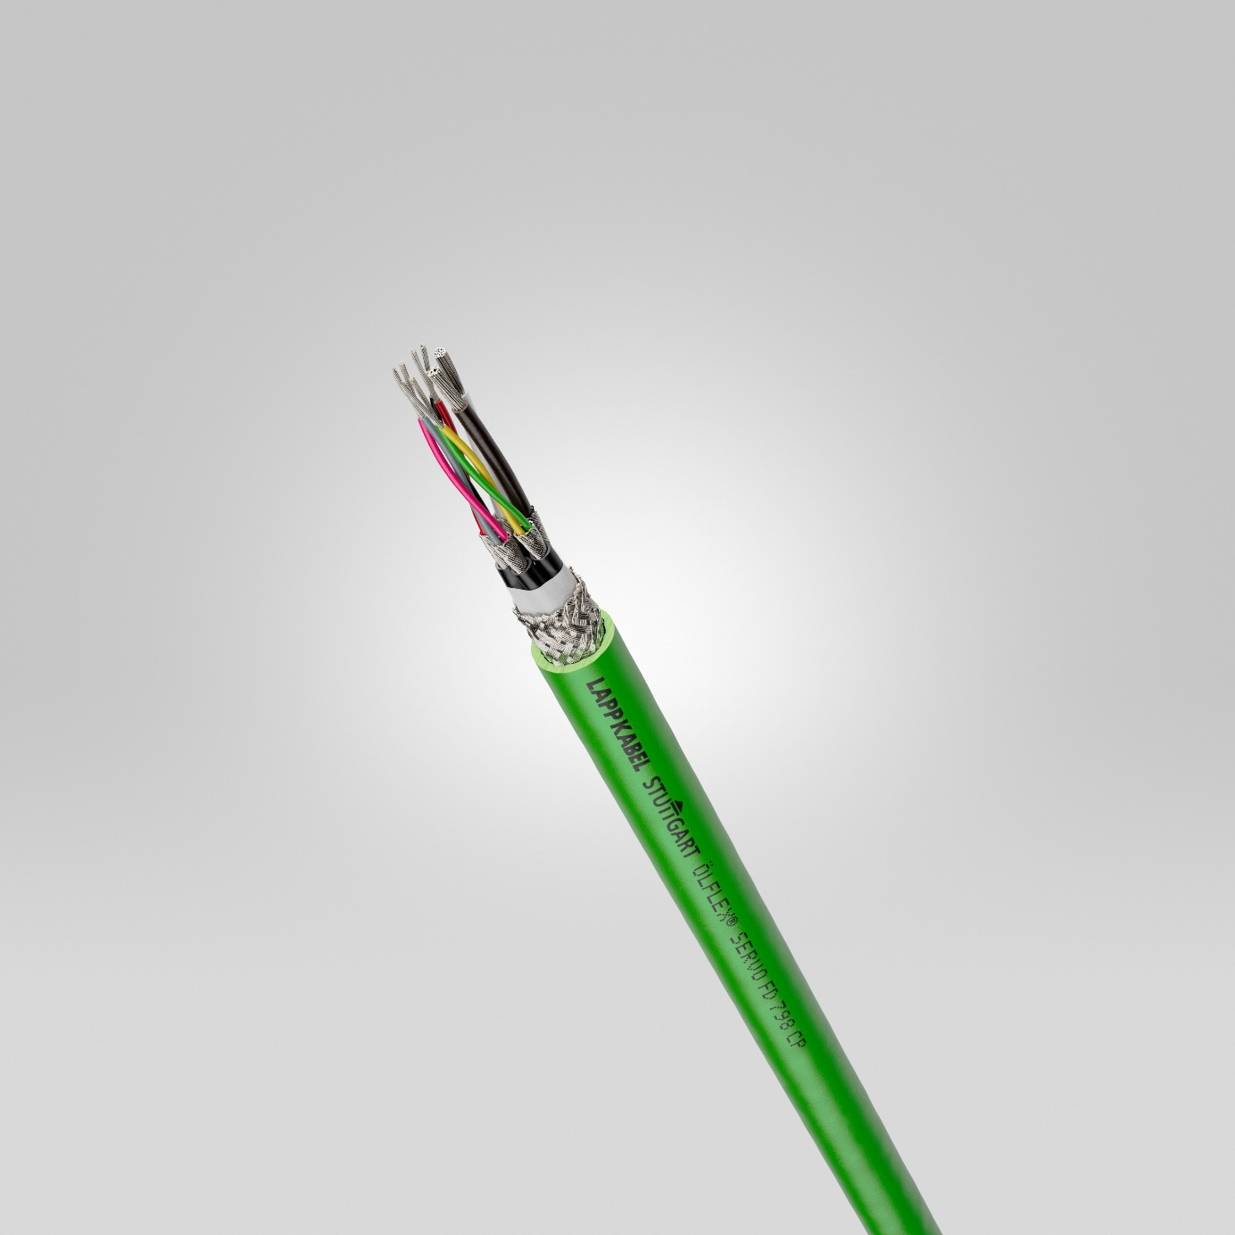
The ÖLFLEX® SERVO FD 798 CP enables highly dynamic cable chain applications.
Stuttgart, 19th November 2020

In November, LAPP will be presenting numerous new connection solutions for a wide range of industries - from photovoltaics to rail to mechanical and plant engineering. They will bring lots of benefits for users.

Photovoltaics:
- LAPP has optimised the H1Z2Z2-K single-core solar cable with design certification for connecting solar module series and inverters. Thanks to a halogen-free core insulation and sheath compound, it is double insulated and adapts to the increased fire protection requirements with a higher CPR class (Dca). In addition, it offers improved mechanical strength as specified in the earth-related "Impact-Resistance Test" according to UL 854 yet, despite its improved properties, has a considerably lower price than the previous version. The insulation and sheathing materials are also cross-linked. This optimises longevity at high temperatures or with high current loads. They also ensure a high dielectric strength and a high maximum short-circuit temperature.

Rail:
- EPIC® H-BE series inserts are ideal for use in industry at higher voltages and currents. The new crimping inserts made of robust polycarbonate have now also been approved for rail vehicles in compliance with DIN EN 45545-2. Due to maximum contact protection between the contact and the cable, they are extremely vibration-resistant and also meet the strict fire protection requirements necessary for railway applications. The UL certification also allows use in North America.

Mechanical and plant engineering:
- The ÖLFLEX® SERVO FD 798 CP is a proven PUR feedback cable for encoders and resolvers and enables highly dynamic cable chain applications. New dimensions are now available for the Extended Line performance class cable with different shielding versions. It can withstand a wide temperature range in extremely harsh, oily environments, has UL/CSA certification and is compatible with all common drive and feedback system manufacturers.
- Switches organise data traffic between machines and networks in companies. This is another area where LAPP is expanding its portfolio. The new ETHERLINE® ACCESS NF is an NAT router with integrated firewall. It protects against unauthorised access to the production network and enables secure, Ethernet-based communication in automation technology. The latest firmware version also enables IP ranges to be entered in NAT mode. The new NAT router is very compact and can be installed on 35 mm top-hat rails in the control cabinet with reduced installation work and can be easily configured with using a web interface. The temperature range has also been extended to -40 to +75°C.
- The new EPIC® SIGNAL D-SUB 1 mm crimp contact is suitable for universal use in machine interfaces for signal and data transmission. It replaces two D-SUB contacts (0.14-0.34 mm²/0.34-0.5 mm²). Its broader connection range enables strands with cross-sections of 0.25-1.00 mm² to be crimped and is compatible with standard D-Sub connectors. Thanks to the wide range of applications, users can reduce the variety of parts they need.
- The new EMC Guard shield terminal is available for control cabinets as well as in motor controllers, housings or machine systems. It is used to earth and shield the control and cable components. The cable can be pressed in without tools and is therefore particularly fast to install and ensures user-friendly handling. Thanks to the large shield contact area, the terminal guarantees optimum shielding. Optimum strain relief is achieved using a strain relief clamp.

Information on LAPP's new products can be found at SPS Connect, the virtual platform of the international SPS trade fair.

You can find the image in printable quality here

Press contakt
Irmgard Nille
Tel.: +49(0)711/7838–2490
Mobil: +49(0)160/97346822
irmgard.nille@in-press.de

U.I. Lapp GmbH
Schulze-Delitzsch-Straße 25
D-70565 Stuttgart

Weitere Informationen zum Thema finden Sie hier: www.lappkabel.de/presse

About LAPP:
Headquartered in Stuttgart, Germany, LAPP is a leading supplier of integrated solutions and branded products in the field of cable and connection technology. The company’s portfolio includes standard and highly flexible cables, industrial connectors and cable entry systems, customized system solutions, automation technology and robotics solutions for the intelligent factory of the future, as well as technical accessories. LAPP’s core market is in the industrial machinery and plant engineering sector. Other key markets are in the food industry as well as the energy and the mobility sector.

LAPP has remained in continuous family ownership since it was founded in 1959. In the 2018/19 business year, it generated consolidated revenue of 1,222 million euros. LAPP currently employs approximately 4,650 people across the world, has 18 production sites and around 44 sales companies. It also works in cooperation with around 100 foreign representatives.

