ETHERLINE® LAN Cat. 6_{A}: New pre-assembled data cables from LAPP
Patchcords with UL certification

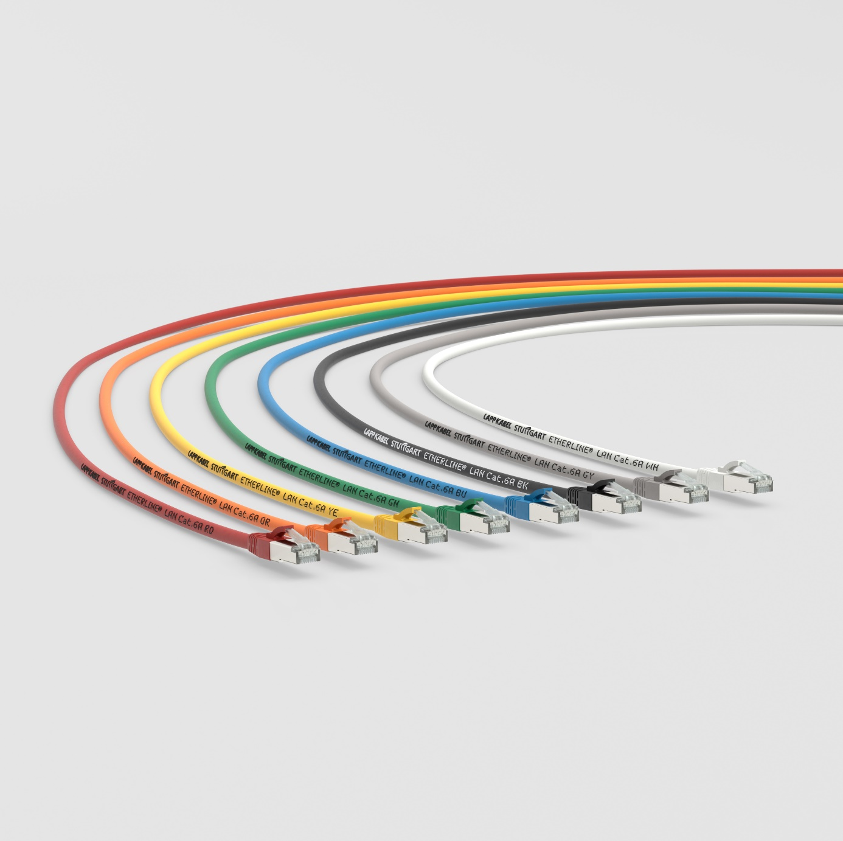The ETHERLINE® LAN Cat. 6_{A} patchcords are available in various colours
Stuttgart, 30th October 2020

Pre-assembled data cables known as patchcords are vital components in network technology. But they usually do not have to satisfy any industrial requirements. The new patchcords from LAPP, on the other hand, are more versatile and suitable for international use. They enable users to reduce their number of parts in storage, thus simplifying logistics.

Thanks to the double shielding of a foil screen and copper braiding, the ETHERLINE® LAN Cat.6_{A} patchcords can be used not only in offices but also in industrial control cabinets with low electromagnetic load. Furthermore, all patchcord types have the internationally recognised safety certification of the Underwriters Laboratories (UL), making them suitable for machines in the USA and Canada.

Further advantages of patchcords from LAPP:
- Faster installation due to the pre-assembled connecting cable on both sides
- No potential for faults through in-house assembly
- Slim RJ45 connector enables use in devices with a high port density
- Compliance with special fire protection requirements thanks to the halogen-free LSZH outer sheath
- Suitable for Ethernet applications up to 10GBase-T

Benjamin Kraus from Industrial Communication Product Management at LAPP said: “All components - from the patchcord to the network socket - must be perfectly coordinated to ensure smooth industrial communication. Thanks to our years of experience with piece goods and our extensive product portfolio, we can provide our customers with expert advice and suitable solutions, all in the quality they expect from LAPP.”

Information on LAPP's new products is also available at SPS Connect, the virtual platform of the international SPS trade fair.

You can find the image in printable quality here

Press contact
Irmgard Nille
Tel.: +49(0)711/7838–2490
Mobil: +49(0)160/97346822
irmgard.nille@in-press.de

U.I. Lapp GmbH
Schulze-Delitzsch-Straße 25
D-70565 Stuttgart

More information: www.lappkabel.de/presse

About LAPP:
Headquartered in Stuttgart, Germany, LAPP is a leading supplier of integrated solutions and branded products in the field of cable and connection technology. The company’s portfolio includes standard and highly flexible cables, industrial connectors and cable entry systems, customized system solutions, automation technology and robotics solutions for the intelligent factory of the future, as well as technical accessories. LAPP’s core market is in the industrial machinery and plant engineering sector. Other key markets are in the food industry as well as the energy and the mobility sector.

LAPP has remained in continuous family ownership since it was founded in 1959. In the 2018/19 business year, it generated consolidated revenue of 1,222 million euros. LAPP currently employs approximately 4,650 people across the world, has 18 production sites and around 44 sales companies. It also works in cooperation with around 100 foreign representatives.

