LAPP launches new brand identity at Hanover Trade Fair
One company, one name - worldwide

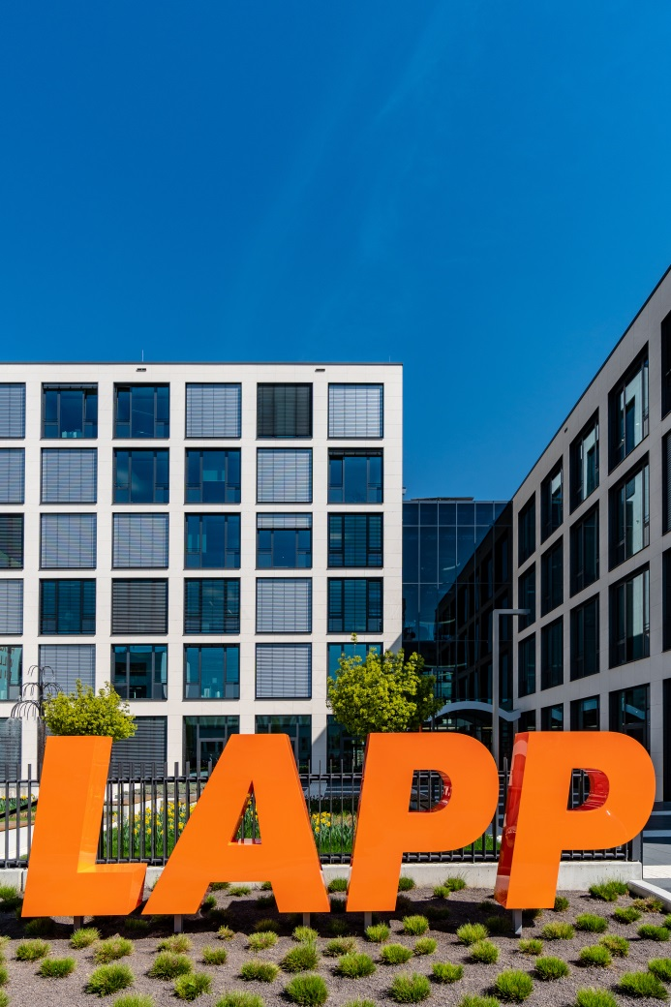
LAPP is simplifying and unifying its global brand identity

Stuttgart, 23 April 2018

LAPP, the expert in connection technology, is developing its brand. By using the name LAPP - in capital letters and with no additions - the family company is underlining its international alignment and positioning as a leading supplier of connection solutions. In future, national subsidiaries and departments will all operate under the name LAPP with no additions. The message is clear - one name and one logo for the entire company, offering its customers the same outstanding service at all times, wherever they are. The new brand identity will be on display for the first time at the Hanover Trade Fair. In future, the family name will represent the company’s fundamental values - focus on success, focus on customers, innovation and family.

The new branding is LAPP’s response to the fact that what was originally a cable manufacturer has developed into a provider of connection solutions. Name affixes such as “Kabel”, “Cable” or “Cablo”, which have been used in many countries since the company was founded in 1959, will disappear. In recent years, LAPP has successfully developed into a provider of integrated solutions and branded products for numerous industries and applications; as evidenced by the positive results for the past financial year which saw a 13.9 per cent increase of global turnover. “Now is the right time to have a uniform name worldwide and a unified logo to link everything together,” explains Chairman Andreas Lapp. Customers and their needs were at the heart of the decision. “These days it is no longer so important in which country our customers buy our products and where they are delivered to - we’ve been working as an international team for a long time. It is a logical progression for our external identity to reflect that. And what’s more: that is exactly what our customers expect”, Andreas Lapp continues.

The change is a logical step in the company’s development but is also a joint decision by the Lapp family - LAPP is still LAPP. This was shown by the change of generations that occurred in 2017, when Matthias Lapp, a member of the third generation of the founding Lapp family, took over the role of CEO for Europe, Africa, the Middle East and South America.

Find the image in printable quality here

Press contact:
Dr. Markus Müller Irmgard Nille
Tel: +49(0)711/7838-5170 Tel.: +49(0)711/7838–2490
Mobil: +49(0)172/1022713 Mobil: +49(0)160/97346822
markus.j.mueller@lappgroup.com irmgard.nille@in-press.de

U.I. Lapp GmbH
Schulze-Delitzsch-Straße 25
D-70565 Stuttgart

Find more information here: www.lappkabel.com/press

About LAPP:
Headquartered in Stuttgart, Germany, LAPP is a leading supplier of integrated solutions and branded products in the field of cable and connection technology. The company’s portfolio includes standard and highly flexible cables, industrial connectors and cable entry systems, customized system solutions, automation technology and robotics solutions for the intelligent factory of the future, as well as technical accessories. LAPP’s core market is in the industrial machinery and plant engineering sector. Other key markets are in the food industry as well as the energy and the mobility sector.
LAPP has remained in continuous family ownership since it was founded in 1959. In the 2016/17 business year, it generated consolidated revenue of 1,027 million euros. LAPP currently employs approximately 3,770 people across the world, has 17 production sites and around 40 sales companies. It also works in cooperation with around 100 foreign representatives.

