Lapp acquires leading companies in cable harnessing and automation

The Lapp Group acquires SKS Connecto and SKS Automaatio

Stuttgart, December 19, 2017
Lapp Group acquires SKS Automaatio and SKS Connecto in Finland and Poland. “The acquisition of the SKS companies strengthens Lapp’s leading role in cable harnessing and our market position in North-Eastern Europe,” said Andreas Lapp, Chairman of the Board of Lapp Holding.

SKS Connecto Oy is located in Hyvinkää, Finland, and leading in cables and cable harnesses for machine and circuit board constructions as well as in distributor rails. SKS Connecto Polska Sp. z o.o. in Gdansk, Poland, is another location of the company and specializes in cable harnesses and wire set manufacturing and electrical assemblies.

SKS Automaatio Oy is leading in automation and electrical components and is located in Vantaa, Finland. Along with its broad range of products the company offers tailor-made package solutions that fits well with Lapp`s future strategy.

The turnover of both companies is €40 million Euro. About 280 employees are employed there in total. SKS Group, originally existed of 8 companies, is a successful family-run engineering company represented by Heimo J. Aho and was founded in 1924.

“Automation and cable harnessing are important parts of our Strategy 2020. With SKS Automaatio und SKS Connecto as leading companies in those fields, we strengthen our position in automation and solutionsfor the benefit of Lapp and SKS customers”, said Matthias Lapp, CEO of the Lapp region of Europe, Africa, the Middle East and Latin America (LA EMEA).

The contract with the Finnish SKS Group was signed on December 15, 2017. Lapp Group and SKS Group have been partners for over 50 years. “We share the same culture and management philosophy. I really would like to thank the owner families of SKS Group for our trustful cooperation and I am looking forward to our future”, said Andreas Lapp.

The takeover is subject to the approval of the relevant regulatory authorities.

Press contact:
Johan Olofsson Stefanie Holst
Tel.: +49(0)711/7838–23 66
Mobil: +46(0)733 87 50 00 Mobil: +49(0)151/52629701
johan.olofsson@lappgroup.com stefanie.holst@lappgroup.com

Lapp Holding AG
Oskar-Lapp-Str. 2
D-70565 Stuttgart

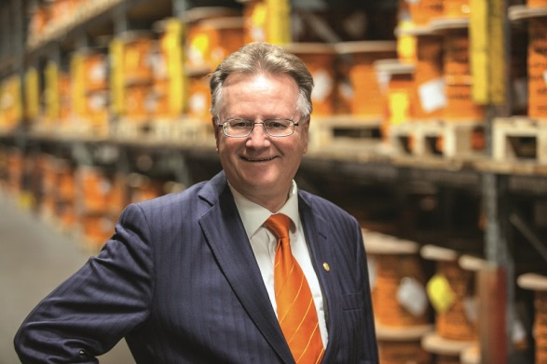
Image 1: Andreas Lapp, CEO of the Lapp Group.

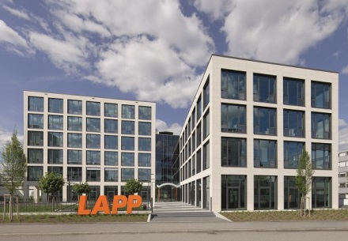
Image 2: The European Headquarters of the Lapp Group is located in Stuttgart, Germany.
You can find image 1 in printable quality here
You can find image 2 in printable quality here

Here you find more information:www.lappkabel.com/press

About the Lapp Group:
Headquartered in Stuttgart, Germany, the Lapp Group is a leading supplier of integrated solutions and branded products in the field of cable and connection technology. The Group’s portfolio includes standard and highly flexible cables, industrial connectors and screw technology, customized system solutions, automation technology and robotics solutions for the intelligent factory of the future, as well as technical accessories. The Lapp Group’s core market is in the industrial machinery and plant engineering sector. Other key markets are in the food industry as well as the energy and the mobility sector.
The Lapp Group has remained in continuous family ownership since it was founded in 1959. In the 2015/16 business year, it generated consolidated revenue of 901 million euros. Lapp currently employs approximately 3,440 people across the world, has 17 production sites and over 40 sales companies. It also works in cooperation with around 100 foreign representatives.

